PROGRAMMABLE LOGIC CONTROLLERS

**✅** 1. PLC Fundamentals (Core Concepts)

* What is a PLC?  
  ▸ Definition & role in automation (why PLCs?) **✅**   
  ▸ Advantages over hard‑wired relay logic. **✅**
* PLC Architecture  
  ▸ CPU (control + scan cycle) **✅**  
  ▸ Memory (program memory, data table, I/O image table) **✅**   
  ▸ Input modules (digital/analog) **✅**   
  ▸ Output modules (digital/analog) **✅**  
  ▸ Power supply**✅**
* PLC Scan Cycle  
  ▸ Input scan → Program execution → Output update**✅**   
  ▸ Relation to continuous loops in software**✅**
* PLC Programming Languages (overview)  
  ▸ Ladder Diagram (main focus) **✅**   
  ▸ Mention of others: FBD, ST, IL, SFC (just awareness) **✅**

**✅** 2. Ladder Logic Essentials (Main Exam Meat)

* Contacts and Coils  
  ▸ Normally Open (or XIC) **✅**   
  ▸ Normally Closed (or XIO) **✅**   
  ▸ Positive Transition Sensing Contact**✅**   
  ▸ Negative Transition Sensing Contact **✅**  
  ▸ Output Coil / Output Energize (OTE) **✅**   
  ▸ Output Latch (OTL) and Output Unlatch (OTU) **✅**

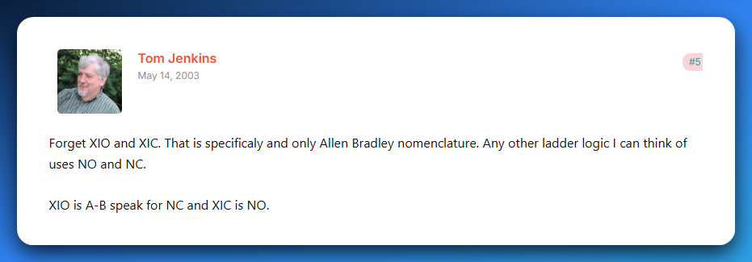

Source: [plctalk.net](https://www.plctalk.net/forums/threads/xio-xic-vs-no-nc.3486/)

* Logical Operations  
  ▸ AND (series contacts) **✅**  
  ▸ OR (parallel contacts) **✅**   
  ▸ NOT (using NC contacts) **✅**
* Internal Memory Bits  
  ▸ How to use internal relays (B3, M bits) for intermediate logic ❌
* Basic Programs  
  ▸ Start/Stop motor latch circuit❌  
  ▸ Simple interlock (two conditions must be true) ❌

**✅** 3. Timers (Time-Based Control)

* On‑Delay Timer (TON) ❌
* Off‑Delay Timer (TOF) ❌
* Retentive Timer (RTO) ❌
* Timer Reset (RES) ❌  
  *(Know their use‑cases and how to wire them in ladder logic)*

**✅** 4. Counters (Count-Based Control)

* Count Up (CTU) ❌
* Count Down (CTD) ❌
* Counter Reset (RES) ❌  
  *(Be able to create simple counting circuits)*

**✅** 5. Data Handling & Math

* Comparison Instructions  
  ▸ Greater Than (GRT) ❌  
  ▸ Less Than (LES) ❌  
  ▸ Equal (EQU) ❌
* Math Instructions  
  ▸ ADD, SUB, MUL, DIV❌  
  ▸ Scaling analog inputs (basic understanding) ❌
* Move Instruction (MOV)  
  ▸ Copy data between memory locations❌

**✅** 6. Program Structuring Techniques

* Sequencing (step-by-step control, e.g. washing machine cycle) ❌
* Subroutines / JSR (jump to subroutine) ❌
* State machines (using memory bits to track steps) ❌

**✅** 7. Troubleshooting & Simulation

* Diagnostics  
  ▸ Going online with PLC software❌  
  ▸ Forcing I/O (know concept) ❌  
  ▸ Monitoring and interpreting real-time values❌
* Common Faults-  
  ▸ Inputs not wired or misaddressed❌  
  ▸ Timers/counters not resetting as expected❌
* Simulation Practice *(you already reached this in class)*  
  ▸ Start/Stop motor latch❌  
  ▸ Traffic light (timers) ❌  
  ▸ Bottle filling/counting (counters) ❌  
  ▸ Door interlock (AND/OR logic) ❌

**✅** 8. Extra (If Time Allows / Bonus Points)

* Analog I/O handling (4–20 mA sensors, scaling raw values) ❌
* Safety interlocks (why certain conditions must be enforced before outputs energize) ❌(we didn’t learn this part 8 in class only part 7 was the last part.

**✨** Your Study Priority

If time is tight, focus in this order:  
**Ladder Logic Basics → Timers → Counters → Comparisons/Math → Structuring → Troubleshooting/Simulation.**

**💡** Practical Tip

✅ Spend most of your time in a simulator (OpenPLC or LogixPro).  
✅ Build small circuits for each topic.  
✅ Write tiny notes after each topic with a quick ladder snippet.

✅ 9. Minor Topic Additions for a Full House **🏡**

**Data Addressing & Naming Conventions:** Understand how different PLC brands label inputs, outputs, timers, and internal bits (e.g., I:1/0, O:2/1, M0.0), so you can read and write ladder logic accurately.

**Basic Error Handling & Safety Chains:** Learn how to use latches/unlatches or fault bits to flag abnormal conditions, and design safety interlocks (like E‑stops) that override all other logic when triggered.

**PLC Operating Modes:** Know the difference between RUN, PROG/STOP, and REMOTE modes, and how each affects program execution and editing.

**Troubleshooting Scenarios:** Be ready to diagnose practical issues (e.g., motor not starting despite input signal, counters double‑counting) by tracing logic, wiring, and I/O behavior.

**✨** WHAT IS A PLC?

**PLCs** are a specialized industrial computer that controls and automates processes in various industries.

PLCs are designed to be rugged, reliable, and easily programmed to **monitor** and **control** machines and processes.

A **Programmable Logic Controller (PLC)** is basically a rugged, specialized industrial computer built to run automation tasks. Rugged means they can operate in harsh environments.

👉 It *takes in signals* from sensors and switches, processes them according to a stored program, and then sends commands to outputs like motors, valves, or lights.

PLC Operation in real life/ PLC architecture

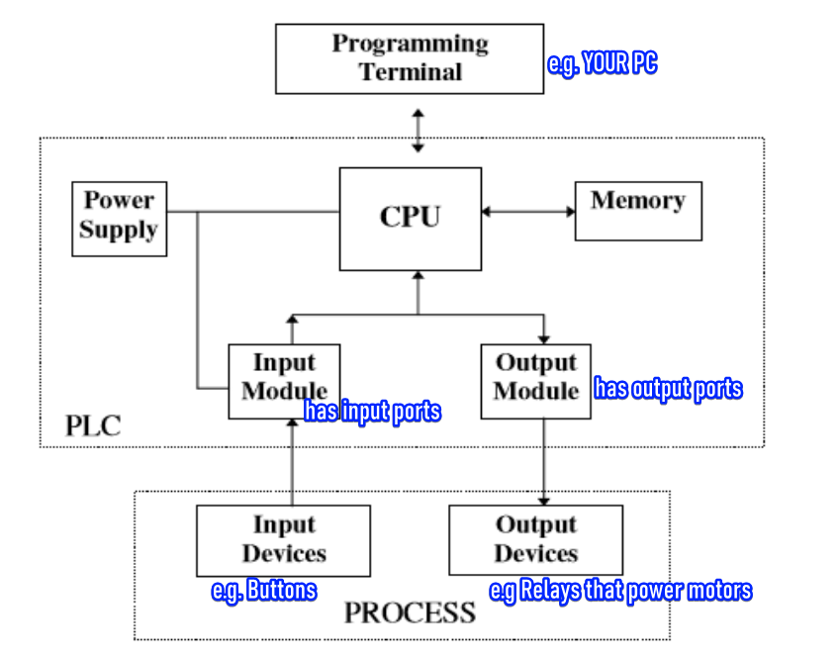

Process 1: Initializing the PLC System

Upon arriving at the company, the first step involves powering up the PLC system. This means energizing the **Power Supply** unit, which then provides stable DC power to the PLC's internal components, including the CPU and I/O modules, bringing the entire controller to life.

At this point, the PLC's CPU typically enters a **Programming Mode** (or Stop Mode), where it is powered on but not actively executing any control logic, waiting to receive instructions.

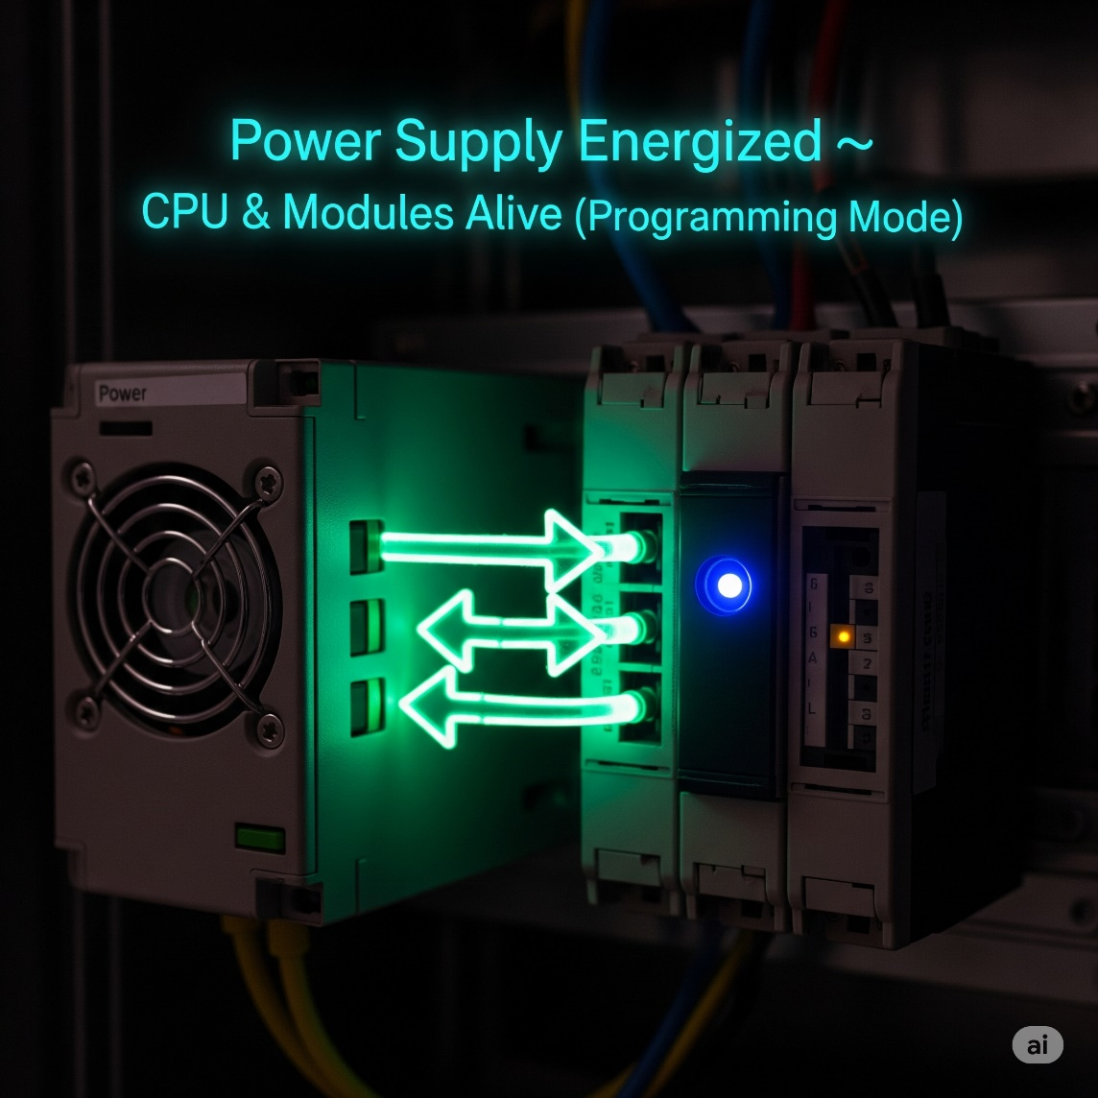

Process: Programming and Downloading Logic

Next, using a **Programming Terminal** (your PC or specialized device), you develop your control logic. This logic can be written in various IEC 61131-3 standard languages, such as Ladder Logic, Function Block Diagram, Structured Text, or Instruction List.

Once the program is complete and debugged in the software, it is then compiled and downloaded from your Programming Terminal to the PLC's **Memory**.

During this download, the PLC's CPU accepts and saves the new program, essentially acquiring its "new skill set" or updated operational instructions.

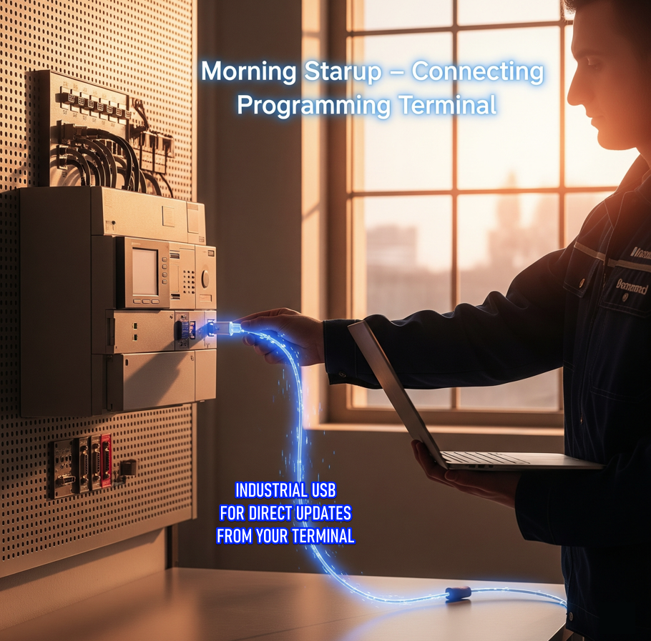

Process: Transition to Run Mode and Program Execution

After a successful program download, the PLC's CPU is switched from Programming Mode to **Run Mode**. In this mode, the PLC begins its continuous, high-speed **scan cycle**.

This cycle involves three primary phases: first, the CPU reads the current states of all **Input Devices** via the **Input Module**, updating its internal memory image of the inputs.

Second, it executes the downloaded program rung-by-rung (or instruction-by-instruction), processing the logic based on the current input states and internal memory bits.

Finally, it updates the states of the **Output Devices** based on the results of the executed program.

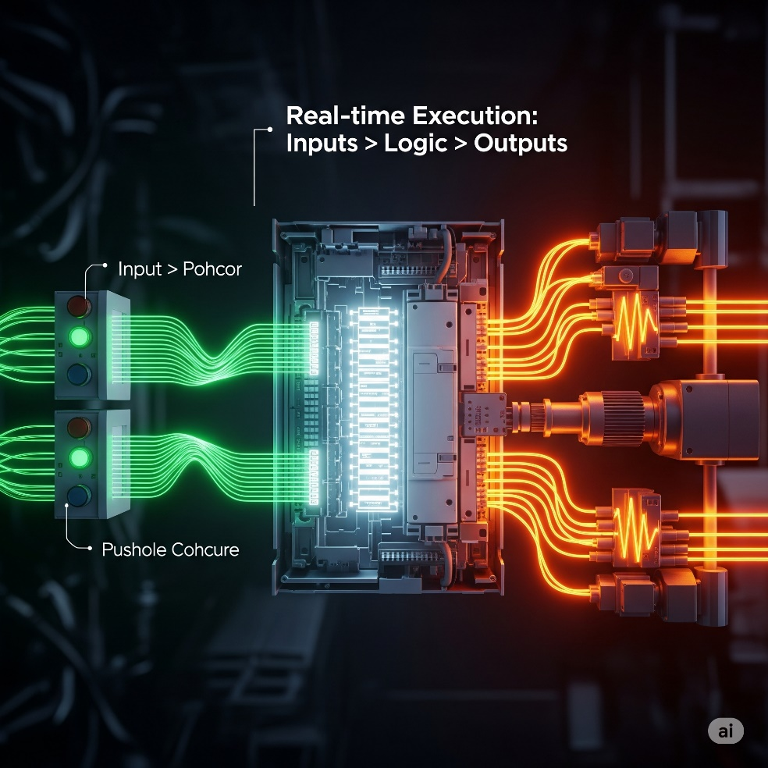

Process: Real-World Actuation via Output Chain

When the PLC's program logic dictates that a specific output should be activated (e.g., a motor needs to start), the CPU sends a low-power digital signal to the corresponding point on the **Output Module**.

This Output Module then converts that low-power digital signal into a suitable electrical signal (e.g., 24V DC). This low-power signal from the Output Module is then typically routed to the coil of an **external control relay or motor contactor**.

This external relay, acting as a robust intermediary, receives the small signal from the PLC, and in response, its heavy-duty contacts close, allowing high-power electricity to flow to and energize the **Output Device** (e.g., the motor), thereby initiating the desired machine action.

Key real‑world use cases:

* Controlling machines on a factory assembly line.
* Managing amusement ride rollercoasters as they twist and turn.
* Automating food‑processing machinery that mix ingredients for your favorite snack.

Why PLCs instead of normal PCs?

Designed to Handle Digital & Analog I/O:

PLCs have built-in I/O modules to directly handle digital and analog signals from industrial devices, while regular PCs need extra hardware and software, making them slower and harder to use for real-time control.

Survive Extreme Temperatures:

PLCs are rugged and built to survive extreme temperatures, while regular PCs can't handle the heat—or the cold—of harsh industrial environments.

Immune to Electrical Noise:

PLCs are built to resist electrical noise from heavy machinery, while regular PCs can glitch or fail in such interference-heavy environments.

Resist Vibration and Impact:

PLCs are designed with sturdy, shock-resistant casings and components, enabling them to withstand vibrations, impacts, and rough handling while regular PCs are too fragile and prone to hardware failures under physical stress.

**🧠** Core Sections of a PLC

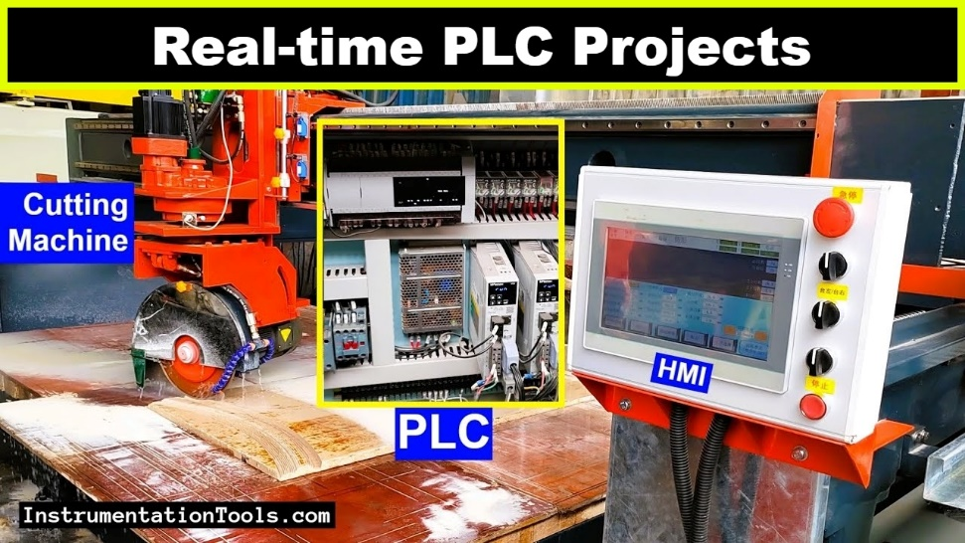

CPU (Central Processing Unit)

The PLC’s “brain.”

Contains a microprocessor, memory chips, and circuits for control logic, monitoring, and communication.

* **Microprocessor**: The brain of the PLC, executing tasks and calculations quickly.
* **Memory Chips**: Store the program and real-time data, like sensor states.
* **Control Logic & Communication Circuits**: Internal pathways for CPU communication with memory, I/O, and other devices.

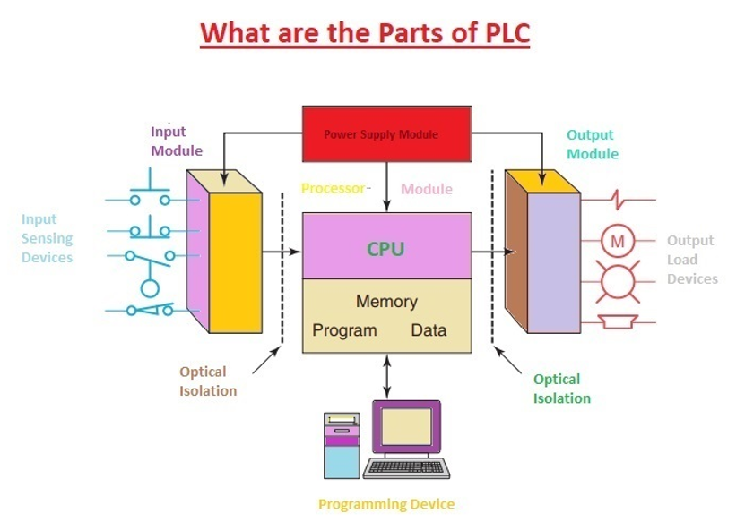

**⚡** CPU Operating Modes

Just like you might switch between "work mode" and "chill mode," the PLC's CPU has distinct operating modes:

* **Programming Mode:** In this mode, the PLCs CPU is ready to receive **new instructions**. When you connect a PC with a PLC programming software, the CPU is in this mode, **ready to accept and save those changes** to its memory. It's like updating the PLC's brain with new skills.
* **Run Mode:** Once the program is downloaded and confirmed, you switch the CPU to Run Mode, where the PLC **springs into action**! In this mode, the CPU constantly executes the program stored in its memory.

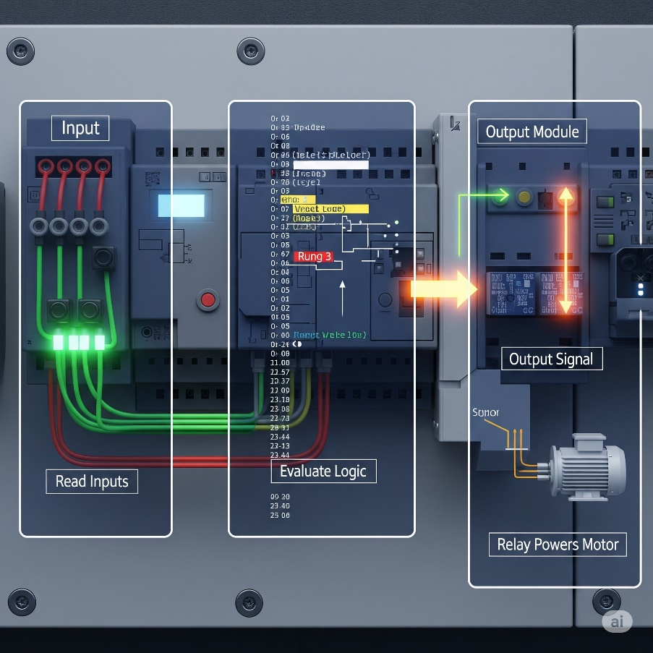

**⚡**I/O Interface System

**PLC’s "nerves"**: These are the input/output (I/O) systems that receive signals from sensors/switches and send commands to actuators (motors, lamps, relays).

Inputs (The Senses – How the PLC Gathers Info): 👂👀

* This part of the PLC is constantly **listening and watching** for signals from the outside world.
* **Field devices** are like the "reporters” sending info *to* and receiving instructions *from* the **PLC**. They gather real-world info (like temperature, position, pressure) or act on commands (like turning a motor on).
* **Sensors:** Sensors give the PLC *status updates*. A proximity sensor says, “Product is in place.” A temperature sensor warns, “It’s getting hot!” 🌡️🔥
* **Switches:** That button which sends an electrical signal (an input) to the PLC, saying, "Let's get started/stop!", controlled by humans.

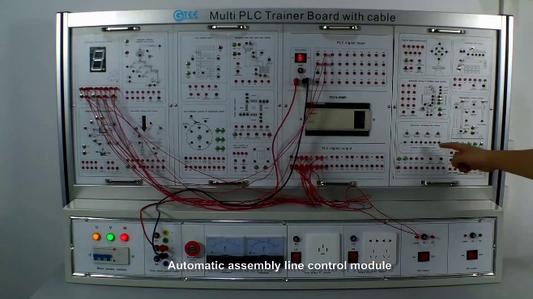 *PLC Training Board.*

**💾** PLC CPU Memory – What it stores and tracks

* Stores the **program logic**, the actual instructions.
* Tracks the current **status of inputs and outputs**
* Data Values – Stores values for:
* Timers ⏱️ (e.g., wait 5 seconds before starting)
* Counters 🔢 (e.g., count 10 items passing a sensor)
* Internal Bits ⚙️ (virtual switches used inside the program)

Outputs (The Muscles – How the PLC Takes Action): 🦾🗣️

* Once the PLC's brain (CPU) has processed the inputs and made a decision, the output interface is how it **sends commands** back out to the real world to make things happen.
* **Actuators** are the "doers" that receive commands from the PLC and perform a physical action.
* **Motors:** If the PLC decides to start a conveyor belt, it sends an electrical signal (an output) to the motor, telling it to spin.
* **Lamps/Lights:** If a machine completes a task, the PLC might turn on a *"Task Complete"* light. Or, if there's an error, it might flash a warning lamp. 🚨
* **Relays:** PLCs can't directly power **big machines** — they’re not strong enough.  
  So they use a **relay** (like a remote-controlled switch) to turn on bigger devices. 🗣️ PLC says: *“Relay, switch that heavy-duty pump on!”*➡️ Relay flips the power to the big machine.

The Scan Time: Blazing Fast Automation! **🚀**

*A PLC is a dedicated industrial controller, built to run a single control program — and it does so continuously and extremely fast.*

1. **🔍 Read Inputs**  
   The PLC checks the status of ***all input devices*** (e.g., are switches pressed? Is the sensor triggered?).
2. **🧠 Execute Program**  
   Using the input data, the CPU **runs the logic** stored in its memory — this includes timers, counters, and all the if/then conditions in the control program.
3. **⚡ Update Outputs**  
   Based on the results, the PLC **sends commands to output devices** (e.g., turn on a motor, light a lamp, or open a valve).

The time it takes for the CPU to complete **one full cycle** – reading inputs, executing the program, and updating outputs – is called the **scan time**.

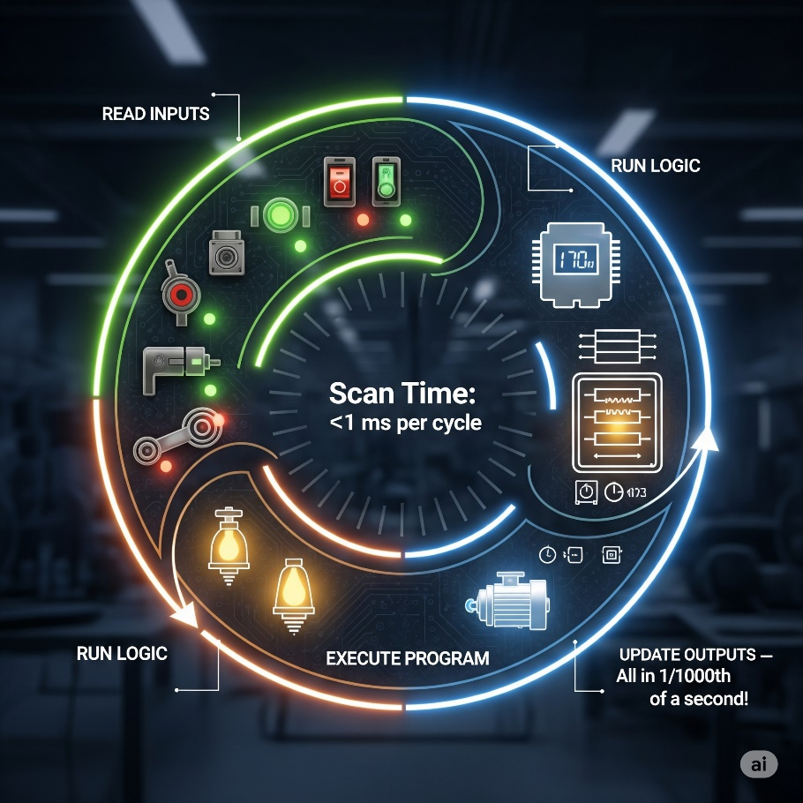

This happens with mind-blowing speed, often in the range of **1/1000th of a second** (that's 1 millisecond!).

Imagine blinking, and the PLC has already completed several hundred scans!

This rapid cycling is crucial for ensuring that industrial processes respond instantly to changes in the real world.

**⚙️** PLC Scan Cycle Recap:

Every PLC constantly runs in a **loop** like this:

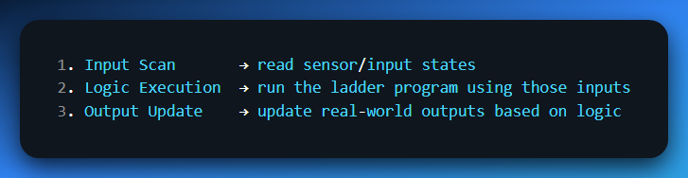

Then back to step 1. Over and over. Super-fast. Like 1,000 times per second.

**🤖** “Relation to Continuous Loops in Software” — What does that mean?

That sentence is drawing a comparison between **how PLCs run** and how **normal programs** in, say, C or Python, run loops like this:

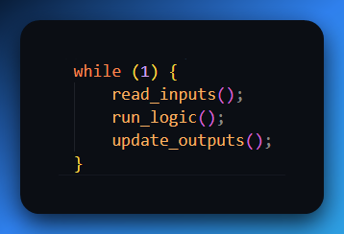

The **PLC scan cycle** is basically a **hidden while-loop** that never stops.  
It’s as if the PLC firmware is running something like:

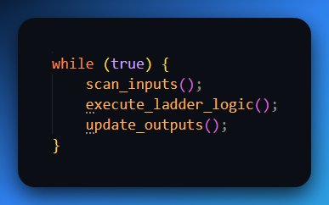

Except it’s optimized, real-time, and done in **hardware** + **firmware**.

**🤯** Why is this even important?

Because it explains:

* Why your outputs **don’t update instantly** when an input changes. They only change on the **next scan**.
* Why timing issues happen if your ladder logic takes too long to execute.
* Why some instructions (like SET/RESET) persist across scans while others (like OUT) only fire if the rung is *true every scan*.

It’s literally how the PLC *lives*. It's not event-driven like Windows code; it's **scan-loop based like embedded systems.**

**🎮** Final Analogy:

Think of a video game:

* Every frame, it:
  + *Checks input (keyboard/mouse)*
  + *Runs game logic*
  + *Draws the frame (output)*

That’s exactly what the PLC is doing. But instead of FPS, it’s scan time.

**⚙️** Why is This Important?

This ultra-fast cycling is **critical** in automation:

* Ensures machines respond **instantly** to changes.
* Keeps operations **precise, reliable, and safe.**

**🔥** Why this matters for your exam

* You can now clearly define what a PLC is, where it’s used, and why it’s built tough.
* You can explain its main parts (CPU and I/O), modes (program/run), and how the scan cycle works.
* You understand what “scan time” means and why memory is crucial.

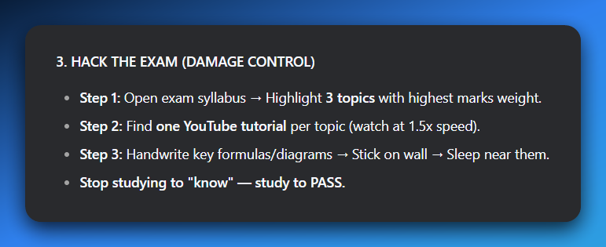

**✅** Main parts of a PLC (Programmable Logic Controller)

1. CPU (Central Processing Unit)  
   👉 *The brain.*
   * Executes the control program (ladder logic, etc.)
   * Does all the decision‑making.
   * Handles communication with other modules.
   * Stores the logic in memory and updates outputs based on inputs.
2. Power Supply  
   👉 *The heart pumping electricity.*
   * Feeds the CPU and I/O modules with stable DC power (often 24volt DC).
   * Without this? Dead PLC. 💀
3. Input Module(s)  
   👉 *The senses (eyes, ears).*
   * Reads signals from field devices (sensors, pushbuttons, limit switches).
   * Converts them into logic levels the CPU understands.
4. Output Module(s)  
   👉 *The muscles (hands, feet).*
   * Sends commands to actuators (motors, relays, lamps, solenoids).
   * Converts CPU logic to real‑world signals.
5. Programming Device (not always mounted, but essential)  
   👉 *The interface.*
   * Laptop or handheld used to load/edit programs into the PLC.
   * Without this, you can’t tell the PLC what to do.
6. Communication Ports / Interfaces  
   👉 *The mouth and ears for networking.*
   * Ethernet, RS‑232, Profibus, etc. for talking to HMIs, SCADA, or other PLCs.

In exam‑mode language:

A PLC is made up of a **CPU** (processes the program), a **power supply** (provides DC power), **input modules** (receive signals from field devices), **output modules** (drive actuators), and **programming/communication interfaces** (for configuration and data exchange).

🔥 **Pro tip:** If they want extra sauce, throw in: *“All these parts work together to replace hard‑wired relay logic with flexible, programmable control.”* 🎯

**✨** HISTORY OF THE PLCs

Before 1968, factories-controlled machines using **relay-based systems**:

* Relays = little electromagnetic switches turning things on/off.
* To control one motor, you needed a power relay.
* To control *that relay*, you needed control relays.
* Add timers, counters… soon you had cabinets stuffed with hundreds of relays.  
  👉 Result: a hot mess. Hard to wire, hard to change, a pain to troubleshoot. 🤯



Enter 1968 (Hydra-Matic division of General Motors):

* Replace relay logic with a **solid-state controller**.
* Must support **ladder logic** programming (familiar to electricians).
* Must handle **harsh industrial environments** (dust, vibration, electrical noise).
* Must be **modular** (easy to expand and maintain).

Dick Morley’s team delivered:

**Modicon 084** – first commercial PLC (limited success due to memory & speed issues). Too slow to perform any function anywhere near the relay response time. In it were a processor board, memory, and a “logic solver” board, which parsed the algorithms associated with ladder logic.



**Modicon 184** – Robust, user‑focused design that turned PLCs into an industry standard. It ignited the market and began the changeover from relay-based control to solid-state units.



Key innovation:

Instead of physically rewiring circuits, engineers now just modify software logic.  
✅ Faster changeovers.  
✅ Reduced downtime.  
✅ Lower maintenance.  
✅ Space-saving, scalable control.

💥 Nick’s Fast Exam Lines:

*“Before PLCs, factories used complex relay-based systems that were expensive, huge, and hard to maintain.*

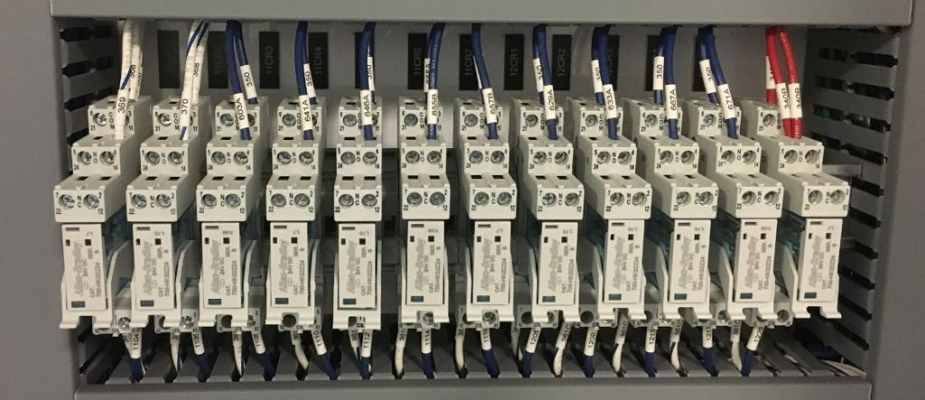

*In 1968, Dick Morley’s team created the first PLC (Modicon 084) to replace relays with a programmable, modular, solid-state controller. The breakthrough Modicon 184 later transformed automation worldwide.”*

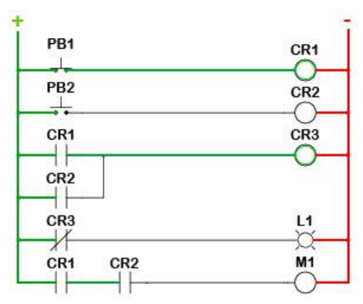

PLCS GROWING UP: FROM BASIC TO BOSS MODE! **📈**

The first PLCs were tiny, eager learners, fresh out of their "birth" phase.

They could handle the basics:

* **Inputs and outputs - turning things ON and OFF.**
* **Simple traditional relay‑style logic (coils and contacts).**
* **Basic Timers and counters.**

But just like a teenager hitting a growth spurt, PLCs quickly started adding some serious muscle and brainpower.

Leveling Up: New Powers for the PLC Brain **🧠✨**

The early PLCs were like a basic calculator, but they soon learned to do much more:

Math Whiz:

Since timers and counters already used "word size internal registers" (think of these as dedicated little memory slots for numbers), it was a natural next step for PLCs to start doing **simple math** – adding, subtracting, multiplying, dividing.

Soon after, they mastered **floating-point math**, allowing them to handle decimals and more complex calculations, which is super important for precise measurements.

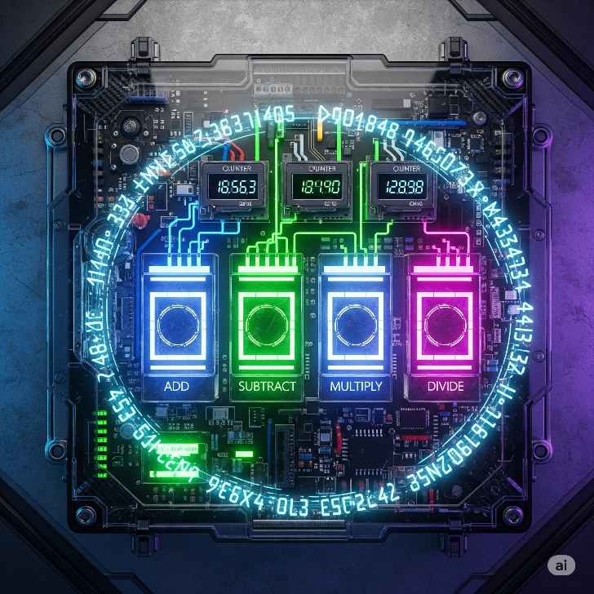

Enhanced Timing & Counting:

Beyond simple "start a timer for 10 seconds," PLCs gained **"one-shots"** (like a single-use trigger that fires once when activated) and more sophisticated timers and counters.

One-shot triggers and smart counters, letting them catch quick signal changes and control complex sequences more precisely.

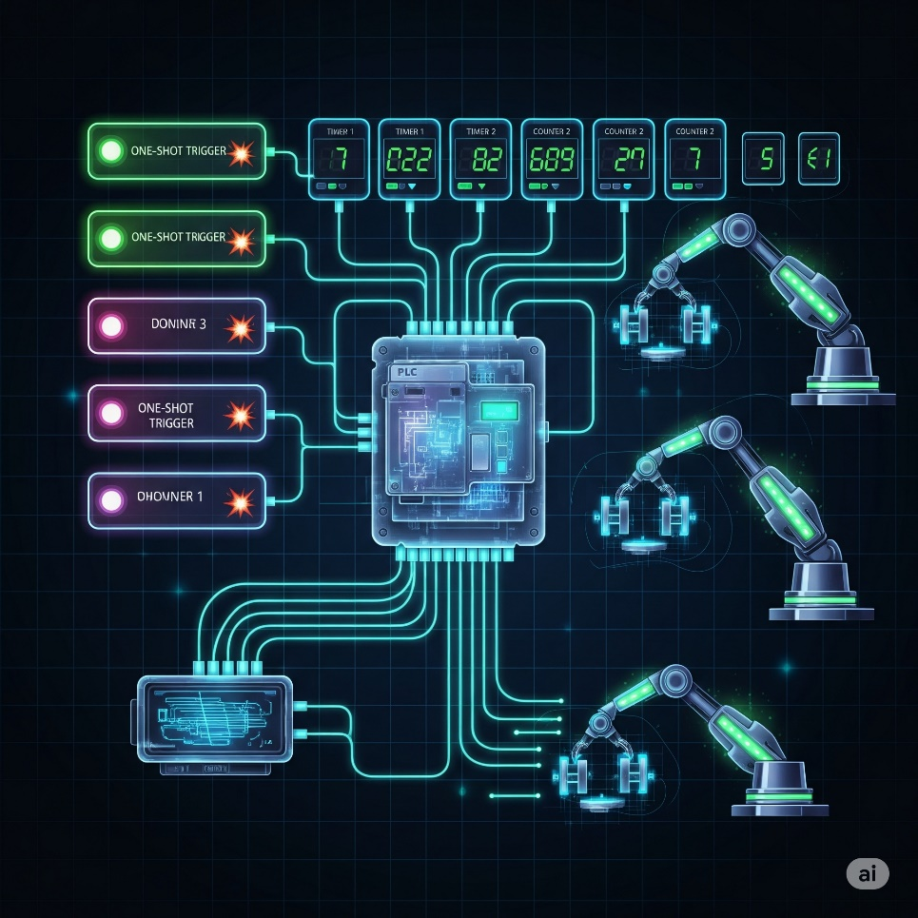

A bottling plant uses **smart counters** to track exactly how many bottles pass through each station, while **one-shot triggers** fire once to activate the capping machine only when a bottle is perfectly positioned.

Process Control Superpowers (PID):

PLCs gained built-in **PID controllers (Proportional-Integral-Derivative),** like having a lightning-fast autopilot that constantly fine-tunes systems to maintain perfect stability.

Imagine trying to keep the temperature of your shower *exactly* at 38°C. Without PID, you'd constantly be fiddling with the hot and cold taps, overshooting and undershooting, PID automatically keeps temperatures, pressures, and speeds exactly where they need to be, revolutionizing continuous processes in chemical plants, food production, and manufacturing.

A **pharmaceutical company** uses PID controllers to maintain precise pressure in tablet compression machines - as the powder density changes throughout production, the PID automatically adjusts hydraulic pressure to ensure every pill has exactly the same hardness and weight.

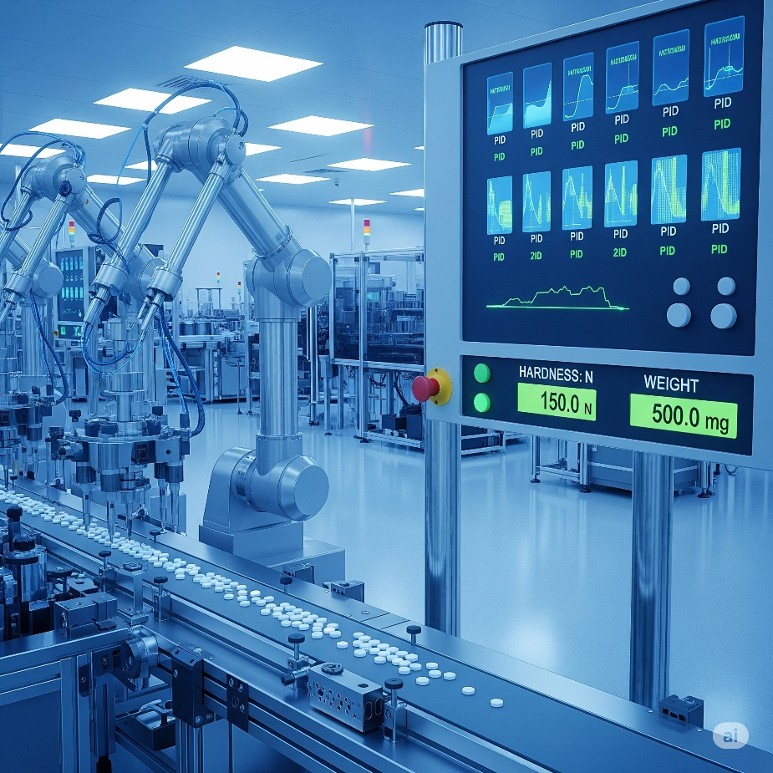

Drum Sequencers:

The OG rhythm masters of automation. These control machines that follow the same steps in order, every time. Like a car wash that automatically moves through: pre-rinse → soap → scrub → rinse → dry → wax.

Each step triggers specific actions and waits for completion before moving to the next, ensuring consistent results for any repetitive process.



Smarter Programming:

**Fill-in-the-blank data boxes:** Programming became more efficient. Instead of writing complex code for common functions, you could just fill in the blanks, like filling out a digital form.

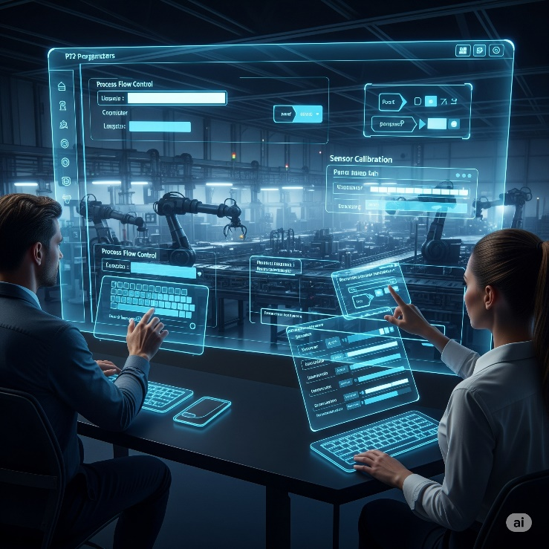

**Meaningful Tag Names:** This was a lifesaver! Instead of cryptic labels like "I:0/0" or "N7:0," engineers could use **descriptive "Tag Names"** like "Start_Button," "Conveyor_Motor_ON," or "Tank_Level_Sensor."



**Real-world analogy:** Imagine if all your contacts in your phone were just numbers instead of names. Tag Names are like giving your friends actual names so you know who you're talking to! This made programs way easier to understand, debug, and maintain, even for someone new to the project.



**Import/Export Tags:** The ability to easily move these Tag Names between different devices (like the PLC and an HMI) eliminated errors and saved tons of time from manually re-entering information. **Human Machine Interfaces** replace manually activated switches, dials, and other controls with graphical representations of the control process and digital controls to influence that process.



*We moved from hardwired panels to smart HMIs.* *Less physical clutter, more data visibility, fewer mistakes.*

TALKING THE TALK: PROGRAMMING & COMMUNICATION EVOLUTION **🗣️💻**

As PLCs got smarter, so did the tools used to program them and the ways they communicated with the outside world.

Programming Devices:

**The "Suitcase" Era:** Early programming devices were dedicated, clunky, and literally the size of suitcases! Not exactly portable.

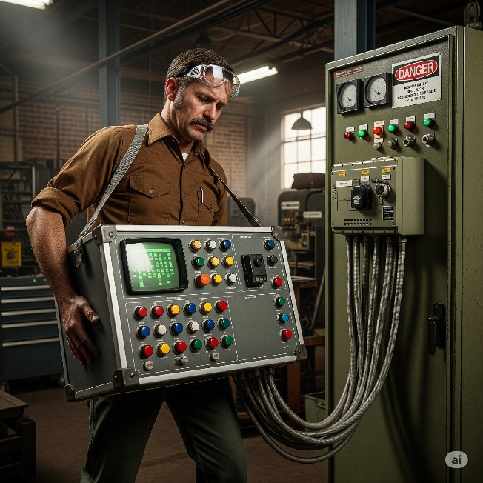

**Handhelds:** Then came smaller, handheld devices, offering a bit more freedom.

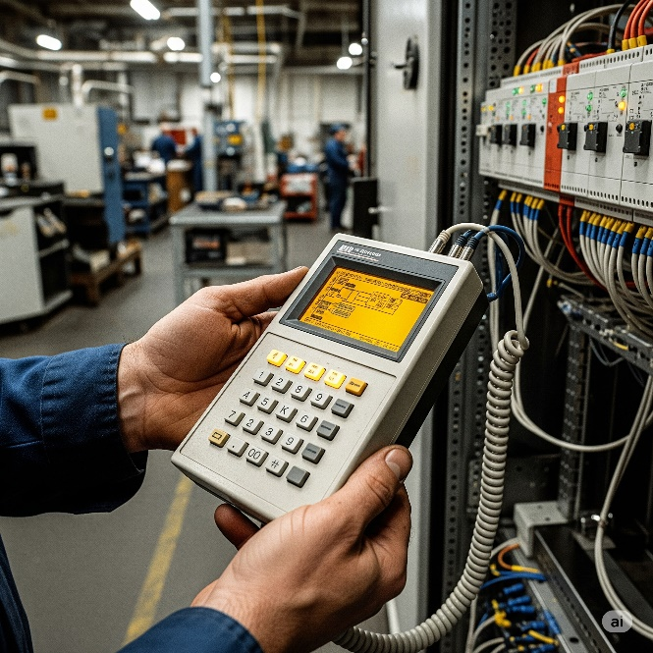

**PC Software Takes Over:** The real revolution happened when proprietary programming software moved to personal computers (PCs).

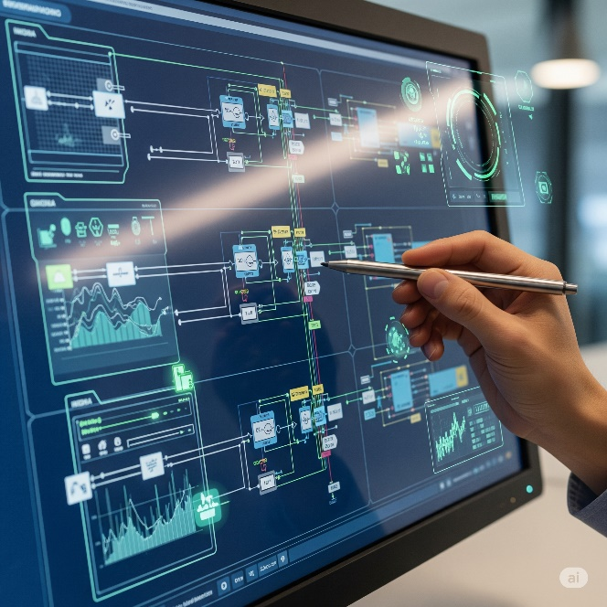

AutomationDirect's **DirectSOFT** was a pioneer as the first Windows-based PLC programming package. This was huge!



Having a PC meant:

* **Visual Programming:** You could see your ladder logic (or other programming languages) clearly on a screen.
* **Easier Testing & Troubleshooting:** PCs offered powerful tools for monitoring the PLC's status in real-time, simulating logic, and quickly pinpointing problems. It was like getting X-ray vision for your machine's brain.

Communication Protocols:

PLCs needed to talk to other devices, and this area saw rapid growth.

1. The Early Days (MODBUS & RS-232): Communication started with basic serial protocols like MODBUS over RS-232 (think of an old-school serial cable connecting two devices directly).

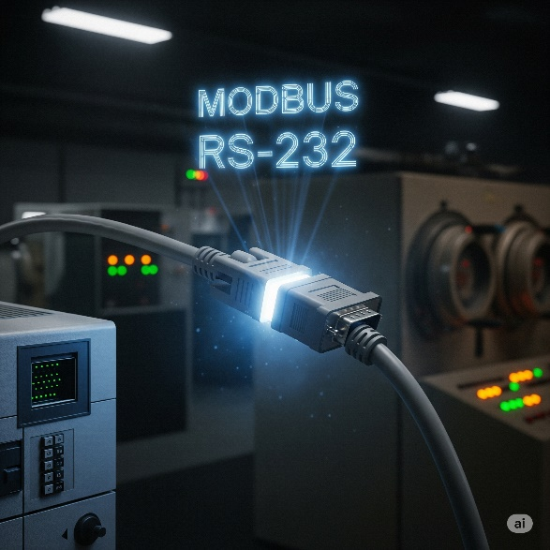

2. Expanding the Network (RS-485, DeviceNet, Profibus): As automation grew, so did the need for PLCs to talk to *many* devices over longer distances. This led to protocols like RS-485, DeviceNet, and Profibus. These new protocols were like setting up a small office network where multiple devices could chat.



**Industrial cables** branch out like highways, each carrying data through protocols like **RS-485, DeviceNet, and Profibus**.

**Sensors** act as the factory's eyes and ears, constantly monitoring temperature, pressure, and product presence. **Drives** function as muscles, controlling motor speed and direction. **Remote I/O modules** serve as nerve endings, extending the PLC's reach across the factory floor.

**Data pulses** flow along these lines like a digital heartbeat, making the invisible network work visible. The blue and orange lighting emphasizes how advanced industrial automation has become.

These **communication protocols** connect everything together, letting the PLC manage hundreds of devices across massive factory operations.

3. The Ethernet Era:Ethernet became the standard for industrial communication through protocols like EtherNet/IP. It's fast and lets PLCs connect with drives, robots, and touchscreen interfaces, creating smart factories where everything talks to each other.

PLCs evolved from simple relay replacements into powerful controllers that handle complex math, manage processes, and communicate with other machines - becoming the backbone of modern industry.

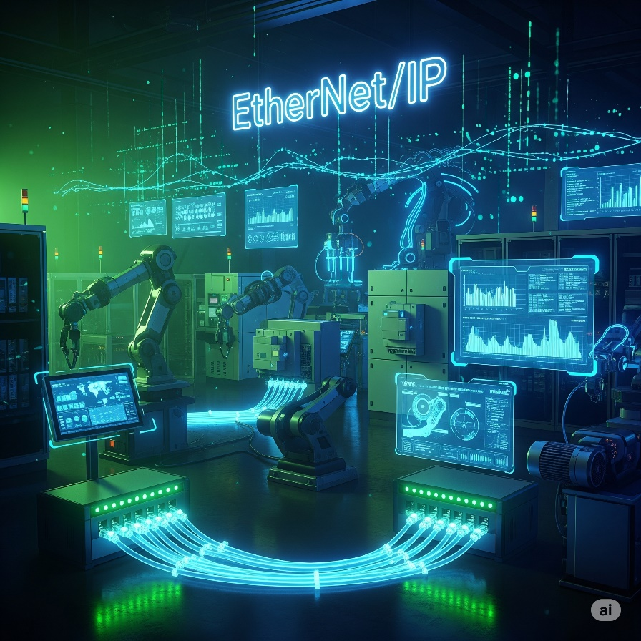

HOW TO CHOOSE YOUR CONTROLLER: THE "SMART BRAIN" CHECKLIST **🧠✅**

Choosing the right "brain" for your machine or system isn't just about grabbing the first thing off the shelf.

It's like picking the perfect teammate for a big project – you gotta consider a few key things to make sure they're a good fit!

This checklist is your cheat sheet to figure out what kind of programmable controller your project actually needs.

Step 1: New System or Existing System? 🏗️🔄

Are you building from scratch or adding to something already running?

**Why this matters:** It's like trying to connect a PlayStation 5 to an 80s TV - different tech doesn't always play nice together. Your new controller needs to communicate with existing equipment, or you'll have expensive paperweights.

**Pro-tip:** Check compatibility before buying to save headaches and money.

A factory tries to connect a new Allen-Bradley PLC to existing Siemens motor drives. The **Allen-Bradley** uses EtherNet/IP while the **Siemens** **drives** only speak Profibus - they literally can't communicate without **expensive gateway** converters, turning a simple upgrade into a costly nightmare.

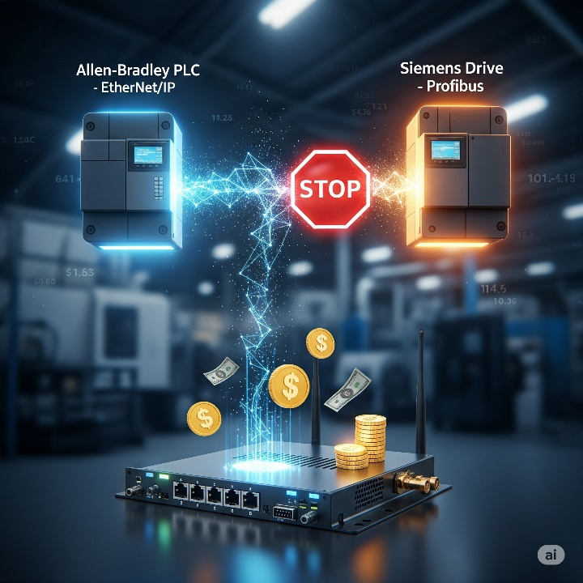

Step 2: Battle the Elements! (Environmental Check) **🌡️💨**

Where will your controller live? Nice air-conditioned office or hot, dusty factory floor? Consider things like:

* **Temperature:** Is it going to be super hot or freezing cold? 🔥❄️
* **Dust & Dirt:** Is the air full of grime, sawdust, or metallic particles? 🌬️
* **Vibration:** Is it going to be constantly shaking from heavy machinery nearby? ⚙️
* **Facility Codes:** Does your workplace have any special rules or safety codes about equipment (like needing to be explosion-proof)? 🚧
* **Why this matters(seriously!):** Imagine trying to use your smartphone in a sauna, or trying to take it deep-sea diving without a waterproof case. It's probably not gonna last long, right? 😬

Standard controllers work in 0-55°C (32-130°F), but extreme heat, dust, or constant shaking will kill them.

Choose ruggedized controllers for harsh environments or protect standard ones with proper enclosures. Skip this step and your whole operation stops when the controller dies.

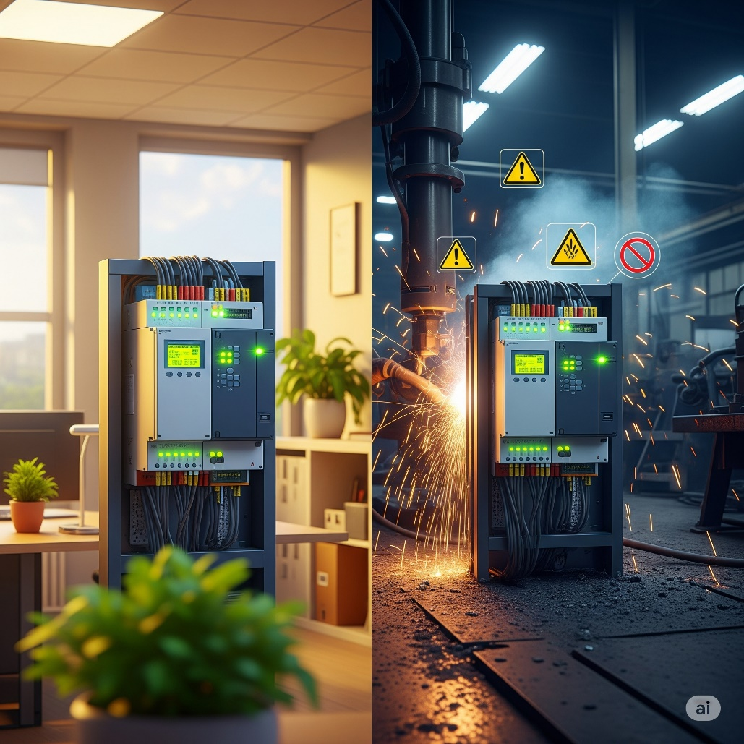

Step 3: Counting the "On/Off" Crew (Discrete Devices) **🚦**

Think about all the things in your system that are just **ON or OFF**. These are called **discrete devices**.

**What to figure out:** How many discrete devices do you have, and do they use AC (wall power) or DC (battery power)?

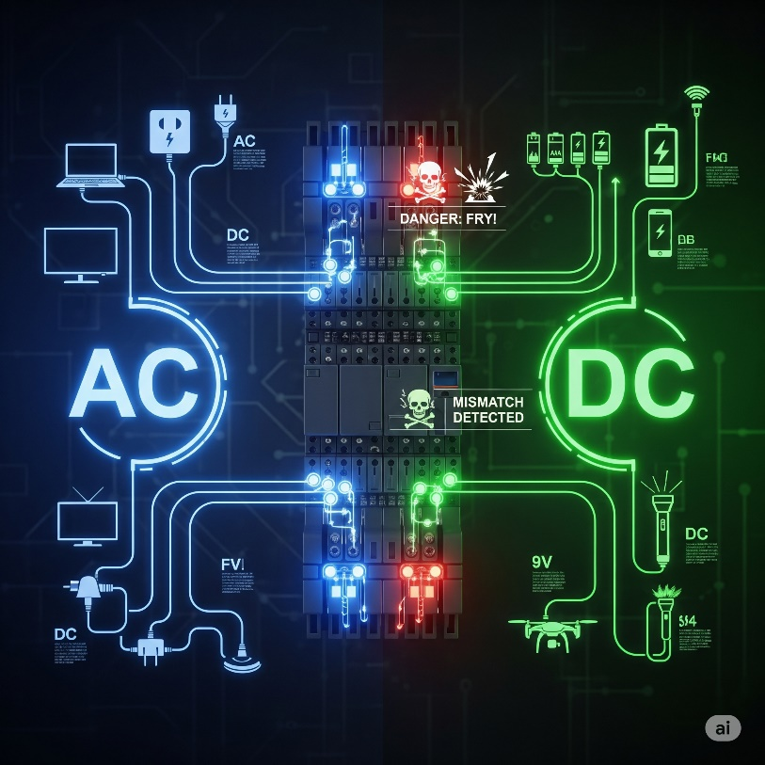

**Why this matters:** Your controller is like a switchboard - each device needs its own connection point. If you have 50 buttons and lights, you need 50 I/O points. Plus, AC devices won't work with DC controllers without frying something.

**Your move:** Count all on/off devices and note if they're AC or DC to determine your I/O requirements: buttons, lights, motors starting/stopping.

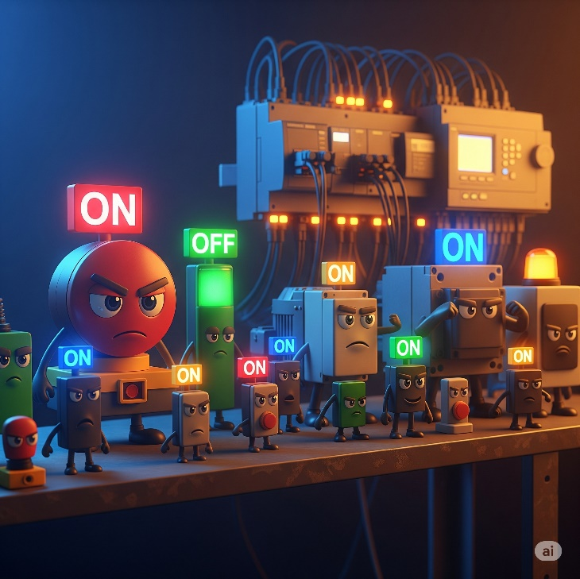

Step 4: Count Your Measuring Devices (Analog Devices) **📏🌡️**

Count devices that measure range of values, not just on/off. These are your **analog devices** e.g. A temperature sensor that tells you it's 25.3°C, a pressure sensor that reads 75.5 PSI, or a flow meter that says you have 10.2 liters per minute. These give you a continuous, precise measurement.

What to figure out:

How many of these "measuring" devices will your system have? And what kind of signal do they send (like voltage, current, or a direct temperature reading)?

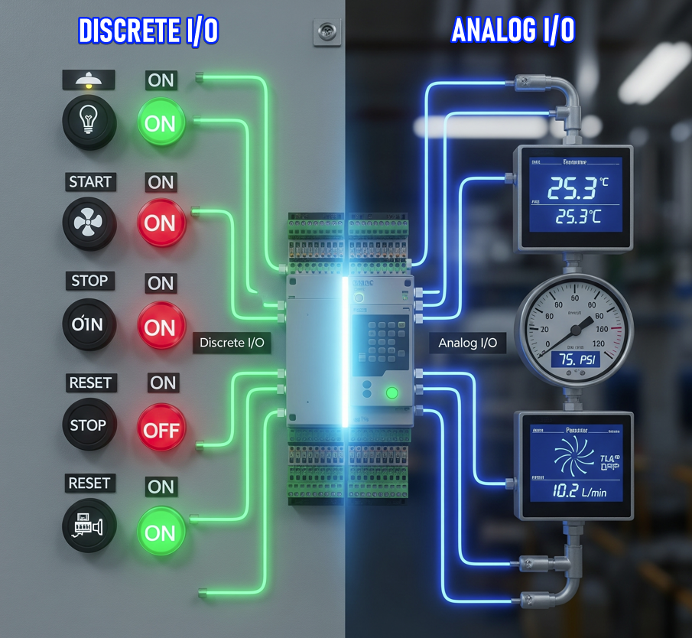

Why this matters:

A **discrete signal** is simple: ON or OFF (like a light switch).

An **analog signal** is continuous: it varies smoothly, like temperature 0–100°C or pressure 0–10 bar.

Your PLC needs **special analog input/output (I/O) modules** to read those continuous values or to send out continuous control signals.

If your PLC only has discrete I/O points, it can’t understand a temperature sensor that outputs 4–20 mA—it would be like trying to watch a 4K webcam through a port that only handles old‑school black‑and‑white signals. It just won’t work.

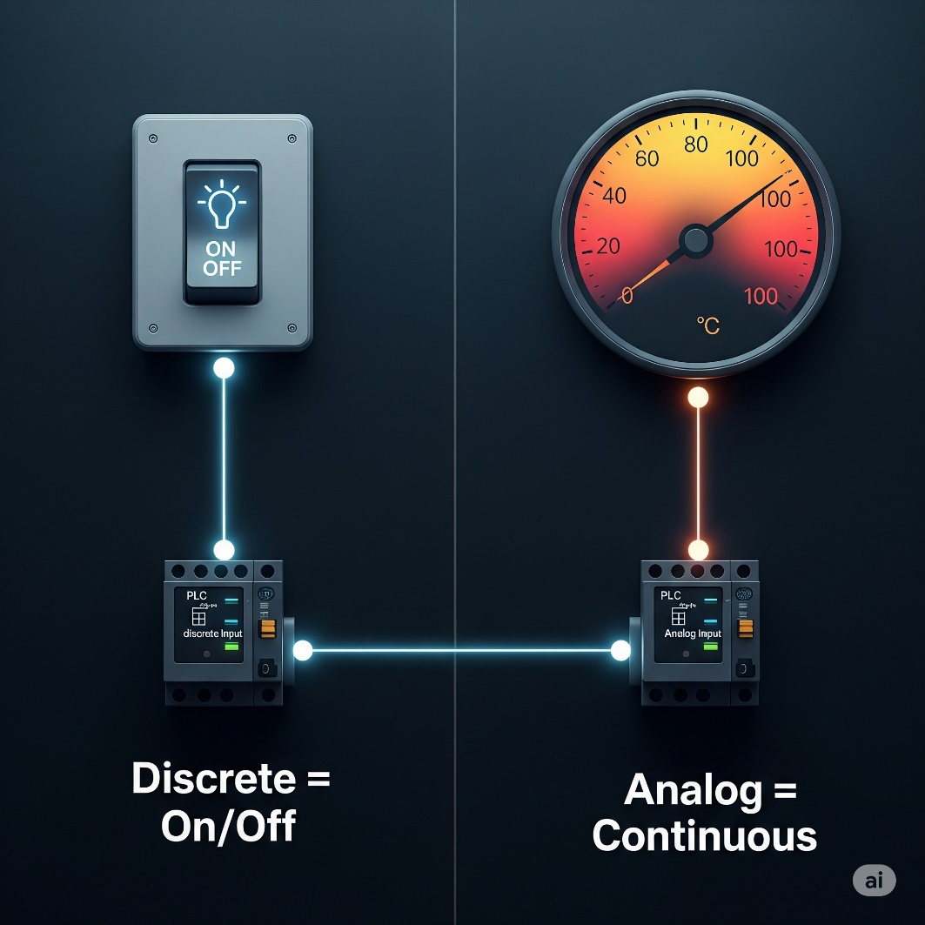

Your move:

**Make a list of every measuring device you plan to connect to your PLC, and note what kind of signal it uses.**  
For each sensor, ask:

* Is it **discrete** (on/off)?
* Or **analog** (variable voltage/current)?
* If analog, what’s the range (e.g., 0–10 V, 4–20 mA)?

💡 Why? Because when you know the exact mix, you can pick a PLC with enough **analog I/O points** (and the right types) to handle all those sensors.  
If you don’t plan ahead, you might buy a PLC that can’t read half your devices—then you’re stuck buying extra modules or a whole new PLC. Ouch.

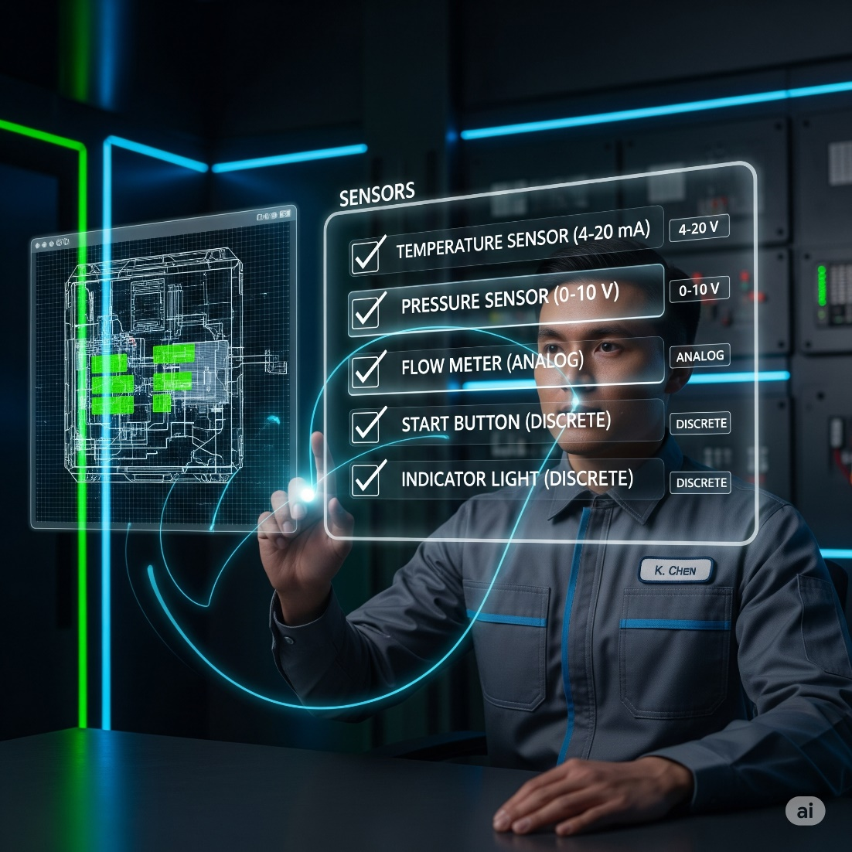

Step 5: Special Features Check **✨🚀**

Does your system need any fancy tricks beyond basic on/off control?

**Examples:**

* **High-speed counting:** Tracking thousands of products per second on fast conveyors
* **Precise positioning:** Robot arms placing components within fractions of millimeters
* **Real-time clock:** Time-stamping events or scheduling automatic operations
* **Special communication:** Connecting to specific networks or motion control systems

**Why this matters:** Basic controllers are like smartphones - great for general tasks. But specialty functions need extra "apps" (modules) to work, just like professional photo editing needs special software.

**Your move:** List all special requirements early. High-performance features usually require expensive add-on modules that aren't included in standard controllers.

**Real-world example:** A bottling plant needs to count 2,000 bottles per minute passing through quality inspection. A standard PLC input can only handle about 100 counts per second, so it would miss most bottles. They need a **high-speed counter module** that can accurately track 500+ counts per second to catch every single bottle for proper quality control.

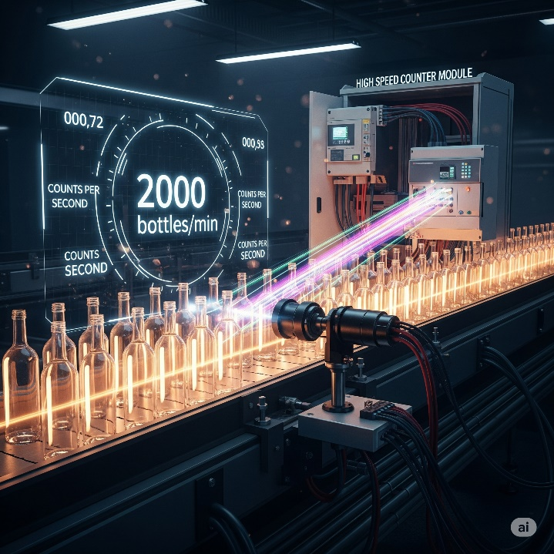

Step 6: CPU Power Check **💻⚡**

Choose your controller's "brain power" - like picking between a basic laptop for emails or a gaming rig for heavy tasks.

**Data Memory:** Temporary storage for all the live numbers your system is tracking right now - sensor readings, counter values, and timer settings.

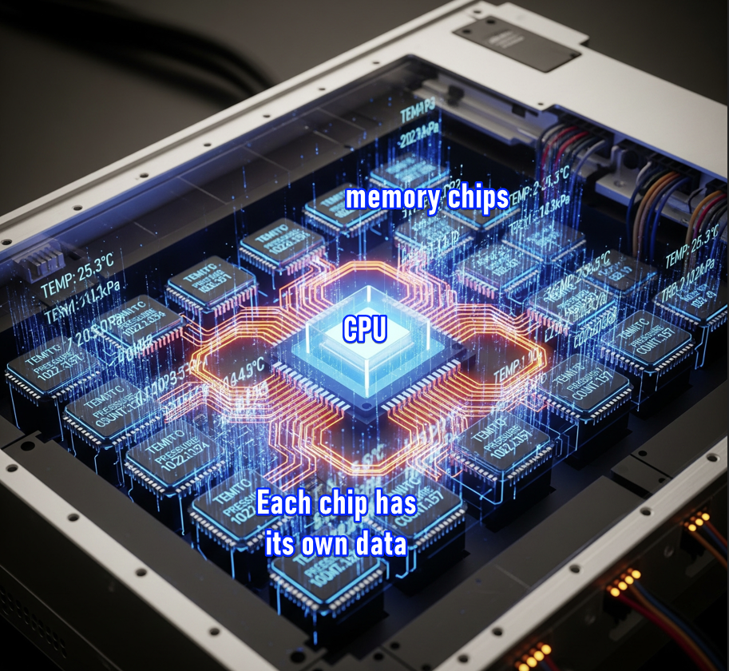

**Why it matters:** Systems that track lots of values or keep histories (like weekly production counts) need more data memory. Heavy data logging determines which CPU model you need.

**Program Memory:** Where your actual program instructions live permanently - like a hard drive storing all your code.

**Why it's important:** Every instruction ("start motor," "wait 5 seconds," "count product") takes up memory space. Complex programs need more program memory.

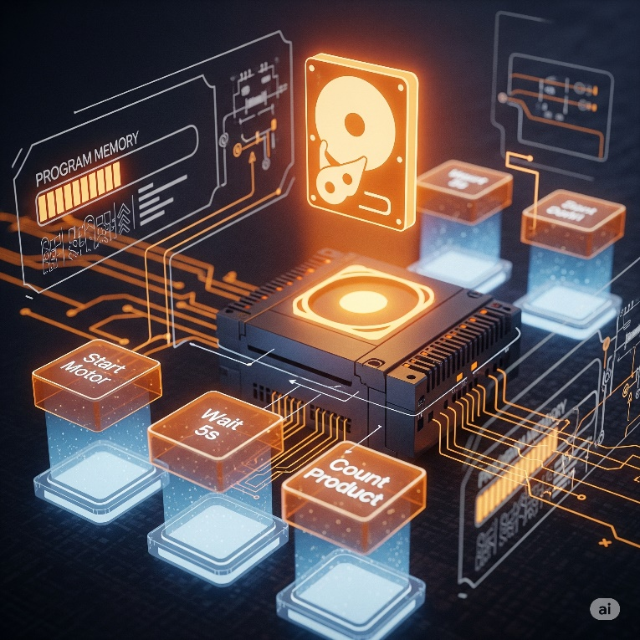

**Quick estimate:** Simple on/off devices need about **5 words per device**. Measuring devices need about **25 words per device**. Complex projects may need more.

A **"word"** is a unit of memory measurement in PLCs - think of it like a small storage box that holds one piece of information, typically 16 bits of data.

**Real-world example:** A simple bottling line with 20 on/off devices (start/stop buttons, motors, lights) and 4 measuring devices (temperature sensors, flow meters) would need roughly:

* **20 devices × 5 words = 100 words**
* **4 devices × 25 words = 100 words**
* **Total: ~200 words of program memory**

So, you'd need a PLC with at least 200+ words of program memory capacity.



**How fast does it need to be? (Scan Time):** How quickly the PLC CPU reads inputs, runs your program, and updates outputs - like how fast your computer processes clicks.

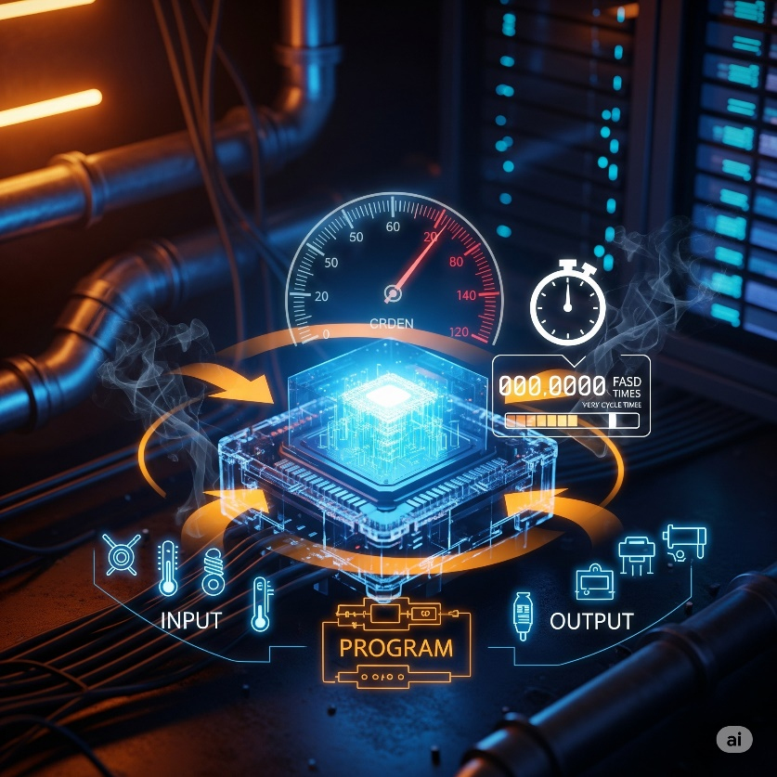

**Why it's important:** High-speed operations (like fast packaging lines) *need quick scan times.* Slow CPUs miss events or react late, messing up your process.

**Pro-tip:** Some CPUs are fast at simple on/off logic but slower at complex math. If you need **PID control** (like that perfect shower temperature), choose CPUs designed for heavy calculations - they'll save you major headaches.



Step 7: Where Are Your Devices Located? **📍🌐**

Are all your sensors, buttons, and motors close to the main PLC/controller, or spread across a big factory or different buildings?

**Remote I/O:** Devices are far away, so you use small connection boxes near the devices that talk back to the main PLC through one cable – similar to using Wi-Fi extenders across a big office.



**Why this matters:** Running hundreds of individual wires across long distances is expensive and a nightmare. Remote I/O uses one communication cable instead.

Wi-Fi extender broadcasts your internet signal further, **Remote I/O modules extend the PLC's ability to communicate with devices that are far away from the main control cabinet.**

**How it works:** Remote systems use industrial networks like **Ethernet** or **serial communication** with protocols like **Modbus** to send data back and forth.

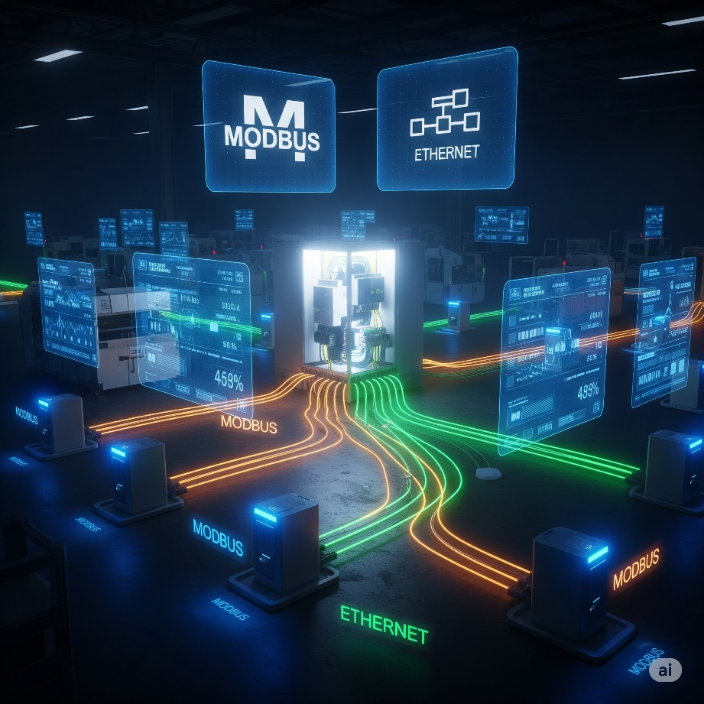

The main PLC is too far away to connect directly to all the devices, so:

1. **Remote I/O modules** are placed close to the distant devices.
2. These modules collect data from local sensors/control local motors.
3. They use protocols like **Modbus, Profibus, or Ethernet** to send all that collected data back to the main PLC through one communication cable.
4. The main PLC processes everything and sends commands back to the remote modules the same way.

So yes - the remote I/O modules act as "messengers" that gather local device info and relay it to/from the distant main PLC using these industrial communication protocols.

**Your move:** Count how many separate locations have devices. Multiple locations = you need remote I/O capability.

Step 8: Who Needs to Talk to Whom? (Communication Requirements) **🗣️💬**

Your PLC doesn’t live in a bubble. Besides handling its own inputs and outputs, it might need to “talk” to other brains in the system. Before you pick a PLC, figure out **who it needs to communicate with**.

**🔗** What kinds of communication are we talking about?

* **PLC ↔ PLC:**  
  Sharing data between two or more PLCs so they can coordinate tasks.
* **PLC ↔ SCADA / MES / ERP:**  
  Sending production info up to higher‑level systems like SCADA (for monitoring) or an ERP system (for business management).
* **PLC ↔ Smart Devices:**  
  Directly communicating with smart sensors, barcode scanners, or advanced motor drives.

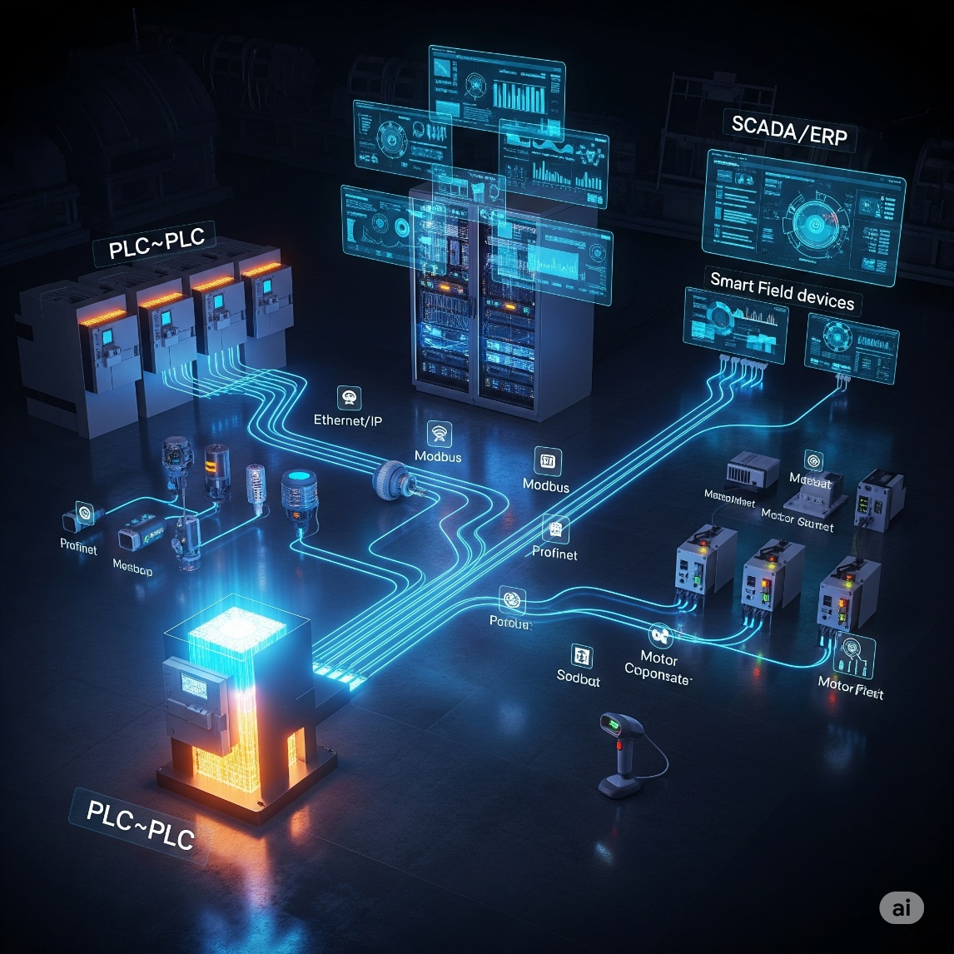

**🎯** Your mission:

Identify *all* the other systems or devices your PLC needs to exchange information with. Don’t assume—write them down.

**⚠️** Why this matters:

Not every PLC comes loaded with multiple communication ports or protocols.  
Think of it like buying a laptop:

* Some have HDMI, 4× USB, and Ethernet right out of the box.
* Others only have the basics, and you’ll need adapters.

If your PLC needs to handle heavy communication, you might:  
✅ Choose a CPU that already supports those protocols, **or**  
✅ Plan to buy extra communication modules.

**👀** Your move:

Make a clear list of every system or device your PLC must talk to.  
This list will guide you in selecting the right CPU and making sure you’ve budgeted for any additional communication hardware.

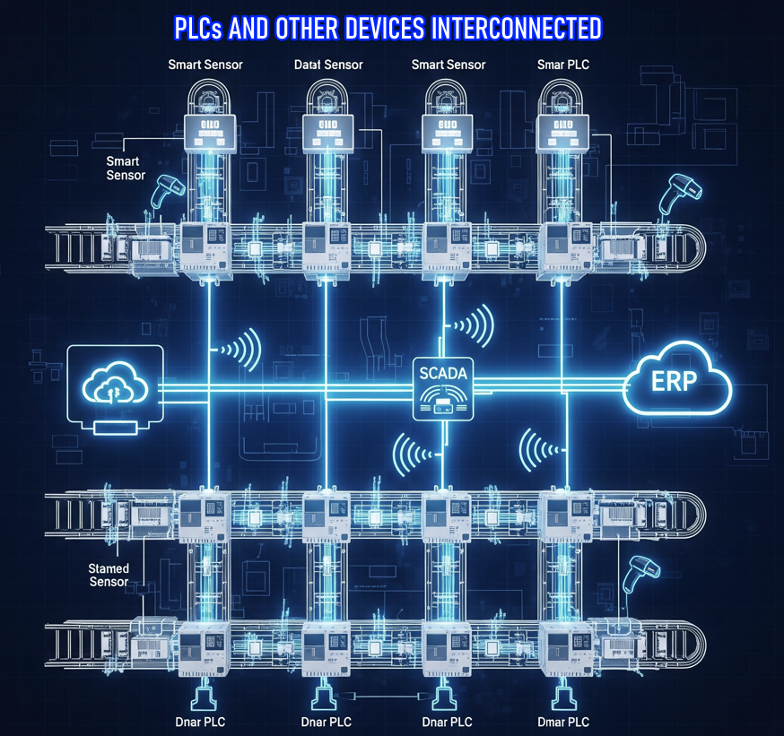

Step 9: Determining your Programming Requirements**✍️🤖**

**✨ Programming Requirements: Do You Need More Than the Basics?**

**Ask yourself:**  
Does your application only need traditional instructions (like timers, counters, and basic logic), or does it require special built-in instructions as well?

**Why this matters:**  
Not every controller supports every type of instruction.  
You must choose a PLC model that can handle all the instructions your specific application will need.

✅ Standard instructions (the basics almost every PLC can do):

* **Timers:** Count time (e.g., “wait 10 seconds before starting the motor”).
* **Counters:** Count events (e.g., “count 5 products, then trigger a conveyor”).
* **Basic logic:** Combine inputs and outputs (e.g., “If this button is pressed AND the sensor is clear, then run the motor”).

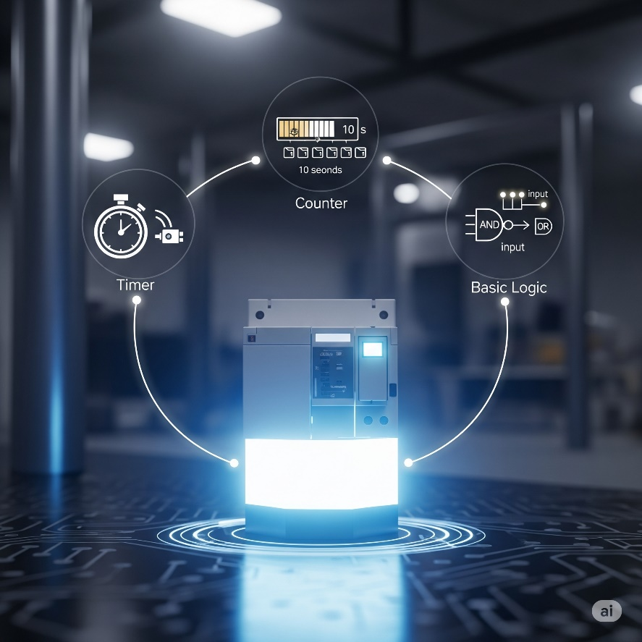

🚀 Special instructions (the advanced features):

Some PLCs include powerful ready‑made functions to save you from writing complex code yourself:

* **PID Control Blocks:** For smooth control like keeping temperature or pressure steady without you hand‑coding the math.
* **Motion Control:** For robots or machines that need precise movement or synchronization.
* **Recipe Management:** Quickly switching between different product setups without rewiring or rewriting code.
* **Database Connectivity:** Talking directly to databases to log data or fetch settings.

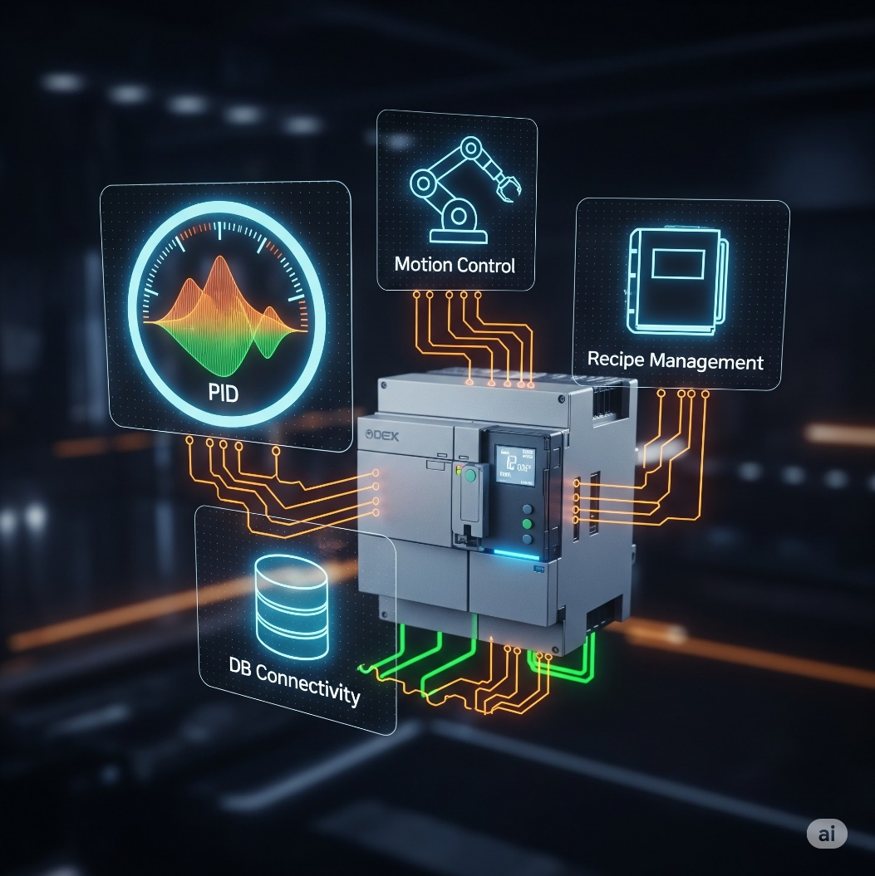

⚠️ Why this matters:

Not every PLC supports every special function.  
👉 **Pick the wrong model**, and you might end up trying to build complex control logic from scratch—frustrating, error‑prone, and time‑consuming.

👉 **Bad requirements reconnaissance** is a recipe for disaster, and it absolutely leads to your machinery "suffering" – which means poor performance, downtime, errors, and a whole lot of headaches.

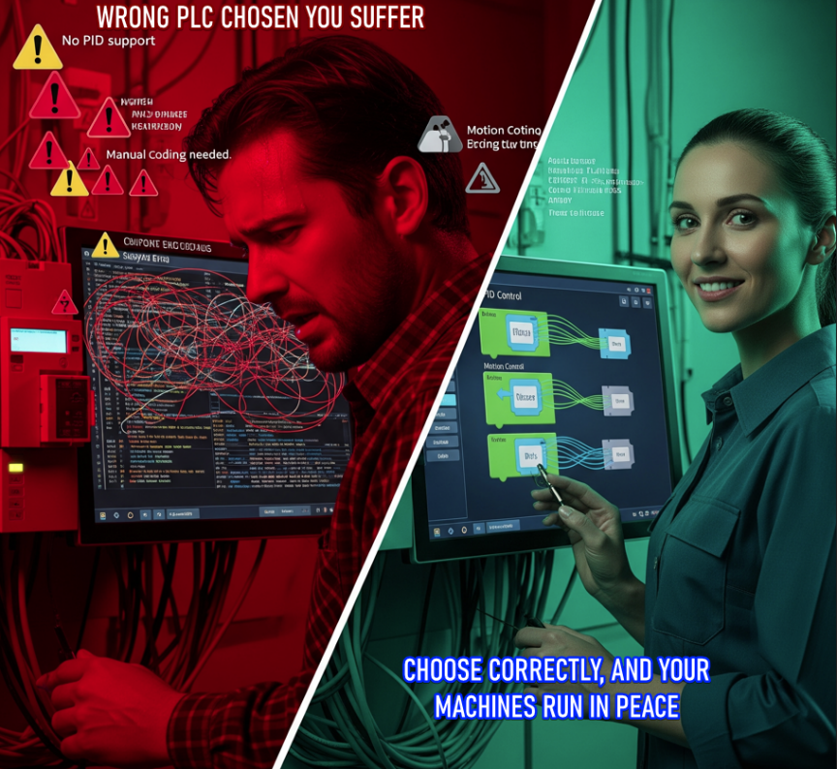

🎯 Your move:

Carefully review your application.  
👉 Make a list of any special instructions or advanced features (like PID, motion control, recipe management) that you’ll need, and confirm the PLC you choose fully supports them.

WHY WE USE PLC SOFTWARE??

**🛠️** PLC Software: Your Digital Toolbox

Think of your PLC as a super‑powered robot. Without the right software, though, it’s just an expensive paperweight.  
👉 **The programming software is where the magic happens**—you write commands, debug problems, and bring that controller to life.

**Pro‑tip:** Picking your PLC software is just as important as picking the hardware.  
You don’t want to grab an amazing controller only to find out the software feels clunky, confusing, or downright frustrating. Been there… not fun.

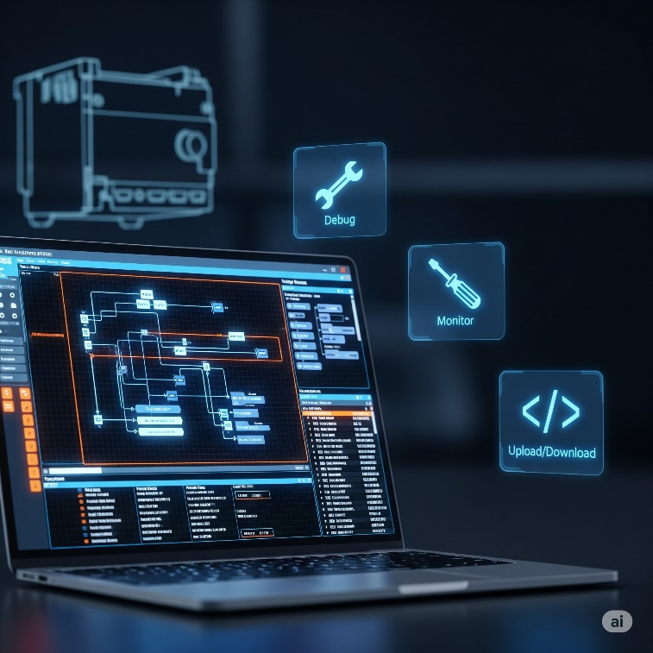

**🎮** Built‑in Simulator: Your Virtual Playground

A **built‑in simulator** is like having a digital clone of your PLC on your computer. It gives you a safe environment to test your ladder logic (or other code) *without touching the real machine.*

✅ Why it’s a lifesaver:

* You can test your code before going live.
* Try out different scenarios and catch logic errors early.
* Avoid real‑world mishaps or production downtime.
* Many simulators even mimic analog sensors and buttons, giving you a full‑blown dry run.

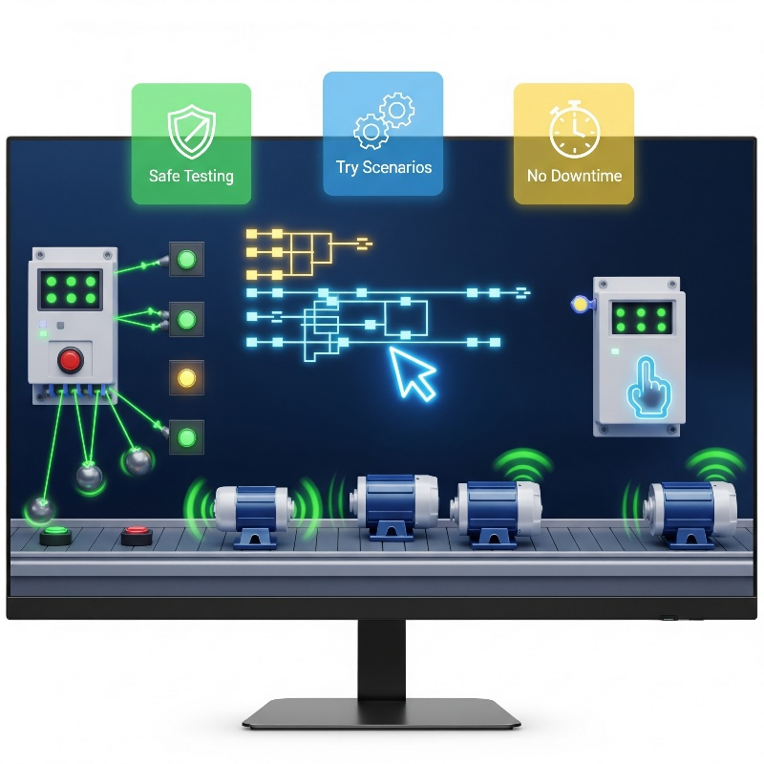

👀 Bottom line:

The right software—especially one with a good simulator—lets you build, test, and tweak your programs with confidence before a single real‑world output ever switches on.

**🔥** 2. Hot Swapping & Run‑Time Transfers: No Downtime, Baby!

Once your production line is humming, making changes can feel like defusing a bomb—one wrong move and you’re shutting everything down. But with the right software (and hardware support), you don’t have to slam the brakes on your entire system just to make small tweaks.

**🚀** Hot Swapping

This lets you replace physical parts of your PLC system—like an I/O module—*while everything is still powered on and running*.  
👉 Imagine swapping a tire on a moving car… okay, not quite that wild, but you get the picture!  
**Result:** Less downtime, less panic, and way fewer angry calls from the production manager.

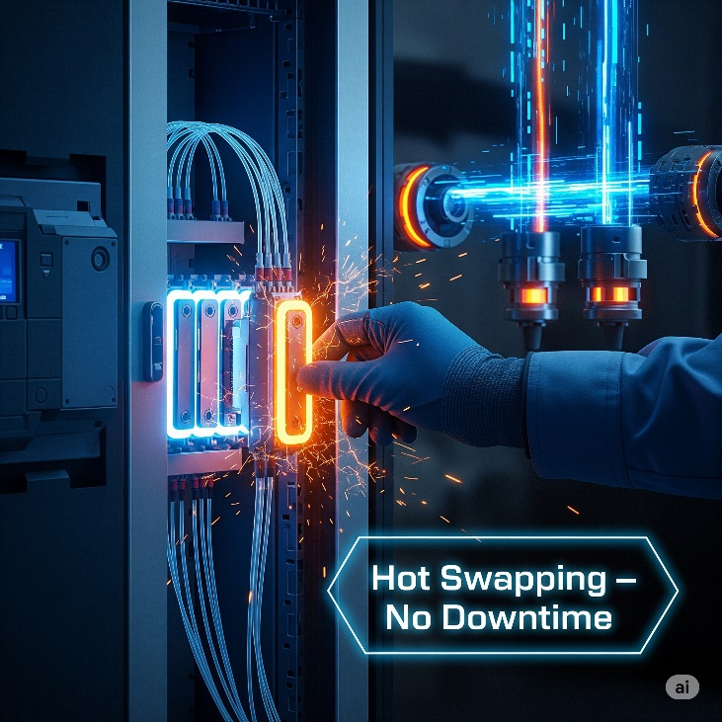

**⚡** Run‑Time Transfers (a.k.a. Online Edits)

Need to tweak your code? With run‑time transfers, you can update and download changes to your PLC program *without stopping the controller*.  
👉 Think of it like installing a new feature on your phone without rebooting the whole device.

**💎** Why it’s a big deal:

✅ No full system shutdowns just for minor edits.  
✅ Saves hours (and big money) on maintenance.  
✅ Keeps production flowing while you upgrade or debug.

**Bottom line:** Hot swapping and run‑time edits aren’t just nice‑to‑have—they’re game‑changers for any system that needs to keep running 24/7.

**✨** 3. Auto Discovery: Plug‑and‑Play Magic

This one’s a total time‑saver. With auto discovery, your PLC software can *automatically detect* the hardware you’ve connected—no tedious manual setup.

**⚡** Why it’s clutch:

Instead of manually telling the software, “Hey, I plugged in this I/O module here, that one over there…”, you just slot the modules in, power up, and **boom**—the software instantly recognizes what’s connected.

✅ It assigns addresses (or *tags*) based on where each module is plugged in.  
✅ You can keep those default settings or fine‑tune them later.  
✅ Some advanced systems even auto‑detect **other smart devices**—like motor drives or special sensors—saving you even more setup time.

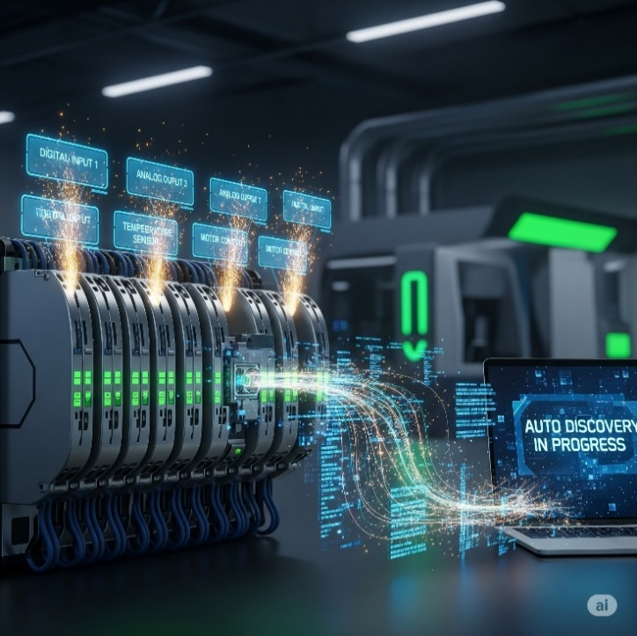

**👀** Bottom line:

Auto discovery turns what used to be a painstaking checklist into a quick, seamless setup. Plug it, power it, let the software do the heavy lifting, and you’re ready to roll. 🚀

**📊** 4. Data View & Histograms: Seeing What’s Up, Live!

These features are like windows straight into your PLC’s brain. They let you watch values change in real time and even help you tweak things on the fly.

**👓** Data View Windows

* Watch live PLC values as the program runs.
* Check if a sensor is active, see a temperature reading, or watch a timer counting down.
* You can even adjust certain values on the spot for testing.

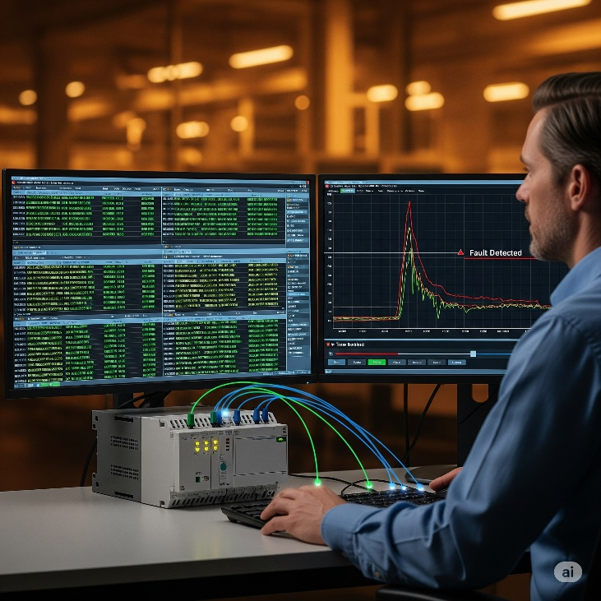

**📈** Graphical Trend Charts & Histograms

* Visualize how values change over time—like temperature trends in an oven or how often a pushbutton is hit.
* Perfect for troubleshooting: you can rewind the data to see what went wrong and when.

**💢** Bottom line:

These tools turn raw numbers into a clear picture of what your system is doing, making debugging and fine‑tuning way easier.

**🔐** 5. Security: Who’s Got the Keys? **👤**

Controlling access to your PLC is *huge*—you don’t want just anyone poking around in your control logic.

**🚧** Why it’s clutch:

* Good PLC software lets you set up user accounts with different permission levels.
* Only authorized users can make edits, upload programs, or tweak critical settings.
* Think of it like admin vs. guest access on a computer—keeps your system safe from accidental (or intentional) chaos.

**Bottom line:** Security features protect your system, your production line, and even your people. Don’t skip it.



**🔍** 6. Search & Cross Reference: Your Code GPS

When your program gets big and messy, these tools save your brain (and your time). You’ll use them all the time.

**🔎 Search:** Find exactly where an address, variable, comment, or instruction is used in your program.

**🔄 Search & Replace:** Find something and update it everywhere it appears — quick, consistent edits.

**🗺️ Cross Reference:** Shows you *every single place* a specific tag or address appears in your logic.

**🚨 Why it’s clutch:** It’s like having GPS in a huge city of code. Instead of scrolling forever, you jump straight to what you need and make safe changes without missing anything.



**📖** 7. Help Files: Your Built‑In Guru

Great PLC software comes with solid, easy‑to‑use help files.

Why it’s clutch:  
When you hit a wall —  
✅ New instruction you’ve never used?  
✅ Code acting weird?  
✅ Not sure what that error means?

The help files should break it down with clear steps, visuals, screenshots, and examples.  
It’s like having an experienced mentor sitting beside you, ready to explain whenever you’re stuck.



**🌐** 8. Connectivity: Plugging In & Getting Online

This is all about how your PC connects to the PLC for programming, monitoring, or updates.

**💻** USB Connections:

Most modern PLCs let you plug in directly via USB. Fast and easy… but your laptop needs to be right there beside the PLC.



Industrial grade cables for direct programming of plcs from computers

**⚡** In practice – 2025:

👉 You come in with your laptop.  
👉 Industrial USB programming cable.  
👉 Hit download, sending it the new ladder logic.  
👉 PLC accepts, updates, reboots or live‑updates.  
👉 Machine goes back to work with the new brain/Instructions.

💡 Pro tip:

In critical environments, engineers often do this in a controlled window (like scheduled maintenance) to avoid unexpected downtimes. But technically, the workflow is exactly what we described above.

**🌍** Ethernet:

For networked systems, Ethernet is king. Connect over long distances, just like home internet.  
(*Pro‑tip:* check if you need extra drivers or software for the connection — some setups can be picky.)

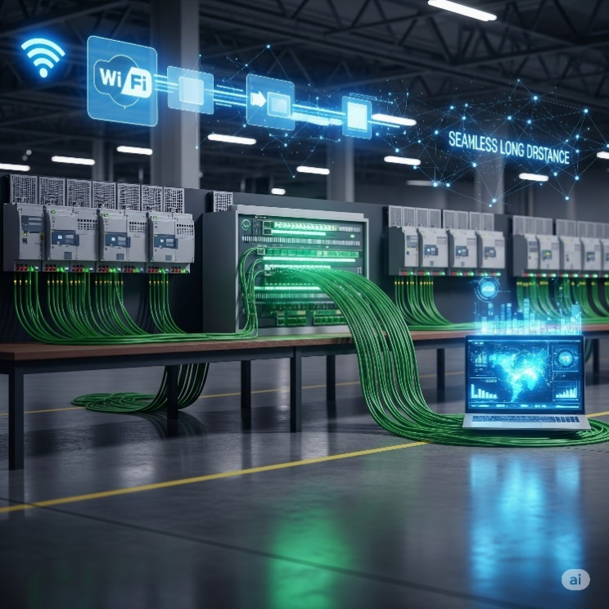

**📦** USB Project Transfers:

Some PLCs let you load a project onto a USB stick and plug it straight into the PLC. Perfect for remote sites where lugging a laptop isn’t practical.

**Why it’s clutch:** Easy, reliable connections mean less time fighting with cables and settings… and more time actually programming and testing.

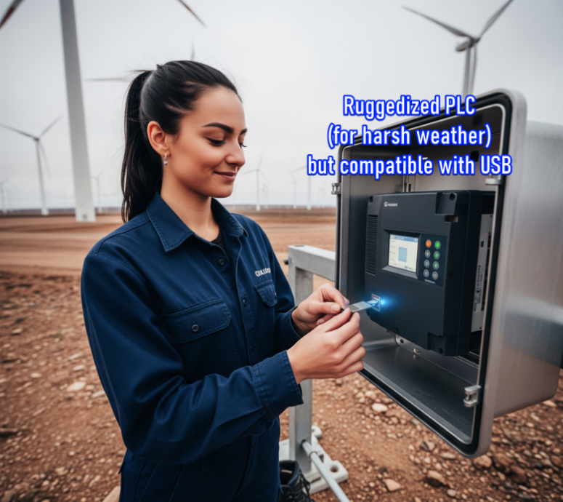

**🎨** 9. Customizable Layouts: Make It Yours! **✨**

Even the most powerful software feels like torture if it’s clunky to use.

Why it’s clutch:  
Good PLC software lets you shape your workspace:  
✅ Move and dock windows wherever you want.  
✅ Adjust text size, colors, and display options.  
✅ Tweak accessibility settings to match your workflow.

Think of it like setting up your IDE for C++ or Python—once it feels comfortable and efficient, your productivity shoots through the roof.

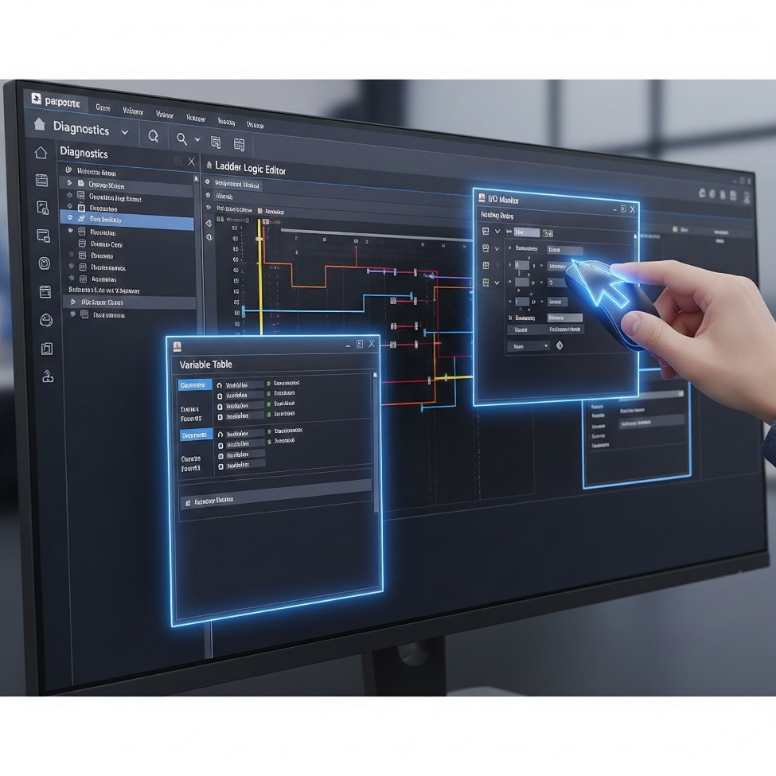

**🤔** 10. Project Compare: What Did I Change?! **📜**

Ever download a project and later wonder, *“Wait… why’s it acting weird? What did I even change?”*  
Been there, done that.

Why it’s clutch:  
Project compare tools show you:  
✅ The differences between your current project and an older saved version.  
✅ Or between your file and what’s actually loaded in the PLC.

You get a detailed breakdown of every change. Perfect for debugging, tracking revisions, and making sure you didn’t accidentally nuke something important.

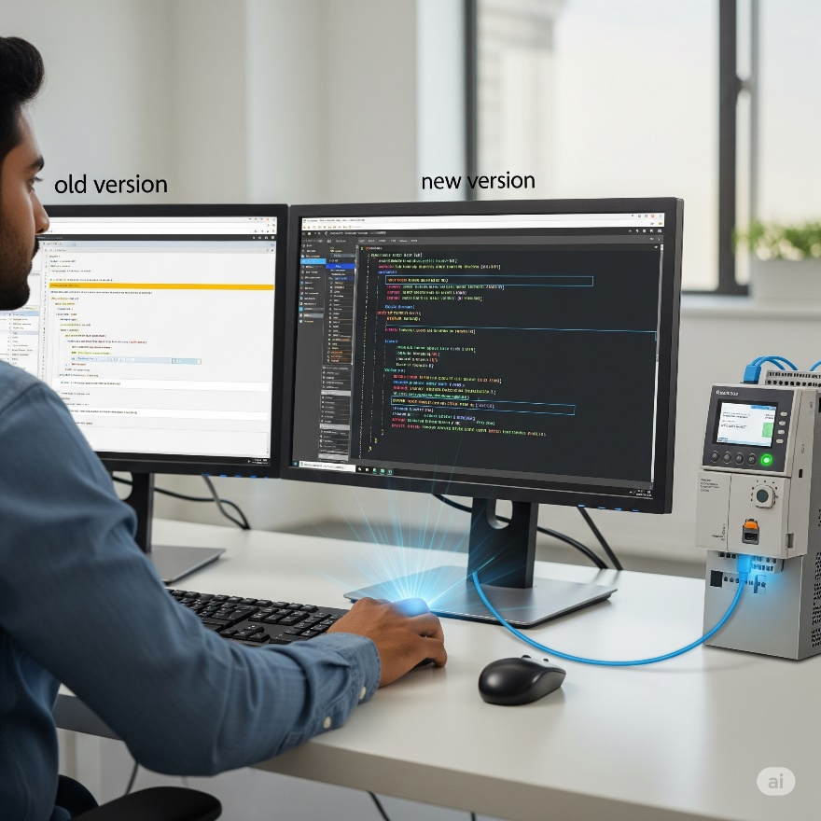

**🐛** 11. Debugging Tools: Squashing Bugs Like a Pro **💥**

Bugs happen. Good debugging tools turn frustration into control.

Why it’s clutch:  
✅ Step through your logic rung by rung (or line by line) to watch how it behaves in real time.  
✅ Pause execution at critical points to see what’s really going on.  
✅ Temporarily disable sections of code or simulate error conditions to test your logic.

**Bottom line:** Debugging tools aren’t just helpful—they’re essential for finding exactly where your logic went sideways and fixing it fast.



**📱** 12. Web Server & Mobile Apps: Control on the Go **🌐**

Modern PLCs aren’t chained to the factory floor anymore—now you can keep tabs from anywhere.

**✅** Web Server Functionality:

Your PLC can host its own little web page. Just type in the PLC’s IP address in a browser and boom—you can see live diagnostics, process values, and status updates from anywhere with internet access.

**✅** Mobile Apps:

Many brands offer mobile apps that talk directly to your PLC.

**💡** Why it’s clutch:

Imagine getting real‑time status updates while you’re grabbing lunch, or seeing an alert pop up on your phone if something goes wrong. Faster response times, less downtime, and total peace of mind wherever you are.

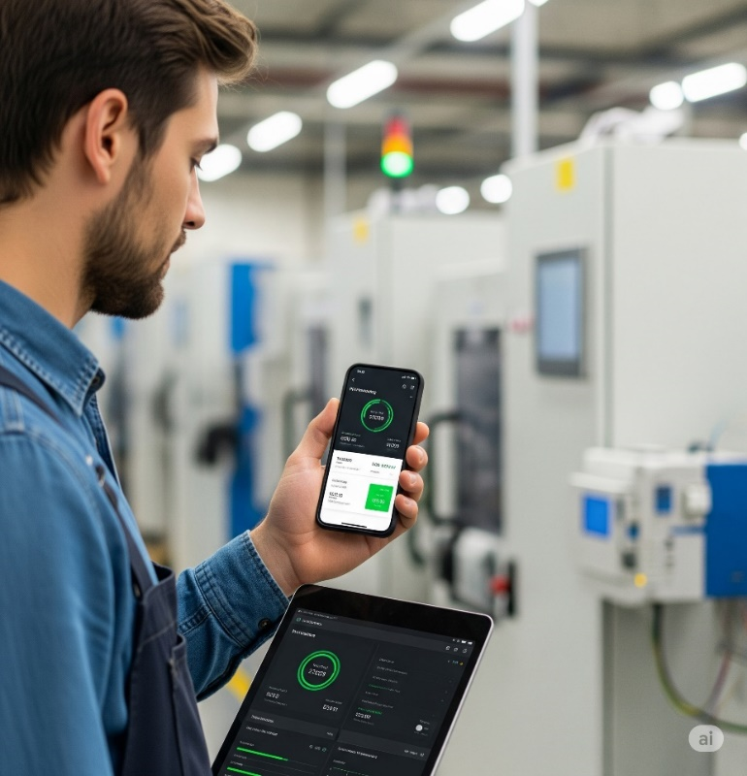

**📧** 13. Email Integration: Get Notified! **🚨**

Some PLCs can send emails all on their own.

**💡** Why it’s clutch:  
Set up email alerts for critical events—machine faults, low material warnings, safety stops, you name it.  
Your PLC instantly notifies you and your team so you can jump in before a small problem turns into a production disaster.

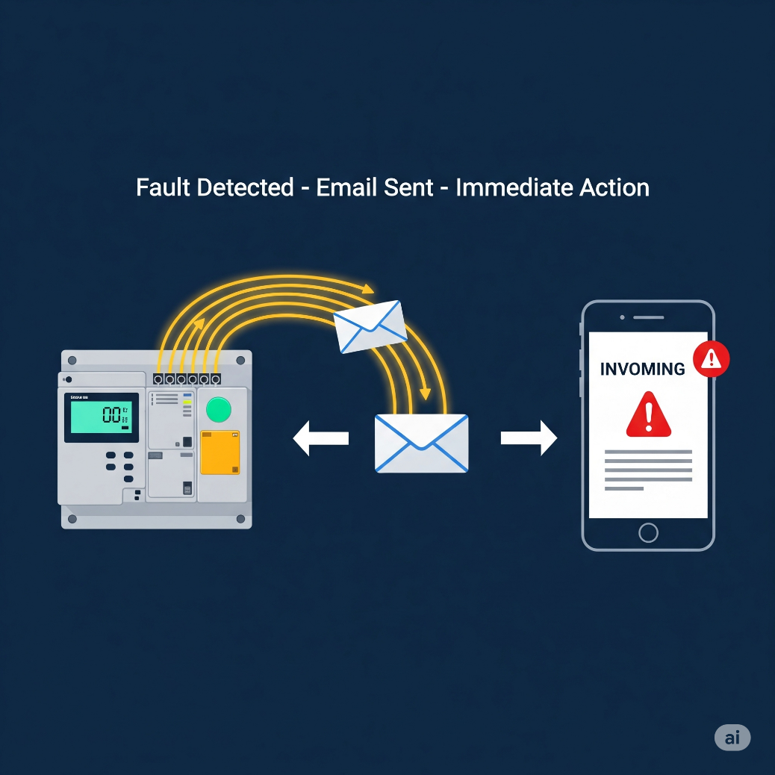

**🌀** 14. PID Options: Smooth Operator Mode **⚙️**

Process control pros, listen up—PID (Proportional, Integral, Derivative) loops are key for smooth, stable control.

**💡** Why it’s clutch:

Pick software with:  
✅ Built‑in PID instructions.  
✅ Easy‑to‑use monitoring and tuning tools.  
✅ Bonus: *Auto‑tuning* features that calculate the best PID settings for you.  
Less headache, more precision, better performance.

In Programmable Logic Controller (PLC) programming, a PID (Proportional-Integral-Derivative) controller is a control loop feedback mechanism widely used to regulate various process variables such as temperature, pressure, or flow.

It works by continuously calculating an error value as the difference between a desired setpoint and a measured process variable, then applying a corrective action based on proportional, integral, and derivative terms. This ensures the process variable approaches and maintains the desired setpoint, even in the face of disturbances.



**🔢** 15. Powerful Math Functions: Crunch Those Numbers! **➕**

Modern processes often need heavy math—don’t settle for basic.

**💡** Why it’s clutch:  
Great PLC software lets you enter advanced equations directly (square roots, scaling formulas, custom calculations) without messy workarounds.  
✅ Cleaner code.  
✅ Less wasted time.  
✅ Ready for advanced control logic.



**📝** 16. Task Manager: Organize Your Program’s Flow **⏱️**

Instead of running one massive chunk of code over and over, a task manager lets you split your program into smaller pieces.

**💡** Why it’s clutch:  
✅ Run tasks only when needed (every scan, once per second, only on startup, or triggered by an event).  
✅ Optimizes scan time and keeps your PLC super responsive.  
✅ Makes your logic way easier to maintain—no spaghetti code here.

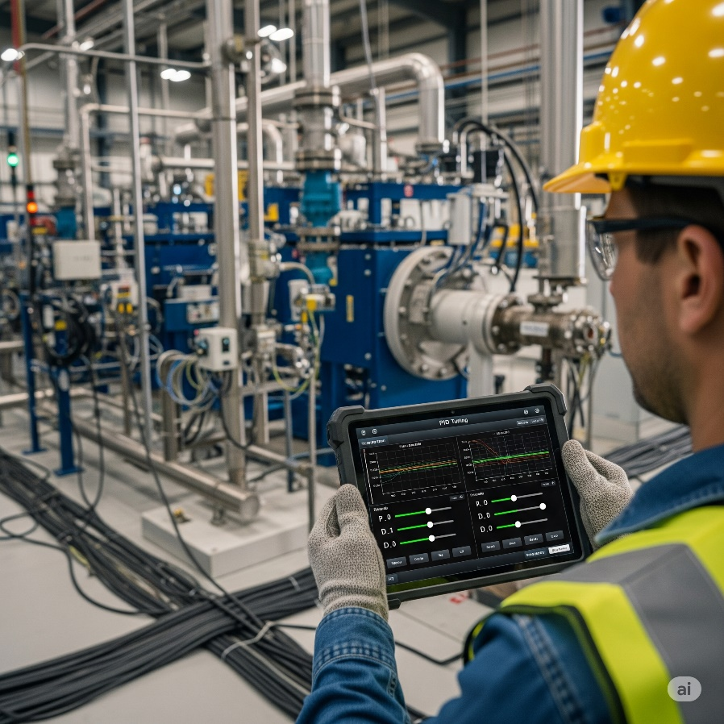

**🧱** 17. Integrated Function Blocks: Programming Shortcuts **🚀**

Function blocks are like ready‑made mini‑programs for common tasks.

**💡** Why it’s clutch:  
Instead of writing dozens of rungs for a PID loop, a motion control routine, or a complex comms setup, you just drop in a block and configure it.  
✅ Faster programming.  
✅ Fewer errors.  
✅ Cleaner, more modular code.



**🗣️** Programming Languages: Speaking Your Language

Ladder Logic still rules the industrial world, but PLCs speak more than one language — so pick what vibes with you:

**✅ Structured Text (ST):**If you’re used to C, Python, or “if–then” logic, you’ll feel at home. It’s text‑based and powerful for math or complex decisions.

**✅ Instruction List (IL):**Hardcore low‑level vibes — if you’ve ever touched Assembly, you’ll get it.

**✅ Sequential Function Charts (SFC):**Organizes your program into clear steps and transitions. Perfect for multi‑stage processes.

**✅ Function Block Diagrams (FBD):**Purely graphical. Drag and drop function blocks to build your logic visually.

**💡 Your Move:** Ladder Logic is essential, but knowing these alternatives gives you flexibility. Pick the one that makes coding and troubleshooting *feel natural* for you.

LADDER LOGIC

👉 **Ladder logic** is still the *main language everyone uses in factories*, but PLCs aren’t stuck with only that.  
You also have other language options:

* **Structured Text (ST):** looks like regular programming (if…then, loops, math).
* **Instruction List (IL):** looks like assembly language (low-level instructions).
* **Sequential Function Charts (SFC):** flowcharts with steps and transitions.
* **Function Block Diagram (FBD):** drag-and-drop blocks, very visual.

**The point:** Pick the one that feels easiest for *you* to program, debug, and maintain. Ladder logic is most common, but if your background is coding or assembly, you might feel more at home in ST or IL.

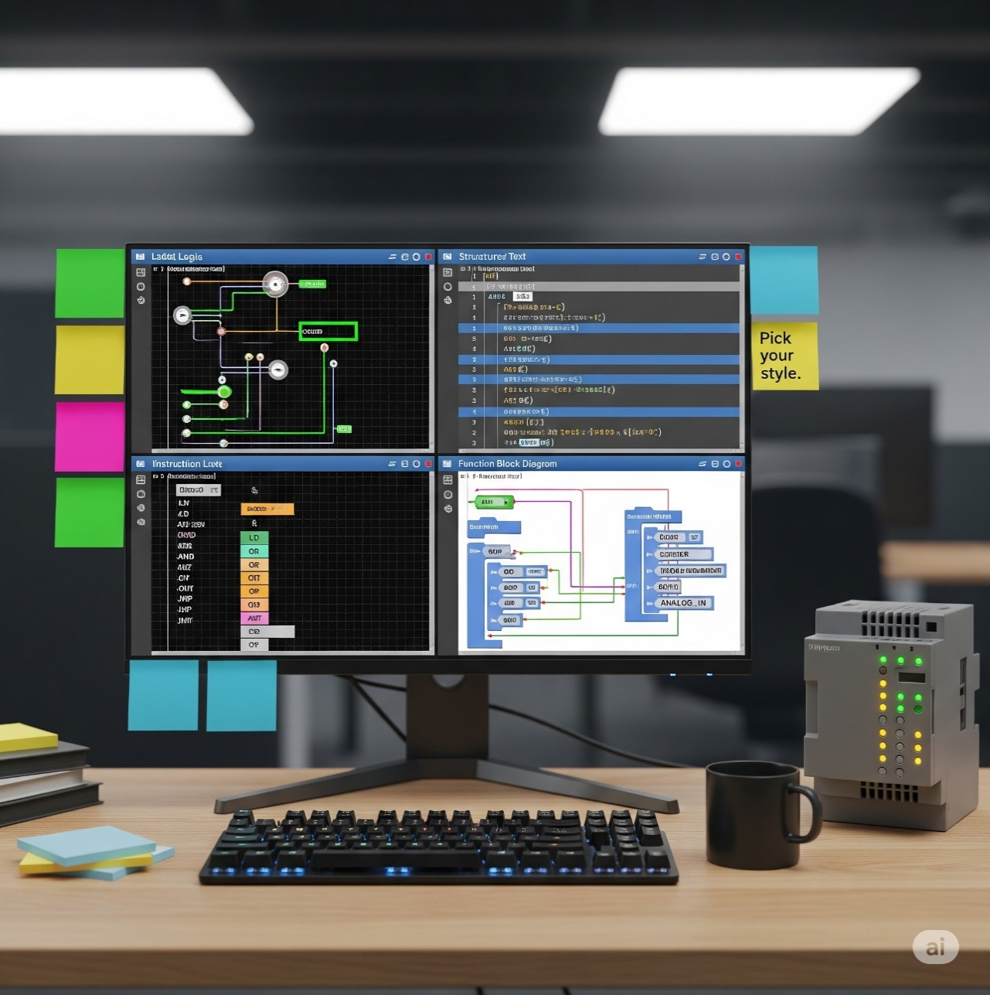

👉 Tag Names vs. Fixed Memory:  
This is about how the PLC stores and labels data.

* Tag Name Based:  
  Instead of remembering cryptic addresses (I:0/0), you give your inputs/outputs friendly names like Start_Button or Motor_Speed.  
  ✅ Easier to integrate with HMIs, easier to read, way more beginner‑friendly.
* Fixed Memory:  
  Uses hard-coded addresses like N7:0.  
  ✅ Some old-school folks like it because they think it’s easier to search or track in certain software.  
  ❌ But it’s less intuitive when your project grows big.

**The point:** Try both. They even suggest you download their free tools (Productivity Suite for tag names, Do-more Designer for fixed memory) and see which style clicks with you.

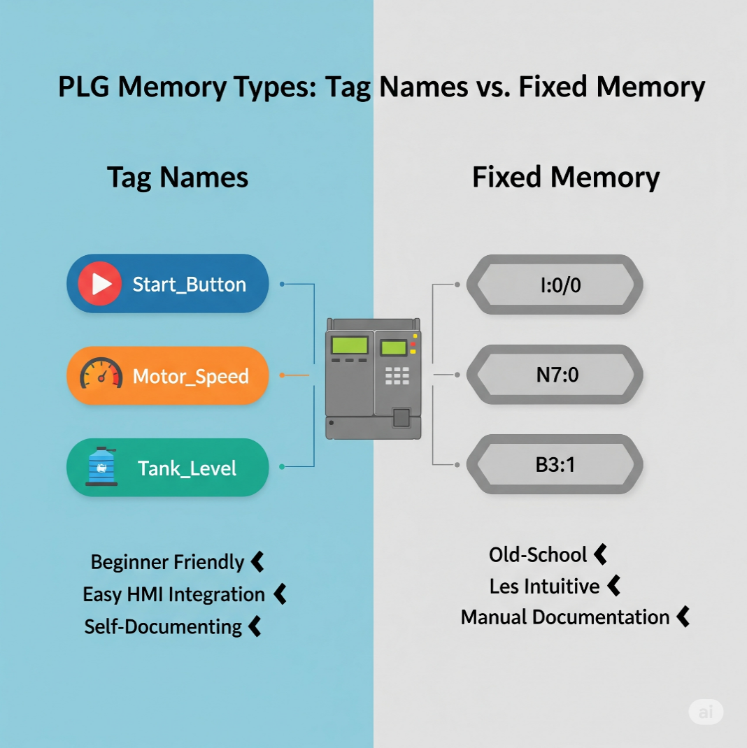

👉 Final takeaway of that whole section:  
They’re not giving you *everything* about PLC software, just highlighting a few extras that can really help your workflow. And if you’re curious, they’re inviting you to test out their free software and watch tutorials.

💡 Your Move:

Go with whatever keeps your code clean and makes sense for your project. If you’re working with modern HMIs or big teams, tag names are a lifesaver.

✅ Wrap‑up:  
These extra considerations aren’t the whole universe of PLC features, but they’re the ones that can save your time, sanity, and project deadlines.

Pick tools and approaches that feel natural and fit your workflow — your future self (and your team) will thank you.

The Foundational Structure: From Physical Relays to Digital Logic

At its heart, **Ladder Logic** is the main language used to program **PLCs**—those industrial computers that keep machines running like clockwork.

But to really understand it, you’ve gotta know where it came from: the old days of **relay logic** and **hard‑wired control panels**.

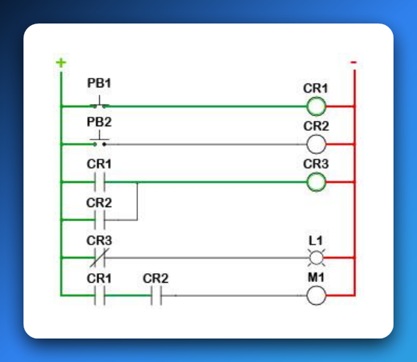

**⚡** 1. The Roots: Relay Logic & Hardware Automation

Before microprocessors were everywhere, factories used **physical relays** to automate machines.

A relay is basically an electrically operated switch:

✅ Send a small current through its coil → it creates a magnetic field → that pulls or releases a metal arm → opening or closing contacts to let power through.

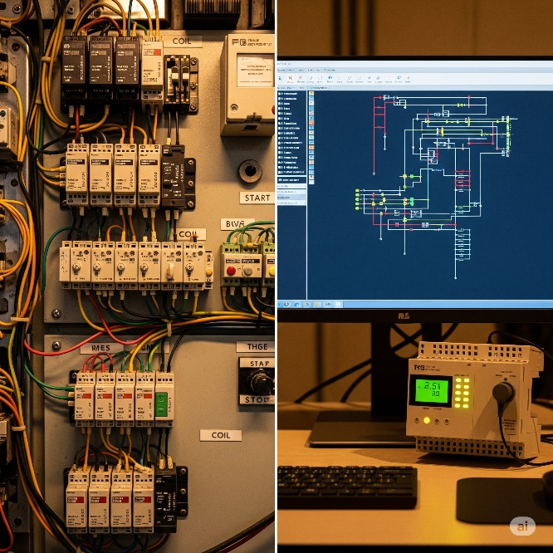

**💥** Why It’s Called a “Ladder”

It’s not just a cute name. Ladder Logic diagrams **look exactly like old relay wiring diagrams**:

Rails (Vertical Lines):

* The **left rail** is the power source (e.g., +24 V DC or 120 V AC).
* The **right rail** is the return path (common/ground).  
  Power always flows left to right.

Rungs (Horizontal Lines):

* Each rung is like one mini‑circuit or one logic rule.
* On each rung, you place components—switches, contacts, coils—in **series** or **parallel**.
* If the path on that rung is complete, the output on the far right energizes.

**⚙️** How It Worked (and Still Does in Principle)

In an old relay cabinet:

* Power starts at the **left rail**, passes through inputs like pushbuttons or sensors, then through relay contacts, and finally reaches an output device like a motor, light, or another relay coil.
* **If every condition on that rung is true (closed contacts, active sensors)** → the circuit completes → the output device gets power and turns on.

Modern Ladder Logic in a PLC mimics this exact same idea—*but instead of physical wires and relays, it’s all done in software.*

**✨** 2. The Evolution: From Tangled Wires to Clean Software Bits

The genius of **Ladder Logic** is how it took the messy world of physical relays and turned it into a neat software language.

Instead of grabbing a screwdriver and wiring real relays together, you **“draw” your logic on-screen** with symbols that look just like the old electrical components.

When the PLC runs your program, it’s basically *pretending* electricity is flowing through those virtual circuits.

**🖥️** Digital Translation – How It Maps Over

Power Flow:  
In software, there’s no real current. Instead, a logical **TRUE (1)** means “power is flowing” along that rung. If the path from the left rail to an output is logically true, that output gets activated.

Open vs. Closed Contacts:  
Physical relay contacts become simple Boolean conditions in the PLC:

* **Normally Open (NO)** – shown as —| |—  
  ✅ True when the input is ON (button pressed, sensor triggered, relay energized).
* **Normally Closed (NC)** – shown as —|/|—  
  ✅ True when the input is OFF (button released, sensor not detecting, relay not energized).

Coils / Outputs:  
Outputs are shown as —( )—.

🚨 When the rung logic leading to that coil is TRUE, the PLC sets that output bit to **1**, which energizes the real-world device (motor spins, light turns on, valve opens) or even an internal memory relay.

👉 Big Picture:  
Instead of digging through wires in a control cabinet, you’re now dragging and dropping logic in software.

**Same principles, zero mess.** That’s the magic of Ladder Logic.

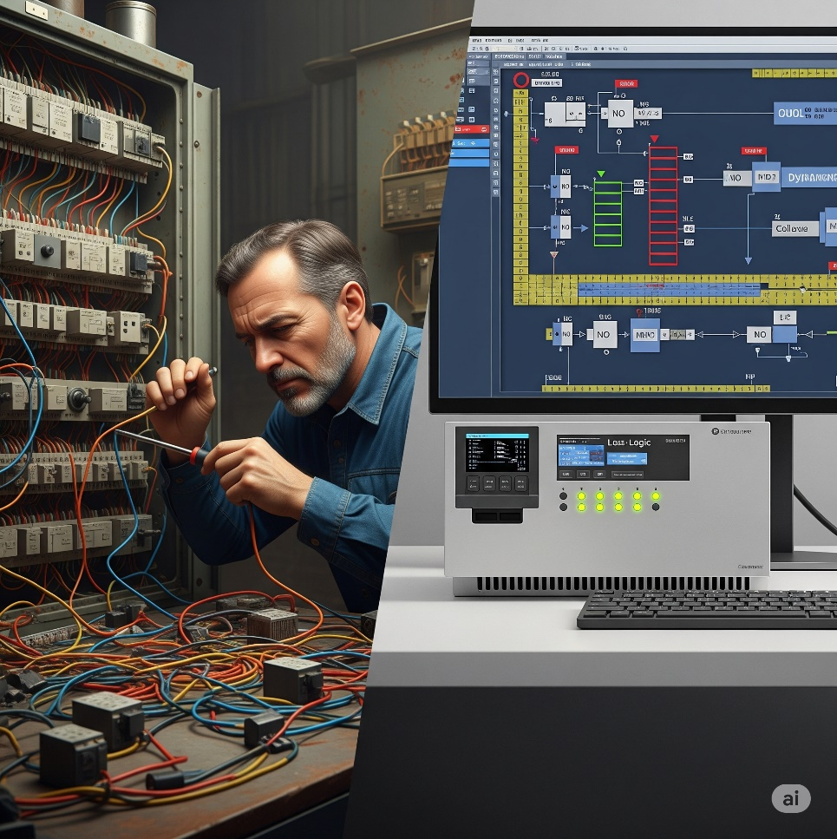

**🏗️** Key Ladder Logic Components & Their Analogies

Let’s break down those classic symbols from your image and see how they vibe both in hardware *and* in software logic:

**🔘** PB (Pushbutton) – Your Event Trigger

**PB1, PB2:** These are **inputs**.  
On a real panel, pressing a pushbutton closes a circuit and sends a signal into a PLC input terminal.  
In Ladder Logic, it’s represented by a contact symbol.

**👉 Analogy:**  
A pushbutton is like calling a function or triggering an interrupt in code.  
When you hit it, you’re saying: *“Yo, start that sequence!”*

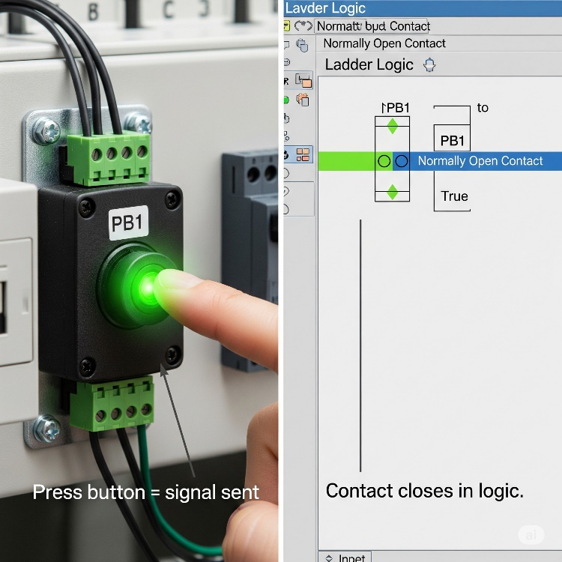

**⚡** CR (Control Relay) – Your Internal State & Your Electrical Middle‑Man

**CR1, CR2, CR3:**  
Inside Ladder Logic, we treat these as **internal memory bits** — energize the coil (CR1) and every CR1 contact in your logic instantly follows that state.

**But in the real hardware world?**  
A control relay also acts as an **electrically controlled switch**.  
It lets the PLC — which only pushes tiny, low‑power signals — safely control **higher‑power devices** like motors, solenoids, or large lamps.  
It’s the buffer between the fragile logic electronics and the beefy machinery, giving you:  
✅ **Electrical isolation** (protects your PLC from power spikes),  
✅ **Safety** (no direct heavy current through your delicate PLC board),  
✅ **Stability** (reliable switching for big loads).

**👉 Analogy:**  
Think of it as a bouncer at a club.  
Your PLC quietly whispers, “let them in,” and the control relay (the bouncer) swings open the big heavy door to the motor or solenoid.  
The PLC never has to wrestle with high current directly — the relay does the heavy lifting.

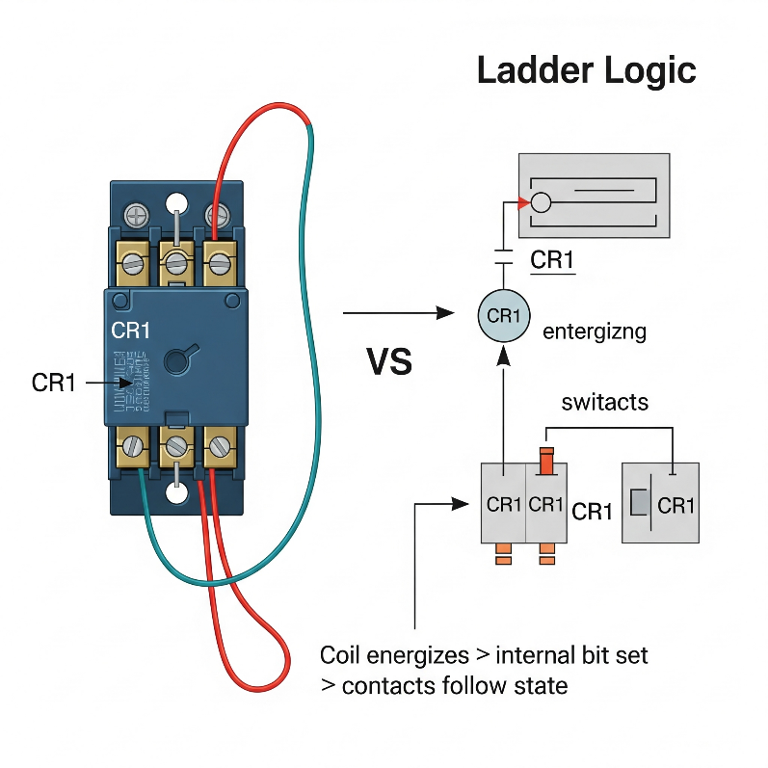

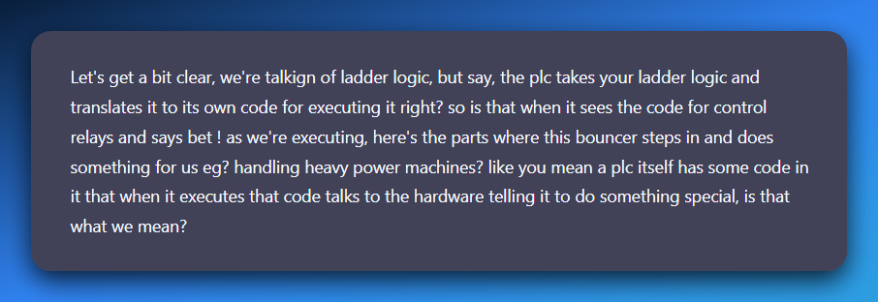

Inside your ladder, when you drop in a coil (CR1) or an output (M1) you’re basically saying to the PLC:

*“Hey PLC, if the logic on this rung is true, energize this output (or set this internal bit).”*

**What happens next depends on what type of coil it is:**

**💥** Internal CR (Control Relay):

* This one lives purely in PLC memory.
* When the CPU executes that rung and it’s true, it sets a *bit* in memory to 1.
* Any rung reading that contact (—| |— CR1) will now see it as “closed.”  
  👉 No actual electricity is switching heavy loads yet — it’s just logic inside the PLC.

**💥** Physical Output Coil (like M1 for a motor):

* When the CPU executes that rung and it’s true, it flips a transistor or energizes a tiny driver circuit on the PLC’s output card.
* That tiny driver is *not* strong enough to power a motor directly — and that’s where real **control relays** or **contactors** out in the panel come in.
* The PLC output energizes the relay coil (low current).
* The relay’s contacts then safely switch the **big current** going to your motor or solenoid.

The PLC scan loop runs through your compiled logic thousands of times a second. Each time it hits an output coil instruction, the CPU updates the hardware output register.

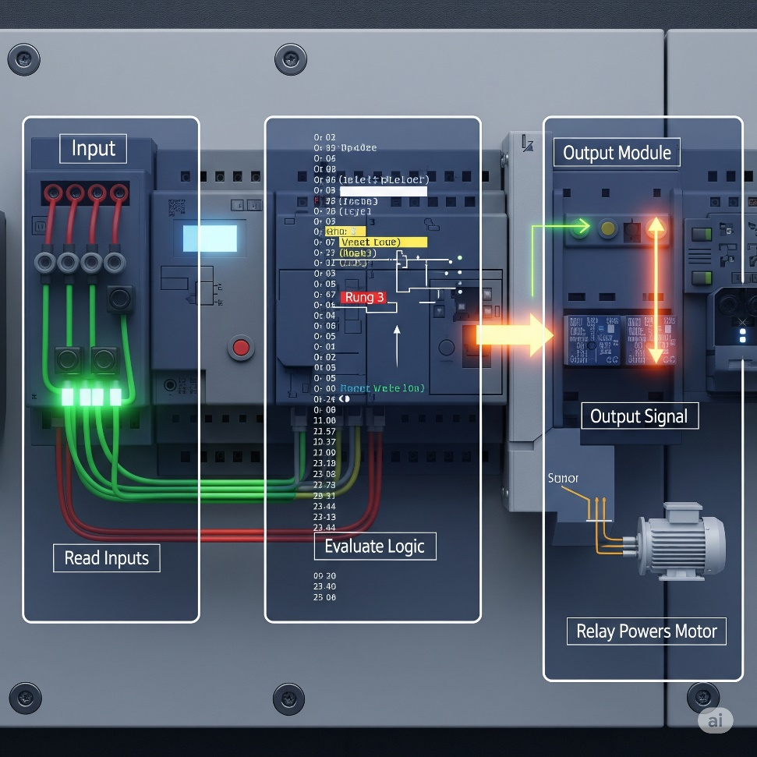

**That register is connected to output modules** — which physically drive relay coils, solid‑state switches, or transistors on your control panel.

The **PLC isn’t** literally muscling 10 amps into a motor — it’s *flipping a small digital signal* that *commands* the relay/contactors to handle the big current.

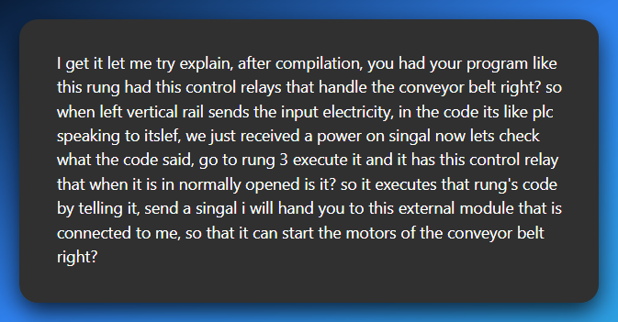

After your ladder logic is compiled, the PLC is constantly scanning. Imagine we’re mid‑scan:

⚡ Input side:  
The PLC reads the status of all input terminals (pushbuttons, sensors, etc.).  
👉 The left rail is like “power” coming in, but in PLC land it’s really just reading TRUE/FALSE from each input.

🧠 Logic side:  
Now the PLC runs through your ladder rungs, top to bottom: *“Ok, rung 3… oh, this rung has a coil that controls the conveyor motor. Let’s check the contacts in this rung.”*

It evaluates your contacts (normally open/closed) based on the input states and internal bits. If the logic path is TRUE (like that normally open contact is now closed because the button was pressed): *“Alright, condition is true — energize that output coil!”*

📤 Output side:  
The PLC doesn’t directly blast **3-phase power(typically provides higher electrical power)**. Instead, it sends a low‑power signal out of an output pin on the output module:

*“Hey output module, set your transistor/relay ON for Conveyor_Motor.”*

🔌 External world:  
The output module energizes a control relay or contactor coil out in the panel.  
**That relay/contact closes heavy-duty contacts that feed the actual conveyor motor’s power circuit.** 👉 And boom — your conveyor motor spins up. 🚀

**🤖** So your sentence becomes:

*“When the PLC is scanning and gets to rung 3, it evaluates that rung’s logic (including your control relay contact). If the logic is TRUE, the PLC sends a signal from its output module to energize an external relay or contactor, which then powers the conveyor motor.”*

Your idea is absolutely right.  
✅ Left rail = inputs read.  
✅ Code rung-by-rung.  
✅ If logic says “go,” PLC outputs a low‑power signal.  
✅ Output module reads the signal → control relay/contact closes → heavy machine (like the conveyor starts moving).

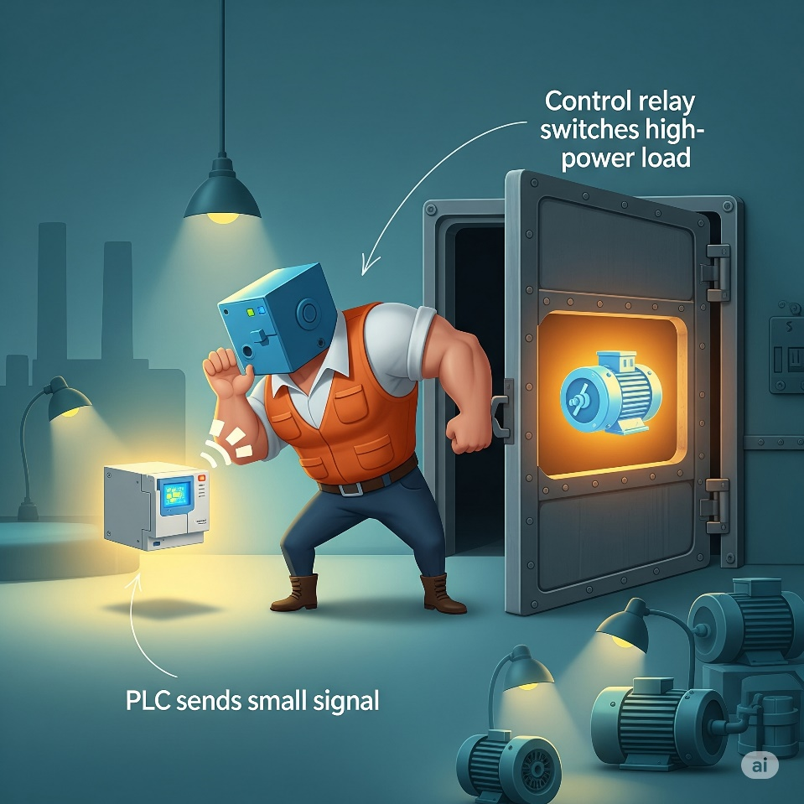

We talked about **(CR1)** as a "coil" and (L1) or (M1) as "output devices." These are essentially the "coils" that get energized.

When a rung's conditions are met, the "output coil" on that rung gets "energized." If it's an internal CR (Control Relay), it sets a memory bit.

If it's a physical output like L1 or M1, it triggers the corresponding output module on the PLC to provide power to the actual device.

**⚡** The Evolution from Wires to Code – Ladder Logic’s Secret Sauce

*Ladder Logic* didn’t just give old relay panels a digital facelift — it *fundamentally changed* how we think about control systems.

Back in the day, every single relay, switch, and motor in a factory had to be hard‑wired together.

If you wanted to change how it behaved, you grabbed a screwdriver and rewired the whole panel (and probably swore a lot).

Now? Those same circuits *live as memory bits* inside a PLC. Instead of cutting and crimping wires, you “draw” your circuit in software — and the PLC turns that into real‑world action.

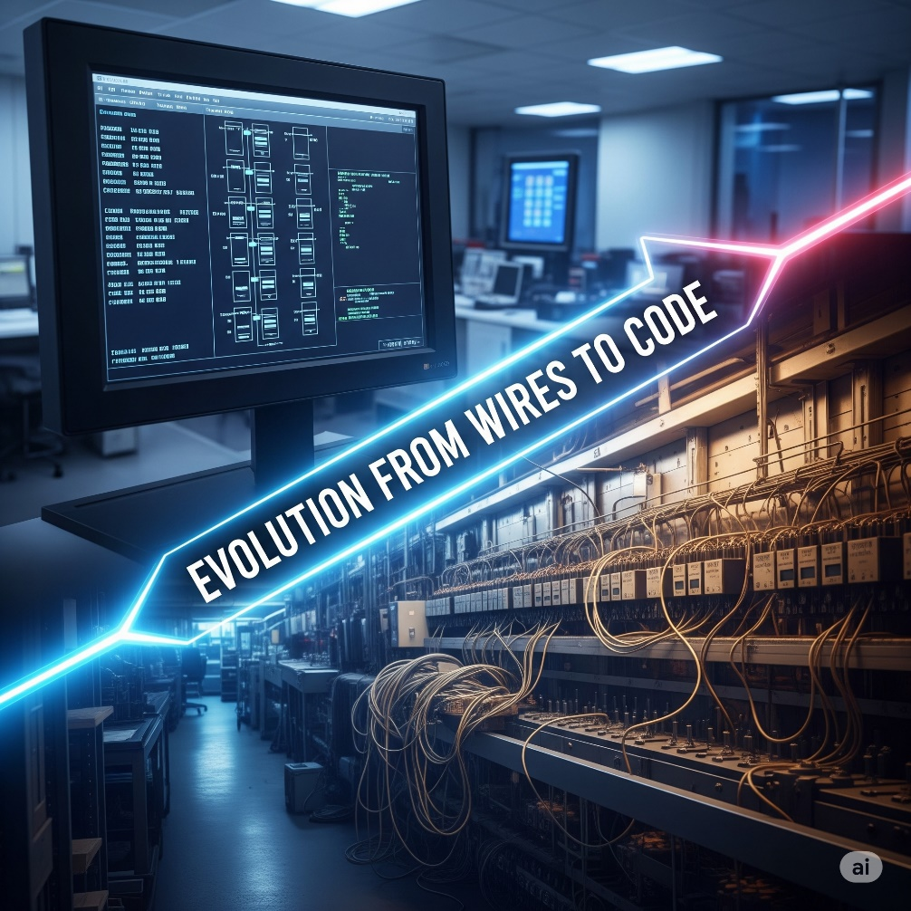

**🛠️** The Ins and Outs: Where Hardware Meets Software

A PLC lives in two worlds at once:

* **Physical world:** pushbuttons, sensors, motors, lights.
* **Digital world:** memory tables, logical rungs, and CPU scans.

The bridge between them? **Input/Output (I/O) modules.**



**👁️** Inputs: The PLC’s Eyes and Ears

Inputs are like sensors feeding data into your system.

They are physical devices — like **pushbuttons (PB)**, **limit switches**, **sensors**, etc. These devices connect to the **PLC's input module**, which monitors whether there’s voltage at each terminal.

When voltage is detected, the PLC sets an internal **memory bit** for that input to TRUE (or 1). That bit can then be referenced in your ladder program.

*Ladder logic was designed to have the same look and feel as ladder diagrams, but with ladder logic the physical contacts and coils are replaced with memory bits.*

**🧠** Example: PB1 and X001

In the diagram, you see:

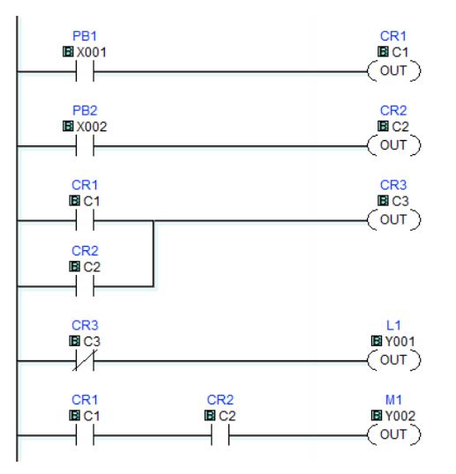

* PB1 is a **physical pushbutton** connected to input terminal **X001**.
* When you press PB1, voltage is sent to that terminal → PLC sets **X001 = TRUE**.
* In the ladder diagram, the —| |— symbol means "check if this bit is TRUE".
* If X001 is 1, the virtual contact **“closes”** and logic can flow to the right.

💡 **This is what we mean by "normally open"**:

The contact —| |— is **open** (no logic flow) unless the bit it watches becomes TRUE.

**🔴** Outputs: The PLC’s Muscles

Outputs are how the PLC **acts on the world** — turning on lights, motors, alarms, etc.

When your ladder logic energizes an **output coil**, the PLC sets the corresponding **Y-bit** in memory. That tells the **output module** to physically energize the circuit.

**⚡ Example: L1 and Y001**

On this rung:

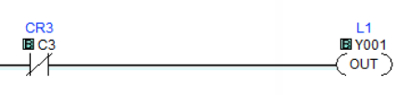

* CR3 (internal bit C3) must be TRUE.
* If so, the output coil Y001 is energized.
* That flips the bit in the output module → current flows → **L1 (a light) turns on**.

**🧠 Analogy:**

* Inputs = "Status updates" from the real world.
* Outputs = "Commands" sent out to the real world.
* The CPU = The brain that interprets inputs and triggers outputs via logic.

**🌀** Internal Bits (Like CR1, CR2, CR3)

Not all contacts and coils represent **real-world hardware**.

CR1, CR2, CR3 are **internal control relays**:

* They're like virtual relays inside the CPU.
* They're used for logic control only — not connected to physical I/O.

For example:

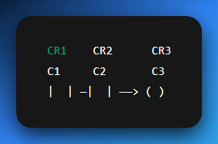

This rung says:

*“If internal relay C1 is TRUE and C2 is TRUE, then set C3 = TRUE.”*

This kind of logic lets you build **intermediate steps**, sequences, and memory-like behavior.

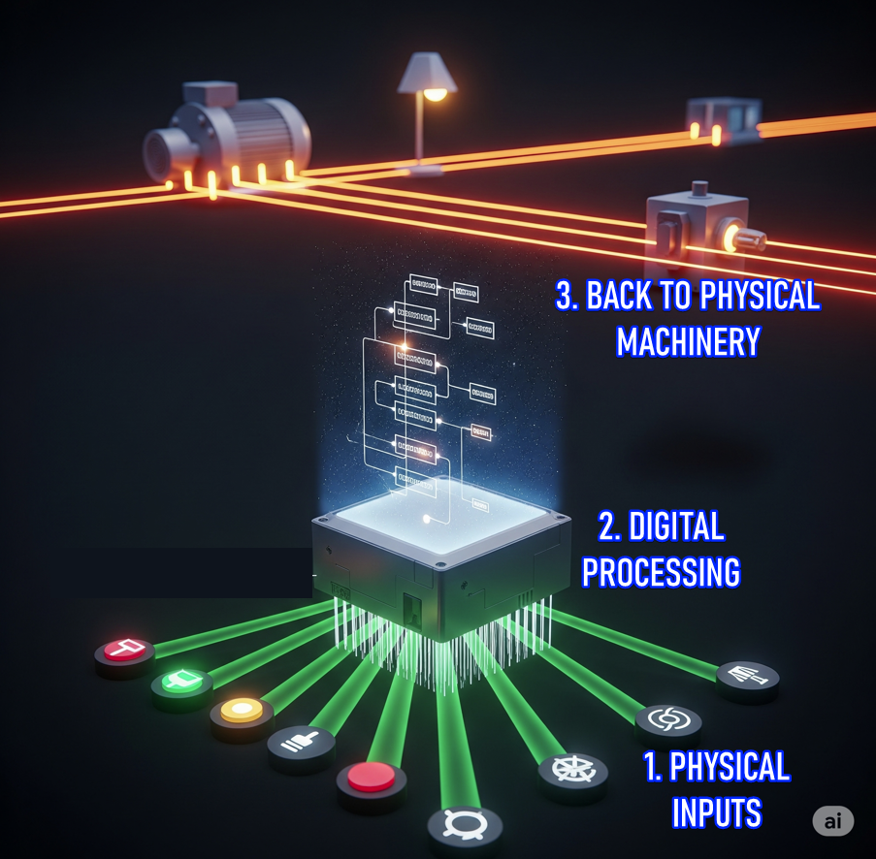

**⚡** TLDR: Why Ladder Logic Hits Different Now

Ladder Logic transformed factory control from **hardware headaches** to **software smoothness**.  
Back then? Changing behavior meant rewiring physical panels — hours of work, high chance of mistakes.  
Now? It’s just: **edit → download → done**.

Behind the scenes, those chunky relays and switches are now just **memory bits** in the PLC's brain (X, Y, M, etc.).

🤔 So, what’s really happening?

* 🧠 **Inputs** → Digital bits (from input modules)
* **🖥 Logic** → Runs through virtual rungs in PLC memory
* ⚙️ **Outputs** → Real-world actions (through output modules)

When your ladder rung hits true, it’s like the PLC says:

*“Yo, flip this bit. Let’s run that motor.”*

And the output module?

“Say less. Power’s going live.”

**🔄** Tying It All Together — One Rung at a Time

Let’s walk through how **electricity "flows"** in this PLC program using your image:

1. **Rung 1:** PB1 (X001) must be pressed → sets CR1 (C1) = TRUE
2. **Rung 2:** PB2 (X002) must be pressed → sets CR2 (C2) = TRUE
3. **Rung 3:** CR1 and CR2 must both be TRUE → sets CR3 (C3) = TRUE
4. **Rung 4:** If CR3 is TRUE → turn on L1 (connected to Y001)
5. **Rung 5:** If both CR1 and CR2 are TRUE → turn on M1 (connected to Y002, possibly a motor)

**⚠️** Quick Note on Contacts

* **—| |—** → **Normally Open Contact** (logic flows when bit is TRUE)
* **—|/|—** → **Normally Closed Contact** (logic flows when bit is FALSE)

This diagram uses all **normally open** contacts, which means:

*“Let power through only when the bit is active.”*

**🧠** Memory View

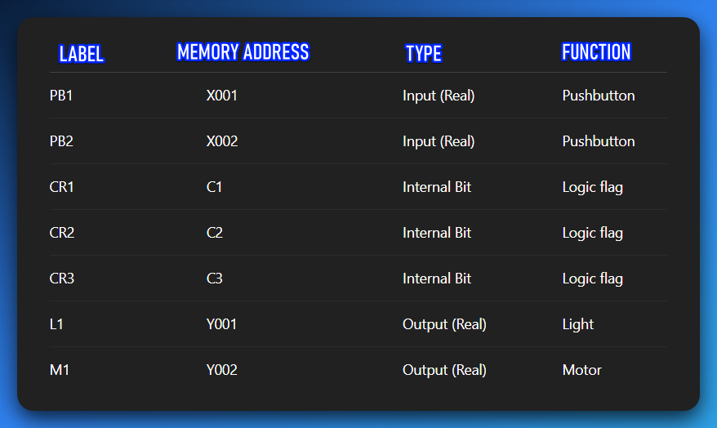

**🧩** Final Summary

*“Press PB1 and PB2 → set internal logic relays → light and motor activate. All through virtual contacts, no physical rewiring needed. Just bits flipping in the PLC's mind.”*

Now that’s how you do modern industrial control — with **digital muscle, logic memory, and clean ladder flow.**

**🧠** Internal Bits = Pure Logic Power

Not everything in your ladder program needs to control a real-world device. Some bits exist just to help you **structure logic cleanly and smartly**.

Control Relays like CR1, CR2, CR3 are **internal memory bits** — like **flags** or **global variables**.

* One rung might **set CR1 = TRUE** (e.g., after certain conditions are met).
* Other rungs can then **check CR1** as if it were a real input — no wire needed.

**💡 Think of it like:**

* CR1 is your custom signal — a pure memory trigger.
* It's like bool CR1 = true; in C.
* Or a malware flag: isPayloadReady = true.

These bits **don’t control power** directly — they **control logic**, and logic controls everything else.

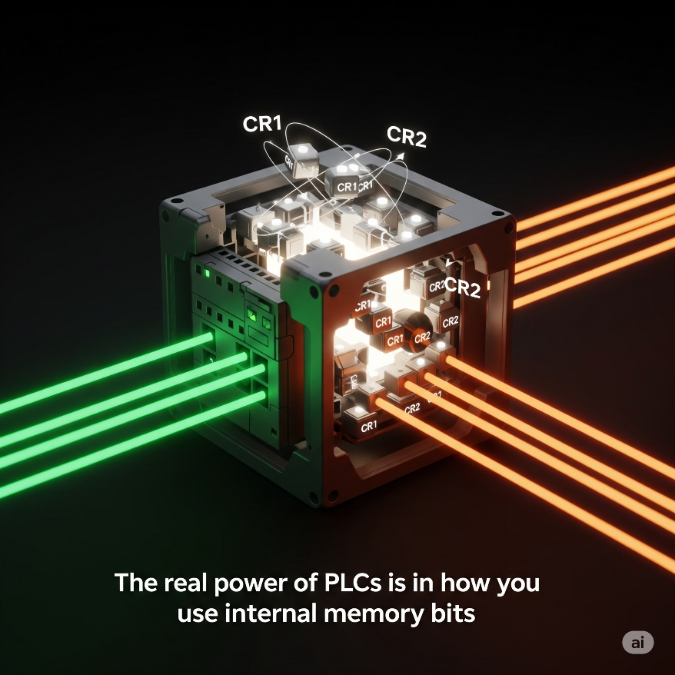

*“The real power of PLCs isn’t just physical I/O — it’s how smartly you use the memory bits between them.”*

✅ Yes, the sequence is:

1. **An input energizes the PLC** (button pressed / sensor triggered).
2. **PLC logic decides → sends out a low‑power signal** from its output module.
3. **That low‑power signal drives a control relay coil** (CR).
4. **The relay’s heavy contacts switch on** and supply high power to a machine (motor, lamp, conveyor).

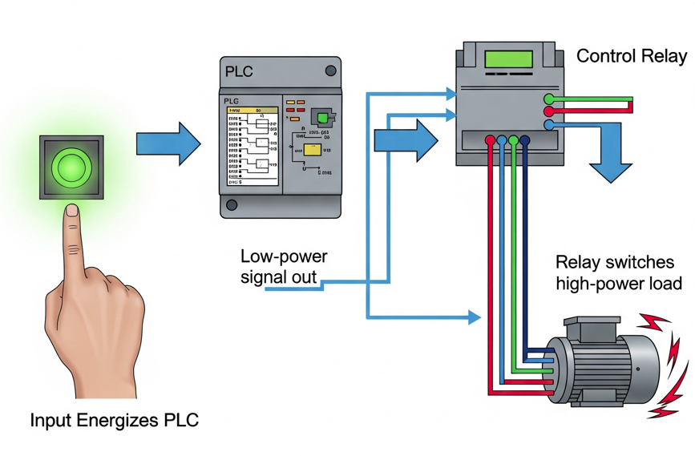

**✨** Temporary Storage and Modular Thinking

**Internal bits** aren’t just for keeping states.  
They’re also great for **holding intermediate results.**Instead of cramming everything into one messy rung, **split the logic into smaller rungs.** **Store** each step’s result in an internal bit.  
It makes your program cleaner, easier to read, and way easier to debug later.

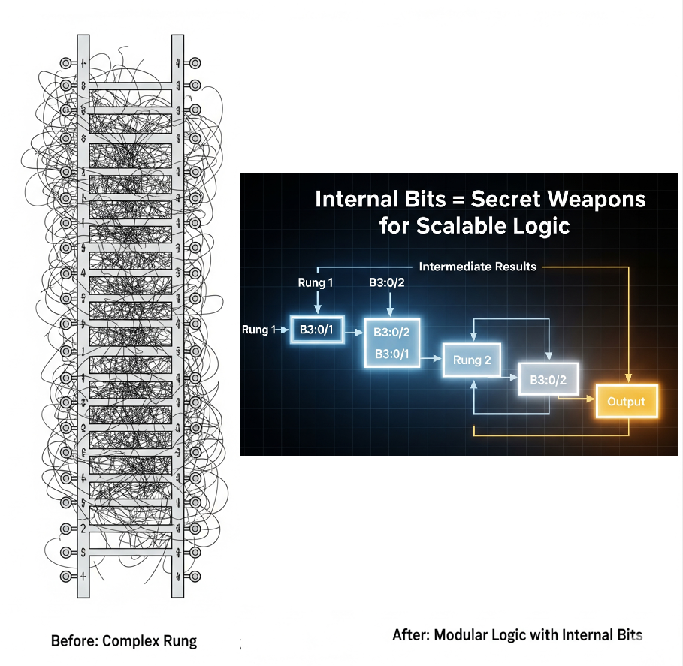

**💡** Bottom line:  
Internal bits are your secret weapons. They let you build smarter, layered logic without adding extra hardware. Combine them with your PLC’s advanced features, and your ladder program becomes a powerful, professional‑grade control system.

Beyond Basic Contacts and Coils: The Modern PLC's Capabilities

While your provided text wisely advises keeping it simple for an introduction, it's vital to acknowledge that **today's PLC CPUs offer a vast array of sophisticated functions, far beyond mere contacts and coils.** This is where the PLC truly transcends its relay logic ancestors and becomes a powerful industrial computer:

* **Math Functions:** Addition, subtraction, multiplication, division, and more complex arithmetic operations. Essential for controlling variables like temperature, pressure, flow rates, and calculating production metrics.
* **Shift Registers:** Used for tracking items as they move along an assembly line, often used in conjunction with sensors to monitor position and sequence.
* **Drum Sequencers:** Imagine a virtual "drum" with multiple tracks, each controlling a specific output or action based on a sequence of steps. Ideal for automating repetitive, multi-step processes like batch mixing or complex assembly operations.
* **PID Control:** Proportional-Integral-Derivative controllers are advanced algorithms used for closed-loop feedback systems (e.g., maintaining a constant temperature in an oven by adjusting heater power based on temperature readings).
* **Data Handling:** Instructions for moving, comparing, and manipulating blocks of data.
* **Communication Protocols:** Built-in support for industrial networks (Ethernet/IP, Modbus TCP, Profinet, etc.) to communicate with other PLCs, HMIs (Human-Machine Interfaces), SCADA systems, and even enterprise databases.
* **Structured Text, Function Block Diagram, SFC:** Modern PLCs often support other IEC 61131-3 programming languages, allowing for more complex, high-level programming constructs similar to C or Pascal.

**🤖** Chapter 5-2: Basic Instructions in Ladder Logic

Boolean Logic and the DNA of Control

Now that you know what Ladder Logic looks like, it’s time to understand **how it actually decides things**. And that takes us straight into **Boolean logic** — the bedrock of all decision-making in PLCs.

Don’t worry, this isn’t Digital Systems 101 — we’re not breaking out Karnaugh maps or Boolean algebra proofs. We’re just gonna look at the essentials: **AND** and **OR** logic.

**🔲** Boolean Logic in Plain Language

PLC logic is built on simple True/False decisions — like light switches:

* **TRUE (1)** → There's voltage or a condition is satisfied
* **FALSE (0)** → No voltage or the condition isn't satisfied

From this binary setup, we build logic gates. In Ladder Logic, these gates are **not separate components** — they’re created through **how you arrange your rungs and contacts**.

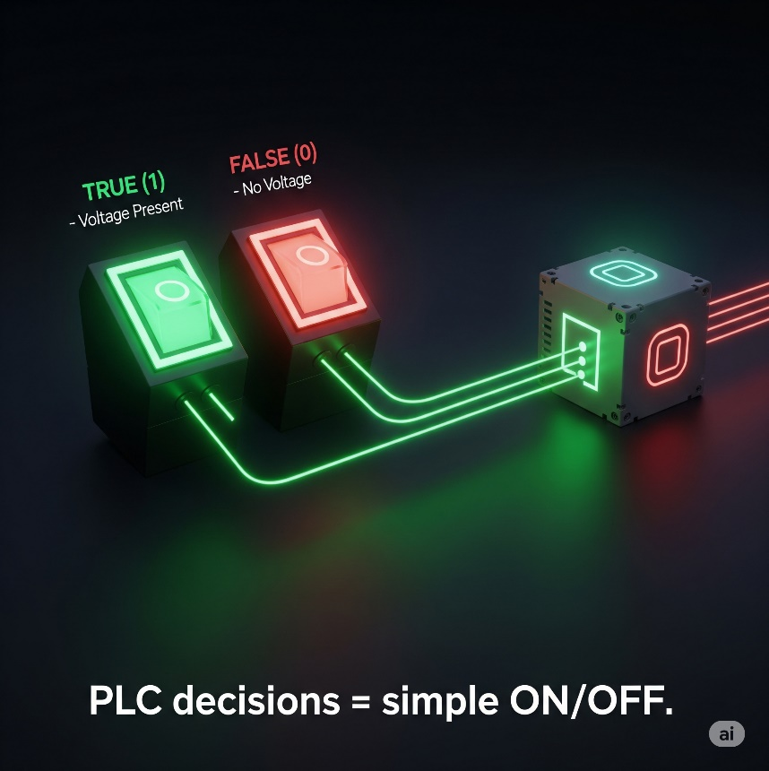

The Gates — Series Logic

🔌 AND gate Ladder Implementation:

**AND** operations are analogous to **multiplication.**

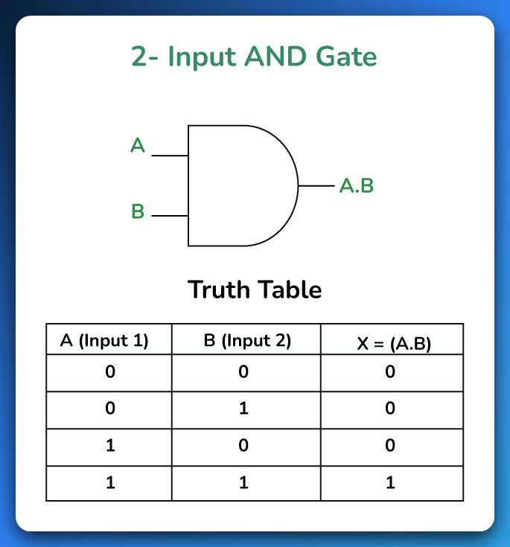

Use **normally open contacts in series**.

This is saying:

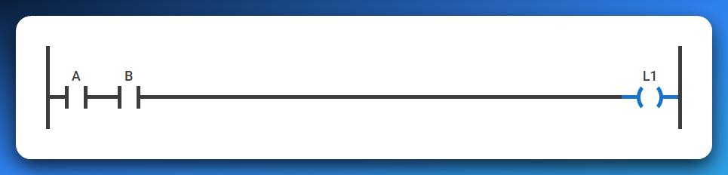

*“Only if A* ***AND*** *B are both TRUE, then turn ON the output.”*

If either A or B is FALSE, current stops flowing — just like if one switch in a series circuit is off.

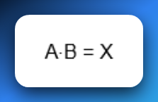

🔌 OR gate Ladder Implementation:  
Use **normally open contacts in parallel**.   
**OR** operations are comparable to **addition**.

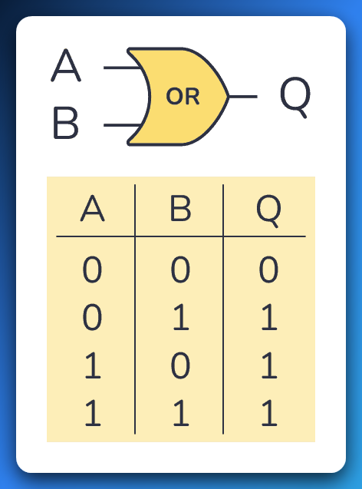

This is saying:

*“If A* ***OR*** *B is TRUE, then turn ON the output.”*

As long as at least one of them is ON, the rung is complete and current flows to the output. 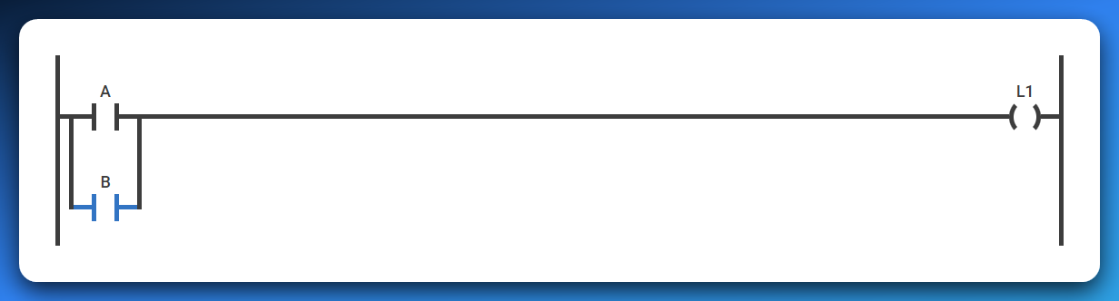

If **A is TRUE** (and B is FALSE), the path through A "closes," allowing logical power to flow to the output.

If **B is TRUE** (and A is FALSE), the path through B "closes," allowing logical power to flow to the output.

If **both A and B are TRUE**, both paths "close," and logical power still flows to the output.

Only if **both A and B are FALSE** will both paths remain "open," stopping the logical power flow and keeping the output OFF.

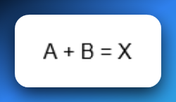

🔌 NOT Gate Ladder Implementation:  
Use a **normally closed (NC)** contact in series.  
NOT operations are comparable to logical inversion.

**Truth Table:**

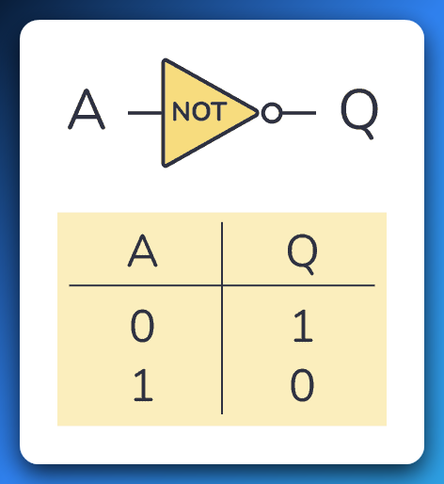

**In short, Q is the opposite of A.**

**A NOT gate can only have one input.** And its truth table is pretty simple since there are only two possible states; the input being HIGH (or “1”) or the input being LOW (or “0”).

**This is saying:**  
**“If A is NOT TRUE, then turn ON the output.”**

As long as the input is **OFF (FALSE)**, the NC contact remains closed, allowing current (logical power) to flow to the output.

If the input becomes **ON (TRUE)**, the NC contact opens, breaking the circuit and stopping the output.

In ladder form, you simply place an NC contact in front of the coil:

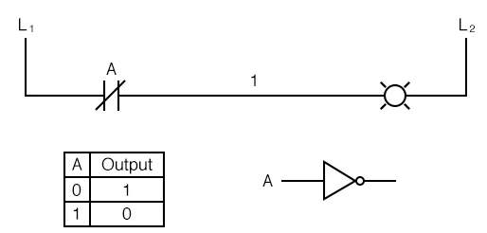

**What it does:** A NOT gate flips the input - if something is ON, it makes the output OFF, and vice versa.

**How to build it in ladder logic:** Use a Normally Closed (NC) contact --|\|--

* When input A is OFF → NC contact is closed → power flows → output turns ON
* When input A is ON → NC contact opens → no power flows → output turns OFF

**Real-world example:** Safety interlock on a machine door:

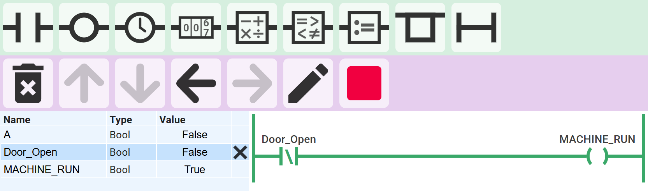

Door is closed (DOOR_OPEN = 0 / False / NOT gate active) → machine can run (output = 1)

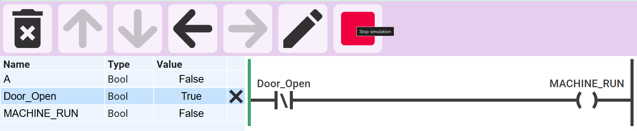

Door is open (DOOR_OPEN = 1 / True) → machine stops (output = 0)

**In plain English:** *"Run the machine only when the door is NOT open."* The NC contact automatically inverts the door sensor signal - when the door opens, it immediately cuts power to the machine.

This is the most basic safety logic you'll see everywhere in industrial automation.

🔌 XOR gate Ladder Implementation:



Use a combination of normally open (NO) and normally closed (NC) contacts.  
This represents the logic: **"If A OR B is TRUE, but not both, then turn ON the output."**

**How it works:**

* **If A is TRUE and B is FALSE**:  
  The path through A (NO) and B (NC) closes → Output turns ON.
* **If B is TRUE and A is FALSE**:  
  The path through B (NO) and A (NC) closes → Output turns ON.
* **If both A and B are TRUE**:  
  Both paths are blocked because NC contacts open → Output stays OFF.
* **If both A and B are FALSE**:  
  Neither NO contact allows current → Output stays OFF.

✅ **Summary:** Output is ON **only when A or B is TRUE**, but **not both at the same time** — exactly what XOR logic means.

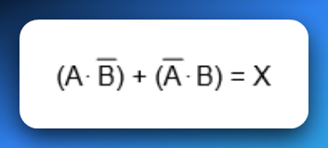

**💡** Key Concept: Contacts Are Logic Conditions

In Ladder Logic, your contacts (—| |—) aren’t checking voltage directly — they’re checking **bit states** in memory.

* A contact in a rung is **like a mini IF-statement**.
* When you place them **in series**, it means “all must be true” (AND).
* When you place them **in parallel**, it means “any can be true” (OR).

And these logic structures determine whether **your output coils (—( )—)** get energized or not.

**🧠** Analogy Time:

* Think of series logic like **security clearance**:  
  “You need both a keycard **and** a password to enter.”
* Think of parallel logic like **alarm triggers**:  
  *“If* ***any*** *of the sensors trip, sound the alarm.”*

**📌** Summary:

* **AND Logic = Series contacts** → All must be TRUE.
* **OR Logic = Parallel contacts** → At least one must be TRUE.
* No separate gate components — it's all about **how you arrange your contacts** in the rung.

The contacts

**🔌** Normally Open (NO) Contact – The “Push‑to‑Start”

Think of a normally open contact like a simple doorbell button.

* **Default (not pressed):** The internal path is open. No current flows. In PLC terms, the memory bit is FALSE (0).
* **When pressed:** The path closes. Electricity flows. In PLC terms, the bit flips to TRUE (1), and logical power can now travel through that rung.

✅ **Analogy:** Press button → bridge closes → current flows → light turns on.



**🛡️** Normally Closed (NC) Contact – The “Safety Gate”

Now flip the logic. A normally closed contact is like a safety gate that’s already allowing current through until you interfere.

* **Default (not pressed):** The path is closed. Electricity flows. In PLC terms, the memory bit is TRUE (1).
* **When pressed:** The path opens. Current stops. In PLC terms, the bit reads FALSE (0), blocking logical power on that rung.

✅ **Analogy:** Press button → bridge opens → no current → light stays off.



✨ Positive Transition-Sensing Contact ---|P|---

**What it does:** ✅ Fires **only for one scan** when your variable flips from FALSE → TRUE ✅ Think of it as a **one-shot rising edge detector** ✅ It only passes power if the left input is already TRUE at that moment

**Real-world examples:**

* **Start button:** Press to start a machine → you want it to start once, not keep trying to start every scan while held down.
* **Part counter:** When a sensor first detects a part → increment counter once, not continuously while the part passes by.
* **Door opening:** When a door switch goes from closed to open → log one "door opened" event, not hundreds while it stays open.
* **Emergency reset:** After fixing an alarm → acknowledge it once when the reset button is pressed, not repeatedly.

**Why it's essential:** Without this, holding a button would flood your system with repeated commands every scan cycle (potentially thousands of times per second), causing chaos in counters, alarms, and sequences.

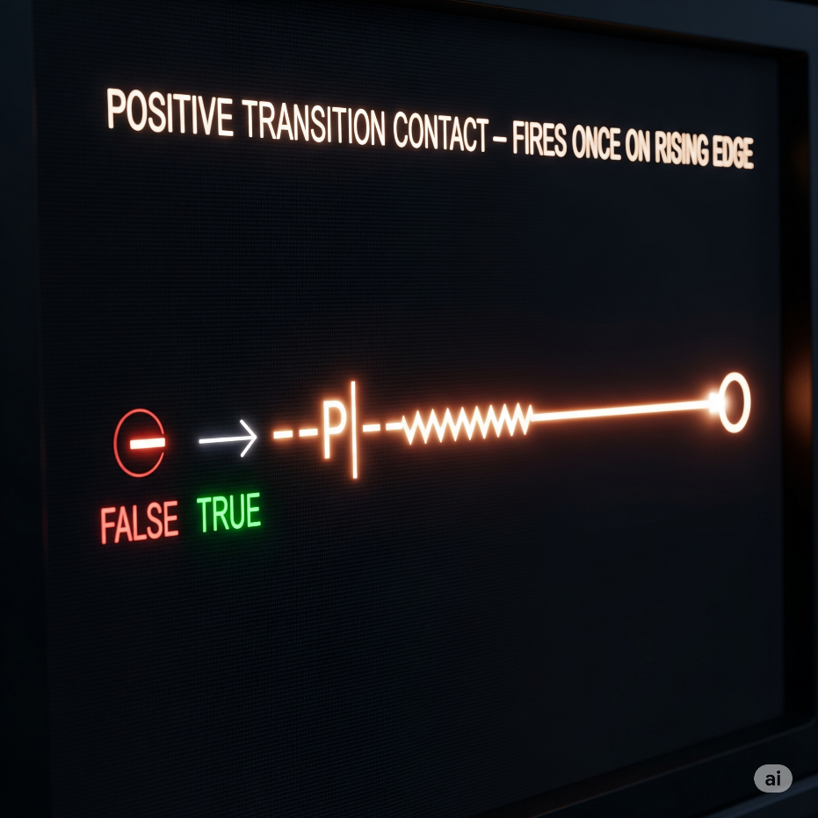

✨ Negative Transition-Sensing Contact ---|N|---

**What it does:** ✅ Fires **only for one scan** when your variable flips from TRUE → FALSE ✅ A **one-shot falling edge detector** ✅ Left input must be TRUE at that moment too

**Real-world examples:**

* **Conveyor control:** When a box leaves the sensor → start the next conveyor section once, not continuously while the sensor is empty
* **Safety logging:** When an emergency stop is released → log one "system restored" event at the exact moment of release
* **Production tracking:** When a part exits the work station → trigger completion counter once as it leaves, not while the station stays empty
* **Door security:** When a door closes → send one "door secured" signal to the alarm system, not constant signals while it stays closed
* **Process completion:** When a tank empties (level sensor goes FALSE) → start the refill cycle once at that instant

**Why it's crucial:** This catches the exact moment something stops or leaves, preventing your system from missing the transition or triggering multiple times. Perfect for "cleanup" actions that should happen right when something ends.

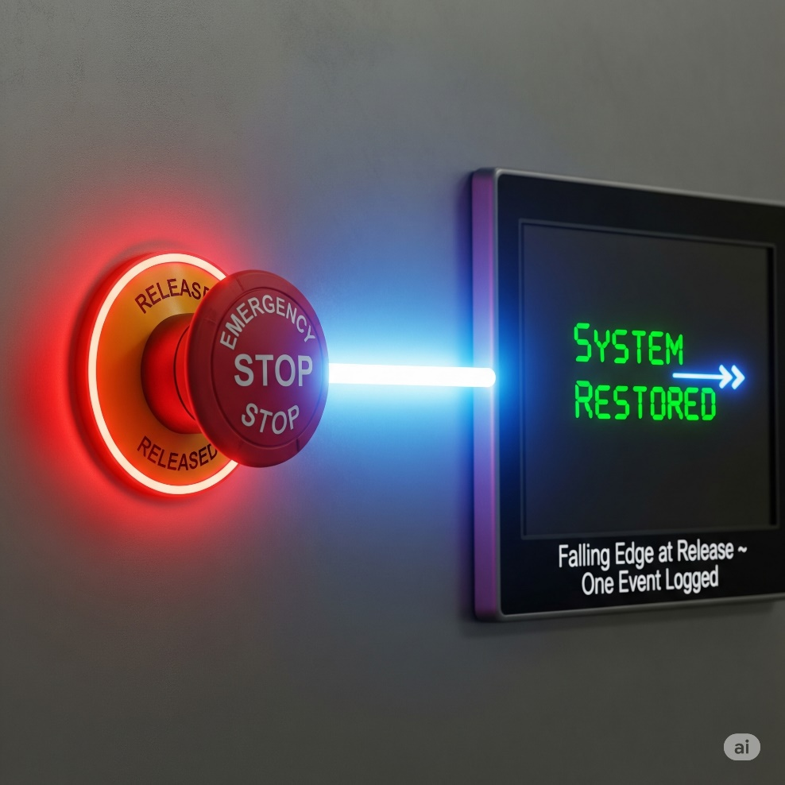

**🌩** OTE (Output Energize) or Output Coil

Think of OTE as the **"result"** of your ladder logic rung. It's what actually happens when all your conditions are met.

**Simple analogy:** You know how a regular light switch works? You flip it up → light turns on. You flip it down → light turns off. OTE is exactly like that light bulb, but instead of a physical switch, it's controlled by the logic you build.

**How it really works:** Every time the PLC scans your program (thousands of times per second), it checks: "Are all the conditions on this rung TRUE right now?"

* If YES → OTE energizes (turns ON)
* If NO → OTE de-energizes (turns OFF)

**Real-world example:** Imagine an automatic parking garage gate:



* Car sensor detects a vehicle AND payment was received AND gate isn't broken → gate opens
* Missing any one condition (no car, no payment, gate broken) → gate stays closed
* The gate follows these conditions in real-time - if payment expires while the car is there, gate closes immediately

**Key point:** OTE has zero memory. It's like a faithful dog - it does exactly what you tell it, when you tell it, every single scan. No thinking, no remembering yesterday, just pure obedience to your current logic.

**The OTE (Open_Gate) is like the "DO IT!" command at the end of the line.** When everything to the left of Open_Gate is TRUE (like, all the green lights are on and the vibes are right), then Open_Gate gets powered up, and it stays on as long as those conditions are met.

🚧 Latch (OTL) and Unlatch (OTU)

OTL (Output Latch) - The Memory Keeper

**In simple terms:** OTL is like a **sticky switch** - once you turn it ON, it STAYS on until something specifically turns it OFF.

**How it's different from OTE:**

* **OTE:** Acts like a regular light switch - follows your logic constantly
* **OTL:** Acts like a **hotel room keycard** - once activated, it remembers and stays active

**How OTL works:** When the rung logic goes TRUE (even for just one scan), OTL sets the output to ON and then **remembers** that state. Even if the rung logic goes back to FALSE, the output STAYS ON.

**Real-world example:** Emergency alarm system(we’ll unlatch it next):



* Smoke sensor triggers for 2 seconds → alarm turns ON
* Smoke clears (sensor goes FALSE) → alarm STAYS ON (latched)
* Alarm keeps blaring until someone manually resets it with an OTU instruction

**Why use latching?** Perfect for situations where you need something to **stay active** even after the trigger condition disappears:

* Emergency alarms that need manual reset
* Equipment that should stay running once started
* Status flags that mark "something happened" until cleared

**Key point:** OTL has **permanent memory** - it's like writing with a pen instead of pencil. Once it's set, only an OTU (Output Unlatch) can erase it.

OTU (Output Unlatch) - The Reset Button

**In simple terms:** OTU is the **eraser** for latched outputs. It specifically turns OFF outputs that were set by OTL instructions.

**How it works:** When the rung logic goes TRUE, OTU forces the specified output to turn OFF and clears its "memory." It's like hitting a reset button. The OTL/OTU partnership:





* Emergency button pressed → alarm latches ON and STAYS on
* Even if emergency button is released → alarm keeps sounding
* Only when technician presses reset AND system is safe → OTU turns alarm OFF

**Key differences:**

* **OTL:** Sets something ON permanently (until reset)
* **OTU:** Sets something OFF permanently (until latched again)
* **OTE:** Just follows current logic (no memory)

**Important:** OTU only affects outputs that were previously latched with OTL. It's like having a specific key that only works on doors that were locked with a matching lock.

💡 Bottom line:

NO let’s power through *when active.* NC stops power *when active.*

Together, they’re the Lego blocks of ladder logic—defining exactly when your rungs conduct or block logical “power.”

Simple, powerful, and everywhere in your PLC world.

A PLC.

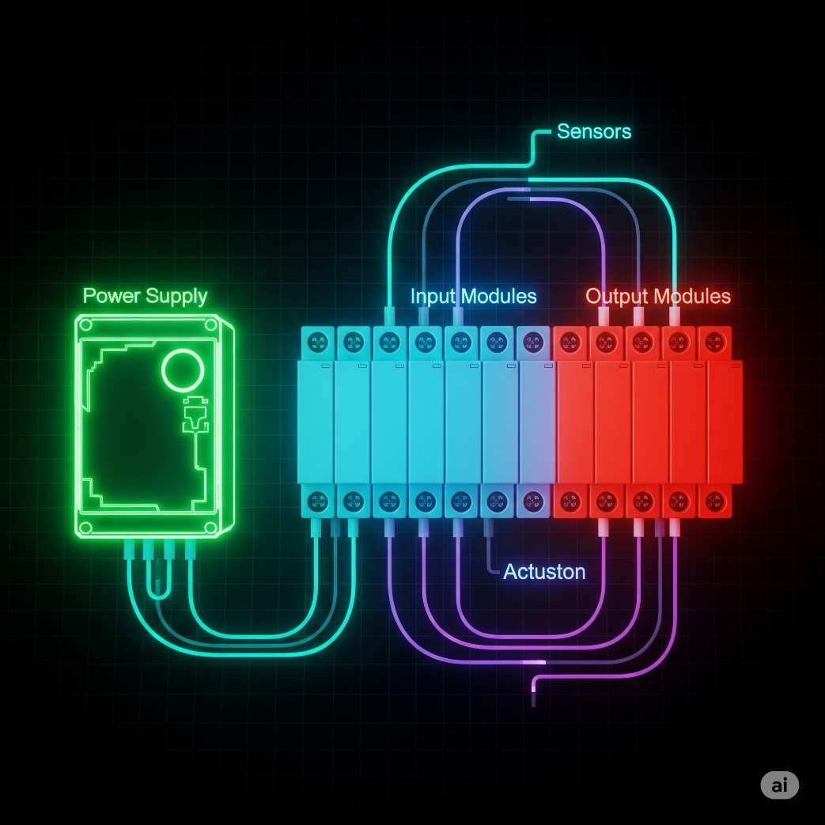

By now we’re good to go forward with this topic.

What are Internal Relays (B3, M bits)?

**🧠** Internal Relays (Also Called: Internal Coils / Memory Bits / Flags)

An **internal relay** is a **Boolean memory location** inside the PLC used **to store intermediate results or control logic flow**, without being physically tied to any I/O device.

It can be:

* **Turned ON or OFF** (just like a physical output coil)
* **Read using contacts** in other rungs (XIC = Normally Open, XIO = Normally Closed)
* Used across **multiple rungs** in your program to coordinate complex logic

**✅** Key Properties

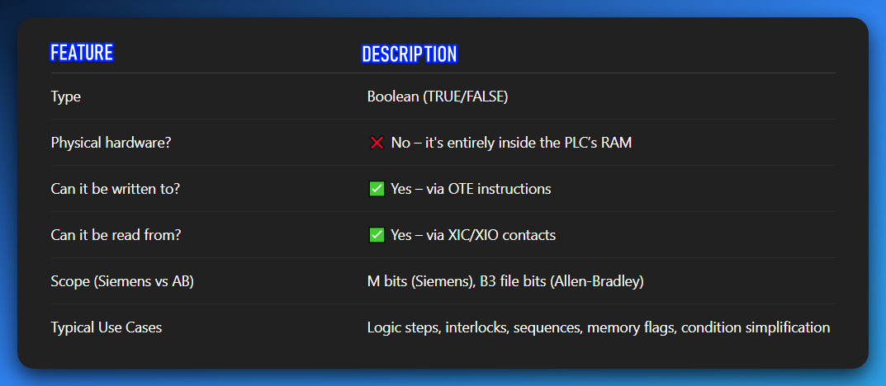

**⚙️** Siemens:

➤ **M0.0** → Memory byte 0, bit 0  
➤ Like accessing the first bit in a specific memory byte.

⚙️ Internal Relays vs. Physical Coils

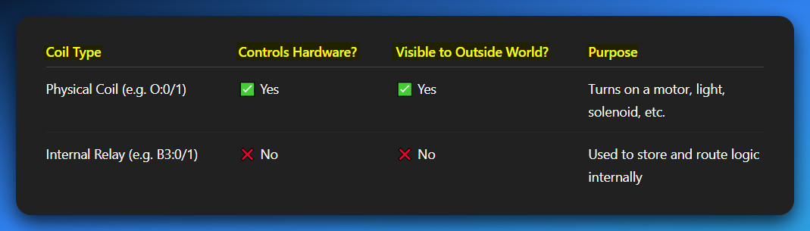

**Real-World Scenario: Intermediate Logic Storage**

Let’s say your system needs to:

* Check if **Machine Ready**
* Check if **Safety Conditions Met**
* Check if **Operator Pressed Start**

Rather than one giant rung, we can break this down:

LADDER LOGIC PART 3

Elements of ladder logic

* **Rails** – Vertical lines that carry electrical power to the control circuit.
* **Rungs** – Horizontal lines where the logic is built; they contain inputs, outputs, and branches.
* **Branches** – Parallel paths on a rung that allow multiple input conditions.
* **Inputs** – Devices like switches or sensors that control the logic flow.
* **Outputs** – Devices like motors or lights activated by the logic.
* **Timer** – Delays actions for a set time (e.g., turn on a light after 5 seconds).
* **Counter** – Counts events or cycles and triggers actions after a set number.

I see a small naming confusion I have always had.

In my school, we used “Ladder Logic” to refer to the programs we were drawing.



So, I had this conflict calling the **image b** ladder logic.   
Now am seeing it being called **relay logic.**

* **Diagram 'a' (Motor Control PLC Ladder Logic):** This is a **program** that runs inside a PLC. It's software.
* **Diagram 'b' (Motor Control Relay Logic):** This is a **wiring diagram** for physical electrical components (relays, switches, motor). It's hardware.

Some Practice

Y = (X1+X2)X3



Read it using the AND, OR gates.

Y=(X1+X2)(X3+X4)



You could attach the midpoint lines as one, or separate them as above.

Y= (X1X2) + X3



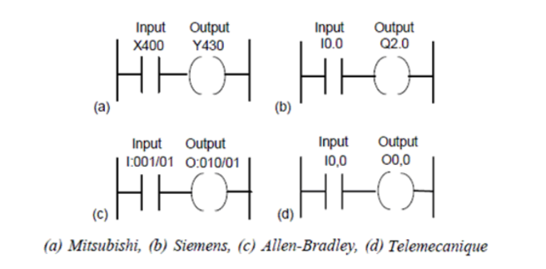

What are these diagrams called?

They are called **Ladder Diagrams** or **Ladder Logic**. They are a programming language used to program a **Programmable Logic Controller (PLC)**.

What's it doing?

Each diagram represents a simple circuit. The vertical lines on the left and right are like power rails. The horizontal lines are called **rungs**. In a simple rung like these, a condition (the input) must be met for an action (the output) to occur.

What are these rungs?

A "rung" is a single line of logic in a ladder diagram. Think of it like a rung on a ladder. Each rung represents a control circuit. The logic flows from left to right.

What for?

Ladder logic is used to automate industrial processes. PLCs are essentially rugged computers that are used to control machinery on factory floors, such as conveyors, robotic arms, and assembly lines. The ladder logic program tells the PLC exactly how to control the physical inputs and outputs of the machine.

A breakdown of the components:

Input (X400, I0.0, etc.):

These are conditions that must be true for the circuit to be complete. They are typically contacts from a physical input device, like a push-button, a sensor, or a switch.

The symbol shown is an "examine if closed" or "normally open" contact. It's "closed" (and lets power through) when the input is activated.

Output (Y430, Q2.0, etc.):

These are the actions that will happen when the input conditions on that rung are met. They represent a physical output device, like a motor, a light, or a solenoid.

The symbol shown is an "energize coil." When the rung is "true," the coil is energized, turning on the corresponding output device.

The different labels (a, b, c, d) show how different PLC manufacturers, like Mitsubishi, Siemens, Allen-Bradley, and Telemecanique, use slightly different naming conventions for their inputs and outputs, even though the fundamental logic is the same.

For example, Siemens uses 'I' for input and 'Q' for output, while Mitsubishi uses 'X' and 'Y'.

The logic itself, however, is universal.

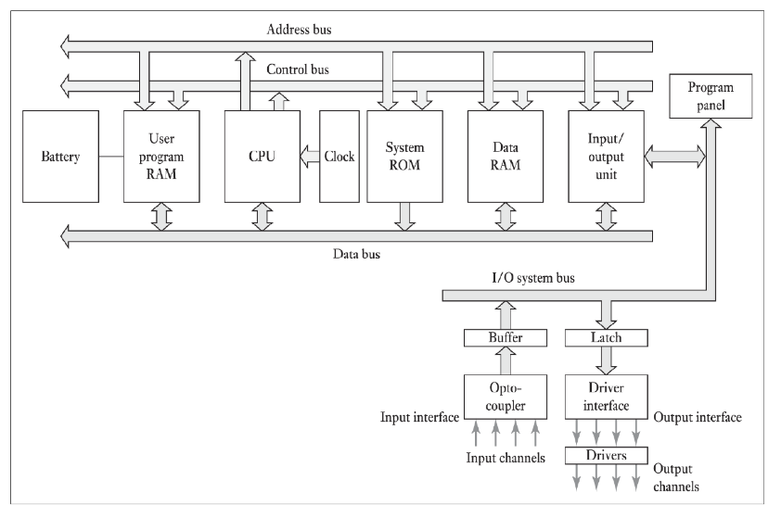

This shows the internal architecture of a PLC, which is the foundation for how it runs the ladder logic programs you saw earlier.

Knowing these parts helps you understand why PLCs work the way they do and can be **very useful for troubleshooting.**

CPU (Central Processing Unit):

The "brain" of the PLC. It's the microprocessor that executes the user program, processes input signals, and updates output signals.

Memory:

This is where the PLC stores its program and data. There are a few different types shown:

* **User Program RAM:** This is where your ladder logic program is stored. The CPU reads instructions from here.
* **Data RAM:** This is where the PLC stores the current status of inputs, outputs, and any internal variables or data used by the program.
* **System ROM:** This holds the PLC's operating system, which is the permanent software that controls how the PLC runs.

Buses (Address, Control, Data):

These are the internal communication highways of the PLC.

* **Data Bus:** Carries the actual data (instructions, values) between the CPU and the memory and I/O units.
* **Address Bus:** Specifies the location (address) in memory or the I/O unit that the CPU wants to read from or write to.
* **Control Bus:** Carries signals that control the timing and flow of data, like read/write commands.

Input/Output (I/O) Unit:

This is how the PLC connects to the real world.

* **Input Unit:** Takes signals from external devices (sensors, switches) and converts them into a format the CPU can understand. It's shown with an **Opto-coupler**, which is an important component that uses light to electrically isolate the sensitive internal PLC circuitry from the external input signals, protecting it from electrical noise and voltage spikes.
* **Output Unit:** Takes signals from the CPU and converts them into a format that can control external devices (motors, lights). It often uses **Drivers** (like transistors or relays) to handle the higher voltage/current needed for these devices. The **Latch** shown helps hold the output state.

Power Supply (Battery):

This provides power to the PLC's internal components. The battery is important because it often maintains the contents of the User Program RAM when the main power is off.

*In an exam, you might be asked to describe the function of these components or explain the flow of information during a typical PLC scan cycle.*

*The PLC scan cycle is a key concept that explains how the PLC reads inputs, executes the program, and updates outputs, and this diagram perfectly illustrates the hardware that makes that process possible.*

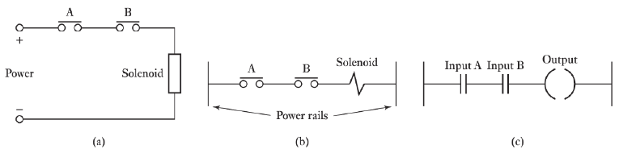

This image shows how a simple electrical circuit translates into ladder logic—a neat way to see how ladder diagrams were designed to feel familiar to anyone who understands traditional electrical relay schematics.

Diagram (a): Standard Electrical Relay Circuit  
This is your classic electrical schematic.

The solenoid (basically an electromagnet) only turns on when there’s a complete path for current from the positive (+) to the negative (–) terminal.

The current path is controlled by switches A and B, which are wired in series.

In plain terms, *both* switches must be closed for the solenoid to activate. This setup is the physical equivalent of an **AND** logic gate.

Diagram (b): Traditional Relay Logic Diagram  
This is an old-school way of representing the same circuit, often used before PLCs came into the picture.

* The two vertical lines are the “power rails” (your positive and negative sources).
* The horizontal line between them is the “rung.”
* Switches A and B appear as “normally open” contacts, while the solenoid is shown as a coil.

This style is almost identical to what you’ll see in modern ladder logic, which is the next step.

Diagram (c): PLC Ladder Logic Diagram  
Here’s the PLC-friendly version. The logic hasn’t changed, just the symbols.

* **Inputs A and B** are represented as “normally open” contacts, wired in series. The PLC will only mark this rung as “true” if both inputs are active.
* **The output** is the coil symbol, which the PLC energizes (turns on) only when the rung condition is true.

Big Picture

All three diagrams express the exact same rule:  
**The output will activate only if Input A AND Input B are active.**

That’s the core principle of ladder logic—series connections always represent an **AND** condition.



Thanks, glad they're helpful! This image is a great summary of the basic symbols and logic gates used in PLC ladder programming.

Basic Symbols (on the left)

--| |-- (Normally Open Contact)  
This is the **NO contact** symbol. By default, it’s “open,” meaning no current flows through it. It only “closes” (lets current pass) when the corresponding physical input—like a button or sensor—is activated. This is the most common type of input symbol you’ll see.

--|/|-- (Normally Closed Contact)  
This is the **NC contact** symbol. By default, it’s “closed,” so current flows. It “opens” (stops the current) when the linked physical input is turned on. You’ll often see this in safety circuits, like an emergency stop, where the system should stay active until the button is pressed.

--( )-- (Output Coil)  
This symbol represents an **output coil**. If the logic on the rung to its left is “true” (current can flow), the coil becomes energized, turning on the corresponding device—like a motor, light, or solenoid.

--[ ]-- (Special Instruction)  
This is a catch-all symbol for **special functions or instructions**. These are used for more advanced operations—things like timers, counters, math operations, or data handling inside the PLC program.

Ladder Logic Rungs (on the right)

The right side shows three different rungs of logic, each with a corresponding explanation:

Rung 1: Input 1 -> Output A

* This is the simplest form of logic.
* It uses a single **Normally Open** contact for Input 1.
* **Logic:** Output A will be energized **IF** Input 1 is turned on.
* This is a simple "direct control" or "Copy" logic.

Rung 2: Input 1 -> Input 3 -> Output B

* This rung has two Normally Open contacts connected in series.
* Logic: Output B will be energized IF Input 1 is turned on AND Input 3 is turned on.
* This is the representation of an AND logic gate. Both conditions must be true for the output to activate.

Rung 3: Input 4 and Input 5 -> Output C

* This rung shows a different connection: two Normally Open contacts connected in parallel.
* Logic: Output C will be energized IF Input 4 is turned on OR Input 5 is turned on.
* This is the representation of an OR logic gate. The output will activate if at least one of the conditions is true.

The END instruction

Signifies the end of the program. The PLC's scan cycle runs through all the rungs from top to bottom, then repeats.

This "END" tells the PLC that it has reached the end of the user-programmed logic.

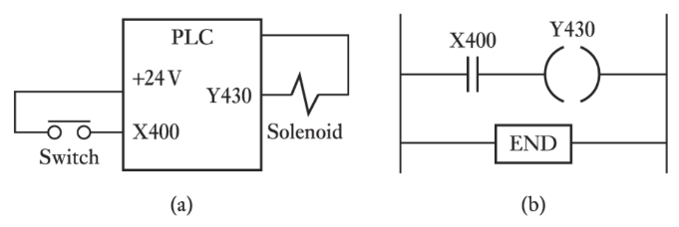

Diagram (a): The Physical Wiring

This diagram shows how the real-world components are hooked up to the PLC.

* **PLC:** The brain of the operation. It’s a box with terminals for power, inputs, and outputs.
* **+24V:** The power source feeding both the PLC’s internal logic and the connected devices.
* **X400 (Input Terminal):** A physical input point on the PLC. The switch is wired here along with the power source. When the switch is pressed, it sends a signal to X400. The PLC’s hardware senses this change instantly.
* **Y430 (Output Terminal):** A physical output point on the PLC. The solenoid is wired here. When the PLC energizes Y430, power flows to the solenoid, causing it to activate.

Diagram (b): The Ladder Logic Program

This is the “software version” of the hardware logic shown above.

* **--| |-- X400:** A Normally Open contact that mirrors the state of the physical switch on X400. When the switch is pressed, this contact “closes” in the program, allowing logic to flow through the rung.
* **--( )-- Y430:** The output coil symbol. If the rung’s logic is true, this coil energizes the physical output Y430—powering the solenoid.
* **END:** Marks the end of the ladder logic program.

How They Work Together

The hardware wiring provides the raw electrical connections, while the ladder logic decides what to do with those signals.

In this example, the rule is simple:  
**IF the switch (X400) is ON, THEN energize the solenoid (Y430).**

The PLC constantly scans the input (X400), evaluates the logic, and updates the output (Y430) in real-time.

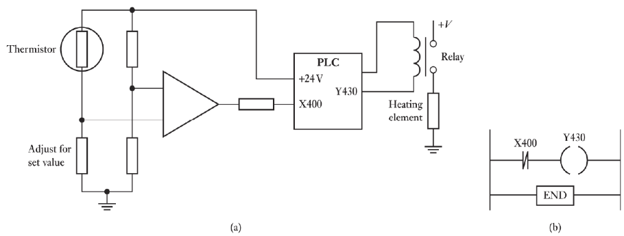

This image steps it up with a **real-world control loop**—combining an analog temperature sensor with a PLC’s digital input to manage a heating element. This kind of ON/OFF control is everywhere in industrial systems, from ovens to HVAC units.

Diagram (a): Physical Wiring and Analog Circuit

Thermistor & Analog Comparator:

A **thermistor** is a temperature-sensitive resistor. Its resistance shifts with temperature changes.

It’s wired into a **Wheatstone bridge** (those two parallel resistor dividers). On the other side of the bridge, a **variable resistor**—labeled *“Adjust for set value”*—lets you set the target temperature.

The **triangle symbol** is an op-amp (operational amplifier), acting as a **comparator**. It compares the voltage from the thermistor side to the voltage from the “set value” side.

When the thermistor detects the set temperature, the op-amp’s output flips state (e.g., low → high), signaling that the threshold has been hit.

PLC Integration:

* The **op-amp’s output** connects to the PLC input **X400**. The PLC doesn’t “know” the temperature; it just sees ON/OFF signals from the comparator.
* The PLC output **Y430** drives a **relay**, which works like an electrically controlled switch.
* When Y430 is energized, the relay closes its contacts, letting high-voltage power (+V) flow to the **heating element**. The relay keeps the heavy current away from the PLC while safely controlling big loads.

Diagram (b): Ladder Logic Program

* **--| |-- X400:** Represents the ON/OFF signal from the op-amp comparator.
* **--( )-- Y430:** The output coil. When the rung is true, Y430 energizes the relay—and the heater kicks on.

The logic is identical to the earlier examples:  
**IF X400 is ON, THEN energize Y430.**

The Purpose of the Circuit

This forms a **basic temperature control system**:

* You set a target temperature with the *“Adjust for set value”* resistor.
* The thermistor constantly monitors the actual temperature.
* If the temperature drops below the setpoint, the op-amp output flips OFF. The PLC sees X400 as false, de-energizing Y430 and turning the heater off.
* If the temperature rises past the setpoint, the op-amp output turns ON. The PLC sees X400 as true, energizing Y430, which powers the heater.

This is called **bang-bang control** (or ON/OFF control): the heater is either fully ON or fully OFF—simple, reliable, and common in industrial automation.

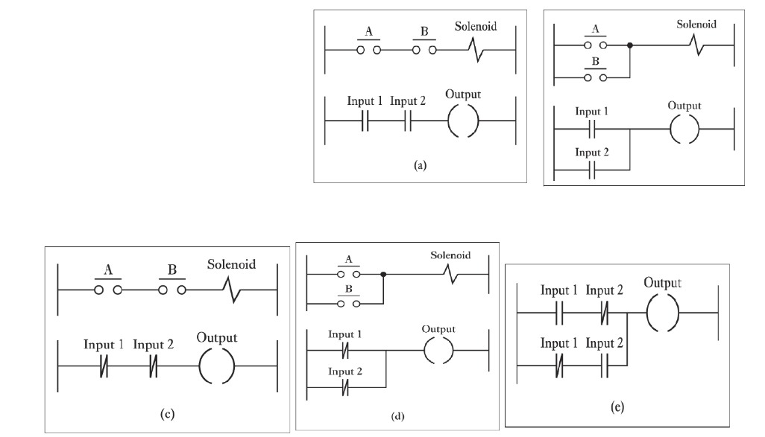

This image is a fantastic summary that combines all the core concepts we've discussed so far. It shows pairs of traditional relay logic diagrams and their corresponding PLC ladder logic diagrams, illustrating how the same logic is represented in both formats.

Let's break down each pair:

(a) Series Connection: AND Logic

* **Traditional:** The contacts A and B are connected one after the other in a **series**.
* **PLC:** Input 1 and Input 2 are represented by normally open contacts, also connected in **series**.
* **Logic:** The solenoid (or output) will energize **IF AND ONLY IF** A **AND** B are both closed. This is the **AND** logic gate.

(b) Parallel Connection: OR Logic

* **Traditional:** The contacts A and B are connected in **parallel**, meaning there are two separate paths for the current to flow.
* **PLC:** Input 1 and Input 2 are represented by normally open contacts, connected in **parallel** on the rung.
* **Logic:** The solenoid (or output) will energize **IF** A is closed **OR** B is closed (or both). This is the **OR** logic gate.

(c) Series Connection with Normally Closed: NOT AND (NAND) Logic

* **Traditional:** The contacts A and B are normally closed (NC) and are in **series**.
* **PLC:** Input 1 and Input 2 are represented by **normally closed** contacts, also in **series**.
* **Logic:** The output will energize **IF** Input 1 is **NOT** activated **AND** Input 2 is **NOT** activated. This is a **NAND** gate in a non-standard form. In a more standard NAND gate, both inputs must be true for the output to be false. Here, both inputs must be false for the output to be true.

(d) Parallel Connection with Normally Closed: NOT OR (NOR) Logic

* **Traditional:** The contacts A and B are normally closed (NC) and are connected in **parallel**.
* **PLC:** Input 1 and Input 2 are represented by **normally closed** contacts, connected in **parallel**.
* **Logic:** The output will energize **IF** Input 1 is **NOT** activated **AND** Input 2 is **NOT** activated. The current path is broken if **EITHER** Input 1 **OR** Input 2 is activated. This is a **NOR** gate.

(e) Combined Logic (AND-OR)

* **PLC:** This shows a combined logic circuit with a parallel branch containing a series branch.
* **Logic:** This is a more complex rung. The output will be energized **IF** (Input 1 **AND** Input 2 are active) **OR** (Input 1 **AND** Input 2 are **NOT** active). This looks a bit like an XNOR gate, where the output is true if both inputs are the same.

The key takeaway from this image is that **series connections in ladder logic represent an AND condition**, while **parallel connections represent an OR condition**. The type of contact used (normally open or normally closed) determines whether you are looking for a condition to be TRUE or FALSE.

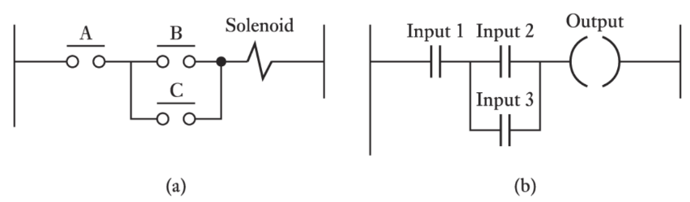

This diagram is another great example of combining the concepts of series and parallel logic to create a more complex control circuit. It shows a common arrangement for controlling a single output with multiple inputs.

Here's a breakdown of the two diagrams:

Diagram (a): The Traditional Relay Logic Diagram

* **Series connection:** Contact **A** is in series with the rest of the circuit. This means contact A **must** be closed for power to reach the solenoid.
* **Parallel connection:** Contacts **B** and **C** are connected in parallel with each other. This means either contact B **OR** contact C can be closed to allow power to pass through this part of the circuit.
* **Logic:** The solenoid will be energized **IF AND ONLY IF** (A is closed) **AND** (B is closed **OR** C is closed).

Diagram (b): The PLC Ladder Logic Diagram

* **Series connection:** The Input 1 contact is in series with the parallel branch. This corresponds to the A contact from the relay logic.
* **Parallel connection:** The Input 2 and Input 3 contacts are connected in parallel. This corresponds to the B and C contacts.
* **Logic:** The Output coil will be energized **IF AND ONLY IF** (Input 1 is turned on) **AND** (Input 2 is turned on **OR** Input 3 is turned on).

The Purpose of This Logic

This type of circuit is often used for a "master control" and "local control" scenario. For example:

* **A/Input 1** could be a master enable switch or a safety gate sensor. The entire system cannot run unless this master condition is met.
* **B/Input 2** could be a "manual start" button on a control panel.
* **C/Input 3** could be an automatic signal from another part of the system, like a sensor indicating a product is in position.

The logic ensures that the Output (e.g., a motor or a hydraulic cylinder) will only activate if the master switch is on **AND** either the manual button is pressed **OR** the automatic signal is received.

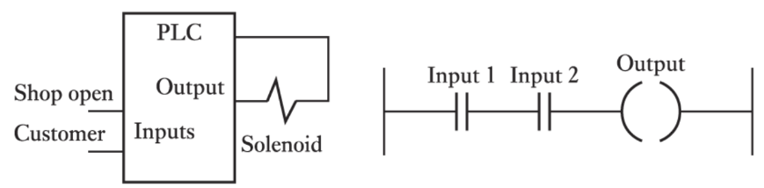

This final image is another excellent example of a real-world scenario, combining the physical wiring with the ladder logic program to control an output based on two simple conditions.

Here's a breakdown of the two parts:

Diagram (a): The Physical Wiring

* **PLC:** This is the programmable logic controller.
* **Inputs:** The two physical inputs are labeled "Shop open" and "Customer."
  + The **"Shop open"** input is likely connected to a switch that's closed when the shop is open.
  + The **"Customer"** input is likely connected to a sensor (like a motion sensor or a pressure mat) that detects when a customer is present.
* **Output:** The physical output is connected to a **Solenoid**. A solenoid is often used to operate things like an automatic door lock or a buzzer. In this scenario, it's probably the latter—a buzzer or chime to alert a shopkeeper.

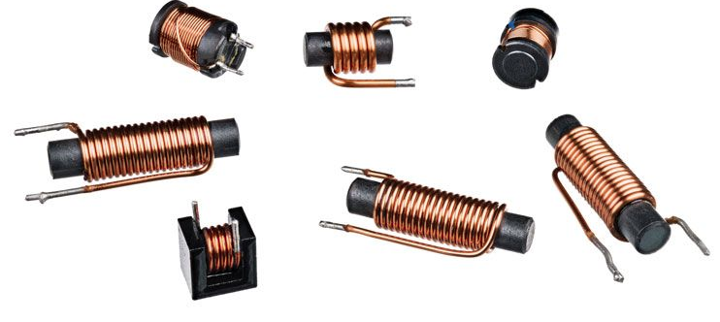

Diagram (b): The Ladder Logic Program

* **--| |-- Input 1:** This is the normally open contact for the first physical input, "Shop open."
* **--| |-- Input 2:** This is the normally open contact for the second physical input, "Customer."
* **--( )-- Output:** This is the output coil that controls the solenoid.
* **Logic:** The two input contacts are in **series**. This means the logic is an **AND** condition. The rung will be "true" and the output will be energized **IF AND ONLY IF** Input 1 is on **AND** Input 2 is on.

The Purpose of This Circuit

This setup creates a **simple automatic customer alert system** for a shopkeeper. The logic is:

**IF** the "Shop open" switch is closed **AND** a "Customer" sensor detects someone, **THEN** activate the "Output" (the solenoid, which could be a buzzer).

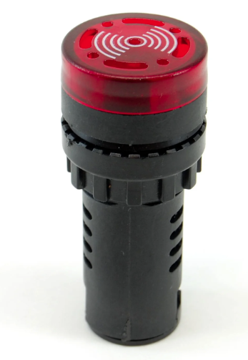

This prevents the buzzer from going off at night when the shop is closed. The "Shop open" switch acts as a master enable, and the "Customer" sensor is the trigger. The PLC's job is to continuously monitor these two inputs and, based on the AND logic programmed in the rung, activate the output at the right time.

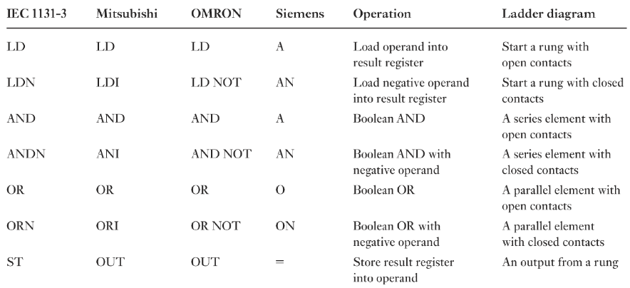

Here are some other **must-know concepts** that you’ll run into as you dive deeper:

1. Memory Coils and Internal Bits

The table mostly focuses on physical inputs (like buttons) and outputs (like lights or motors), but PLCs also use **internal memory locations**—called **memory coils** or **internal bits** (labels like M, C, or T depending on the brand).

Think of these as **virtual outputs**: they don’t control any physical device, but they store ON/OFF states inside the program. These are essential for building **latching circuits** or holding conditions active across multiple rungs.

2. Timers and Counters

These are the bread and butter of advanced control:

* **Timers**: Measure time. For example, you might trigger a light that stays on for 10 seconds after a button is pressed.
* **Counters**: Count events. A common example is counting how many items pass a sensor on a conveyor.

The table mentions “special instructions,” but timers and counters are the *go-to examples* of these.

3. Latching and Unlatching

This is a **core concept** you can’t ignore.  
A **latching circuit** (or *seal-in/holding circuit*) keeps an output **ON** even after the start button is released. It achieves this by “feeding” the output back into its own rung in parallel with the start signal.

The opposite is the **unlatch instruction**, which turns the output **OFF**.  
You’ll see this pattern everywhere—especially for start/stop motor control.

4. Analog Inputs and Outputs

In a previous example, we saw an analog sensor feeding a digital input, but PLCs can handle **true analog signals**—values that aren’t just ON/OFF but exist in ranges, like **0–10V** or **4–20mA**.  
Working with analog signals often involves:

* **Reading the value** from an analog input module.
* **Scaling the value** (e.g., converting 0–10V to 0–100°C).
* **Using logic** to trigger actions based on thresholds or ranges.

5. Data Movement and Comparison

In many real-world systems, you’ll need instructions to **move data** between memory locations or **compare values**.  
For example:

* Move a number from one register to another (like copying a sensor reading).
* Compare if a counter has hit a certain target and trigger an alarm.

6. The PLC Scan Cycle

This is the **heartbeat of every PLC**.  
The PLC continuously:

1. Reads all the input states.
2. Executes the logic program, rung by rung (top to bottom).
3. Updates all the outputs.  
   This loop—called the **scan cycle**—runs endlessly.  
   Understanding how it works is key to predicting your program’s behavior, especially when working with fast-changing inputs.

The Bottom Line

The table is a **fantastic starting point**, but PLC programming is a huge iceberg. As you level up, you’ll need to learn how to handle **advanced instructions, data manipulation, and program structure** to build reliable and flexible control logic.

If you read the table above, you should be able to understand these.

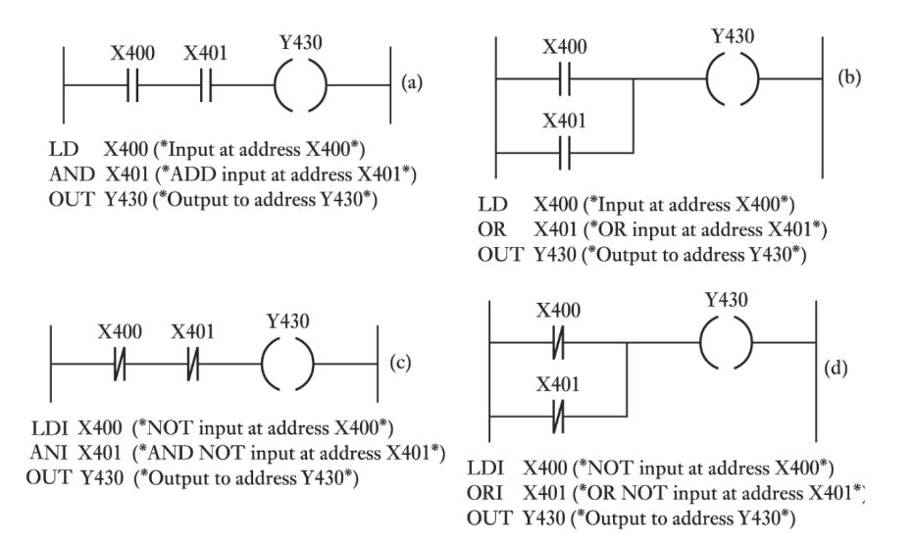

This image is an excellent summary that ties together the ladder logic diagrams with the corresponding **Instruction List (IL)** code.

The **Instruction List** is a low-level, text-based programming language for PLCs that directly corresponds to the graphical ladder logic. This image shows the fundamental logic gates in both formats.

Let's break down each example:

(a) AND Logic

**Ladder Logic:** X400 and X401 are in **series** before the output Y430.

**Logic:** The output Y430 will be energized **IF** X400 is on **AND** X401 is on.

**Instruction List (IL):**

* **LD X400:** **L**oa**d** the state of input X400 into a temporary memory area called the result register.
* **AND X401:** Perform a boolean **AND** operation between the current value in the result register and the state of input X401.
* **OUT Y430:** Store the final result from the register to the output Y430.

**Summary:** LD starts the rung, AND adds a series element, and OUT controls the output.

(b) OR Logic

**Ladder Logic:** X400 and X401 are in **parallel** before the output Y430.

**Logic:** The output Y430 will be energized **IF** X400 is on **OR** X401 is on.

**Instruction List (IL):**

* **LD X400:** **L**oa**d** the state of input X400.
* **OR X401:** Perform a boolean **OR** operation between the result register and X401.
* **OUT Y430:** Store the final result to the output Y430.

**Summary:** LD starts the rung, OR adds a parallel branch, and OUT controls the output.

(c) NAND Logic (using NOT contacts)

**Ladder Logic:** X400 and X401 are **normally closed** contacts in **series** before the output Y430.

**Logic:** The output Y430 will be energized **IF** X400 is **NOT** on **AND** X401 is **NOT** on.

**Instruction List (IL):**

* **LDI X400:** **L**oa**d** the **inverse** (or **NOT**) of the state of input X400.
* **ANI X401:** Perform a boolean **AND** operation with the **inverse** of X401.
* **OUT Y430:** Store the result to output Y430.

**Summary:** LDI and ANI correspond to using normally closed contacts in the ladder diagram.

(d) NOR Logic (using NOT contacts)

**Ladder Logic:** X400 and X401 are **normally closed** contacts in **parallel** before the output Y430.

**Logic:** The output Y430 will be energized **IF** X400 is **NOT** on **AND** X401 is **NOT** on. The circuit path is broken if **either** X400 **OR** X401 is on.

**Instruction List (IL):**

* **LDI X400:** **L**oa**d** the **inverse** of input X400.
* **ORI X401:** Perform a boolean **OR** operation with the **inverse** of X401.
* **OUT Y430:** Store the result to output Y430.

**Summary:** LDI and ORI correspond to using normally closed contacts in a parallel branch.

This image clearly shows that ladder logic is just a graphical way of representing the same instructions that are written in a text-based format like Instruction List. Both methods are used to program a PLC, and they are functionally equivalent.

Now do this one yourself, using the knowledge above, as practice.

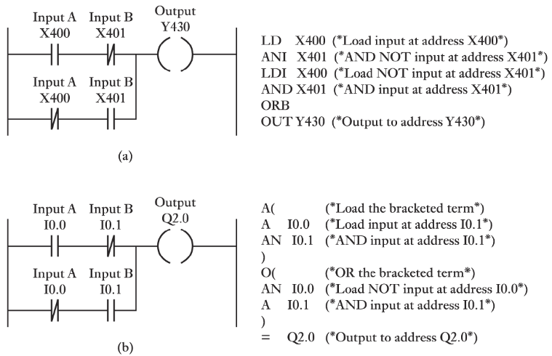

Another one:

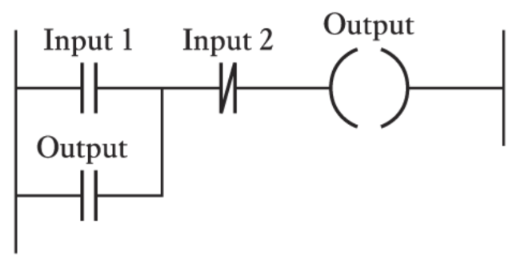

This ladder logic diagram shows a very common and important concept in PLC programming: a **latching** or **seal-in** circuit. It's used to make an output stay on even after the initial trigger input is removed.

Here's a breakdown of the logic:

The Components

* **Input 1 (--| |--):** This is a normally open (NO) contact. It's the "start" or "momentary on" button.
* **Input 2 (--|/|--):** This is a normally closed (NC) contact. It's the "stop" or "reset" button.
* **Output (--( )--):** This is the output coil that you want to control.
* **Output (--| |--):** This is a second normally open contact, but it's controlled by the state of the Output coil itself. This is the "seal-in" or "latching" contact.

The Logic (How it Works)

Let's trace the flow of logic step-by-step:

1. **Initial State:** 
   * Assume Input 1 and Input 2 are both off (as is normal for a start/stop button and an NC contact). The Output is off. The path through Input 1 is open, and the path through the parallel Output contact is also open. The path through Input 2 is closed.
2. **Pressing the Start Button (Input 1):**
   * When you press Input 1, its contact closes.
   * There is now a complete path for logic to flow through Input 1, through the closed Input 2 contact, to the Output coil.
   * The Output coil is energized.
3. **Latching Occurs:**
   * When the Output coil is energized, it "closes" its corresponding contact in the parallel branch.
   * Now there are **two** paths for logic to flow to the Output coil: one through Input 1 and one through the Output's own contact.
4. **Releasing the Start Button (Input 1):**
   * When you release Input 1, its contact opens again. The first path is now broken. **However**, the second path through the Output's own contact is still complete. The Output is on, so its contact stays closed, providing a path for the logic to keep flowing. The Output remains energized, even though the "start" button has been released. This is the "latching" action.
5. **Pressing the Stop Button (Input 2):**
   * To turn off the Output, you must break the circuit.
   * When you press the normally closed Input 2 contact, it opens.
   * This breaks the single remaining path to the Output coil.
   * The Output coil de-energizes.
   * The Output's own contact then opens, breaking the latching path. The circuit is now in the initial state again, and the Output will remain off until Input 1 is pressed again.

This circuit is fundamental to PLC programming for things like motor controls, where you need to start a machine with a momentary button and have it stay on until a separate stop button is pressed.

Let’s re-explain to be honest:

The Components

* **Rung:** The entire horizontal line is a pipe.
* **Input 1 (--| |--):** This is a push-to-open valve (a momentary switch). You push it, the water flows, you let go, it closes.
* **Input 2 (--|/|--):** This is a push-to-close valve. It's normally open, so water is always flowing through it. You push it, it closes, and the water stops. (Wait, let's use a better analogy from the image).
  + Okay, let's reset the valve analogy based on the image's components.
  + **Input 1 (--| |--):** This is a "normally open" valve. Water won't flow until you push a button to open it.
  + **Input 2 (--|/|--):** This is a "normally closed" valve. Water is always flowing through it until you push a button to close it.
  + **Output (--( )--):** This is a solenoid valve. When water flows to it, it opens.
  + **Output (--| |--):** This is a "normally open" valve that is *mechanically linked* to the solenoid valve. If the solenoid opens, this valve also opens.

The "Water Flow" Explanation

1. **STARTING POINT:** No water is flowing. Both Input 1 and the Output's own contact are closed valves. Input 2 is open, and water can flow through it.
2. **PUSHING THE START BUTTON (Input 1):**
   * You push Input 1's button. This opens its valve.
   * Water now has a path: it flows through the open Input 1 valve, through the open Input 2 valve, and reaches the Output solenoid valve.
   * The Output solenoid valve opens.
   * Because the Output solenoid valve opened, its linked contact valve also opens.
3. **RELEASING THE START BUTTON (Input 1):**
   * You let go of Input 1's button. The valve closes.
   * Water can no longer flow through the Input 1 path.
   * **But**, water can still flow through the other path! The Output's own linked contact valve is still open, so water flows through it, through the Input 2 valve, and back to the Output solenoid valve.
   * The Output solenoid valve stays open because it's getting a constant flow of water from its own linked contact valve.
   * **This is the latching!** The output "holds itself on" by providing its own path for the logic to continue flowing.
4. **PUSHING THE STOP BUTTON (Input 2):**
   * You push Input 2's button. This closes its valve.
   * The flow of water to the Output solenoid valve is now completely cut off. Both paths are blocked.
   * The Output solenoid valve closes.
   * Because the Output solenoid valve closed, its linked contact valve also closes.
   * You release the Input 2 button, and its valve opens again. But since the Output's linked valve is now closed, the circuit is back to the starting point, and no water is flowing.

This circuit is designed to work like the on/off switch on a machine. You push the "ON" button for a second, and the machine starts and stays on. You then push a different "OFF" button to stop it. The Output's own contact is the key to making this possible.

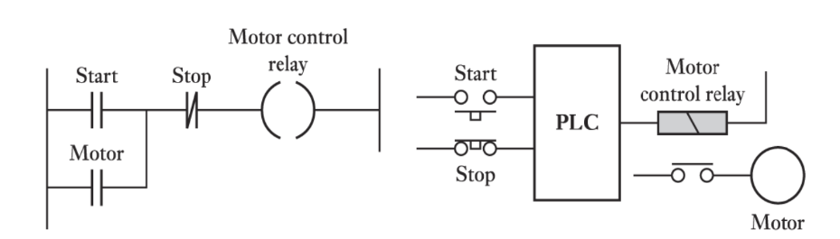

This image is a perfect example of how a **traditional motor control circuit**—built with relays—can be reimagined using a **PLC**. It showcases the core purpose of a PLC: replacing complex hard-wired logic with clean, flexible software-based logic.

Left Diagram: Traditional Relay Logic (Latching Motor Circuit)

This is the old-school way of controlling a motor using physical relay components. It’s essentially the **latching circuit** we discussed earlier, just applied to a motor.

* **Start (--| |--)** – A **Normally Open (NO)** push button. When pressed, it allows current to flow.
* **Stop (--|/|--)** – A **Normally Closed (NC)** push button. It allows current by default but opens (breaking the circuit) when pressed.
* **Motor Control Relay (--( )--)** – The coil of a relay. When energized, it switches its associated contacts (like the one labeled *Motor* below).
* **Motor Contact (--| |--)** – A NO contact tied to the Motor Control Relay. When the relay energizes, this contact closes, creating the **“seal-in”** or **latching path**.

How It Works (Traditional):

1. **Initial State:** The Motor control relay is de-energized, so its Motor contact is open. The Stop button is closed, the Start button is open. The motor is off.
2. **Press Start:** Current flows through the closed Stop contact and the now-closed Start contact to energize the Motor control relay.
3. **Latching:** When the Motor control relay energizes, its associated Motor contact closes. This provides an alternative path for current, bypassing the Start button.
4. **Release Start:** The Start button opens, but current continues to flow through the Motor contact, keeping the Motor control relay energized. The motor continues to run.
5. **Press Stop:** The Stop button opens, breaking the entire circuit path. The Motor control relay de-energizes, its Motor contact opens, and the motor stops.

Right Diagram: PLC-Based Motor Control

This diagram shows how the same motor control functionality is achieved using a PLC.

* **Start (Physical Button):** This is a physical Normally Open (NO) push-button wired to a digital input of the PLC.
* **Stop (Physical Button):** This is a physical Normally Closed (NC) push-button wired to another digital input of the PLC.
* **PLC:** The Programmable Logic Controller. It receives signals from the physical Start and Stop buttons.
* **Motor control relay (PLC Output):** This represents a physical relay whose coil is connected to a digital output of the PLC. The PLC energizes this output, which in turn energizes the physical Motor control relay.
* **Motor:** This represents the actual motor. The contacts of the Motor control relay (controlled by the PLC's output) switch the main power to the motor.

How it works (PLC-based):

1. **Input Reading:** The PLC continuously monitors the state of its inputs connected to the Start and Stop buttons.
2. **Program Execution:** Inside the PLC, you would program a ladder logic rung *exactly* like the one shown on the left. Let's say Start is mapped to X000, Stop to X001, and the Motor control relay output is Y000.

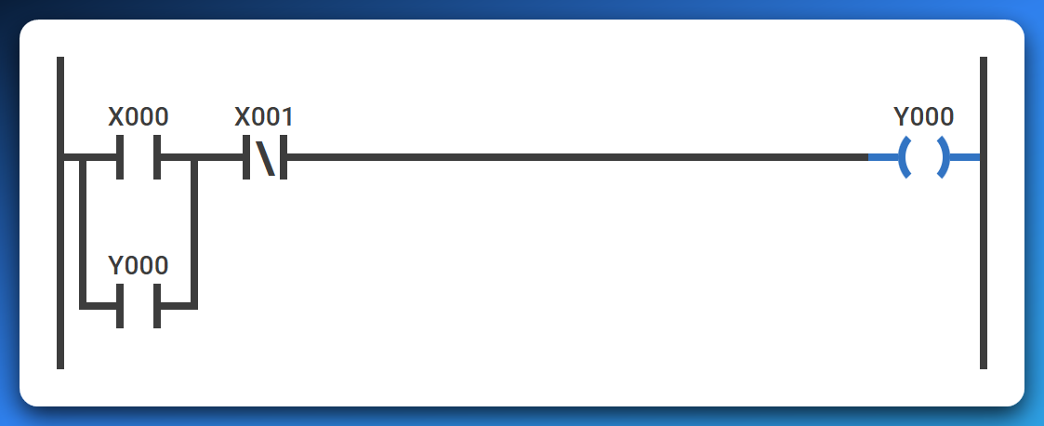

1. **Output Control:**
   * When the physical Start button is pressed, the PLC detects X000 as ON. If X001 (from the Stop button) is also ON (meaning the button is not pressed), the PLC's internal logic energizes Y000.
   * Y000 (the PLC's output) is then used in the latching contact within the PLC's program.
   * The physical Motor control relay coil receives power from the PLC's Y000 output, activating the relay and thus starting the motor.
   * When the physical Start button is released, the PLC detects X000 as OFF, but the Y000 internal contact within the PLC's program keeps the Y000 output energized (latching). The motor stays on.
   * When the physical Stop button is pressed, the PLC detects X001 as OFF (because it's NC, pressing it makes the input false). This breaks the logic path in the PLC program, de-energizing Y000, and stopping the motor.

The Key Difference (and Advantage) of a PLC

The logic itself—the latching principle—hasn’t changed. What’s different is **how it’s implemented**. With a PLC:

* You no longer need to rewire physical relays to modify the control logic.
* Updates, debugging, or adding features become as simple as editing the program.
* Complex wiring diagrams shrink down to clear, readable ladder logic.

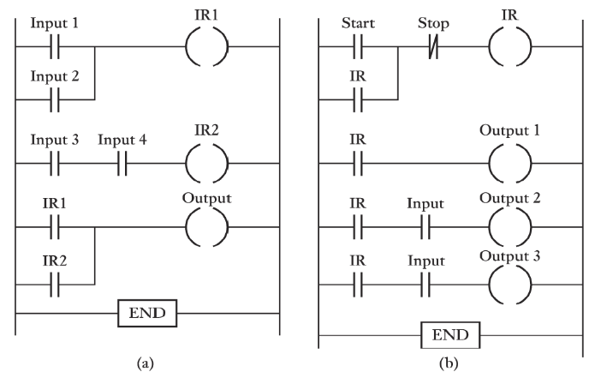

This image presents two multi-rung ladder logic programs, each demonstrating more complex control scenarios than single-rung examples.

The key concept introduced and heavily utilized here is the use of **Internal Relays (IR)**, also known as internal coils, memory bits, or flags.

These are **virtual outputs** within the PLC's memory that don't directly control a physical device but are used to store intermediate logic results, making complex programs more organized and efficient.

Let's explain each program:

(a) Program (a) - Combining Logic with Internal Relays

This program shows how multiple conditions can be combined using internal relays to control a final output.

* **Rung 1: Input 1 OR Input 2 ➡ IR1**
  + **Logic:** IR1 (Internal Relay 1) will be energized **IF** Input 1 is ON **OR** Input 2 is ON.
  + This is a simple OR gate. IR1 acts as an intermediate flag; it's ON if either of these conditions is met.
* **Rung 2: Input 3 AND Input 4 ➡ IR2**
  + **Logic:** IR2 (Internal Relay 2) will be energized **IF** Input 3 is ON **AND** Input 4 is ON.
  + This is a simple AND gate. IR2 is another intermediate flag; it's ON if both these conditions are met.
* **Rung 3: IR1 OR IR2 ➡ Output** 
  + **Logic:** The final Output will be energized **IF** IR1 is ON **OR** IR2 is ON.
  + This rung takes the results from the previous two rungs. The Output will be ON if ( (Input 1 OR Input 2) OR (Input 3 AND Input 4) ) is true.
* **END:** Marks the end of the program.

**Purpose of IR1 and IR2:** They simplify the overall logic. Instead of creating one very long and potentially complex rung, the logic is broken down into smaller, manageable pieces. This makes the program easier to read, understand, debug, and modify. If Input 1 or Input 2 are also used elsewhere, IR1 can act as a single "summary" input.

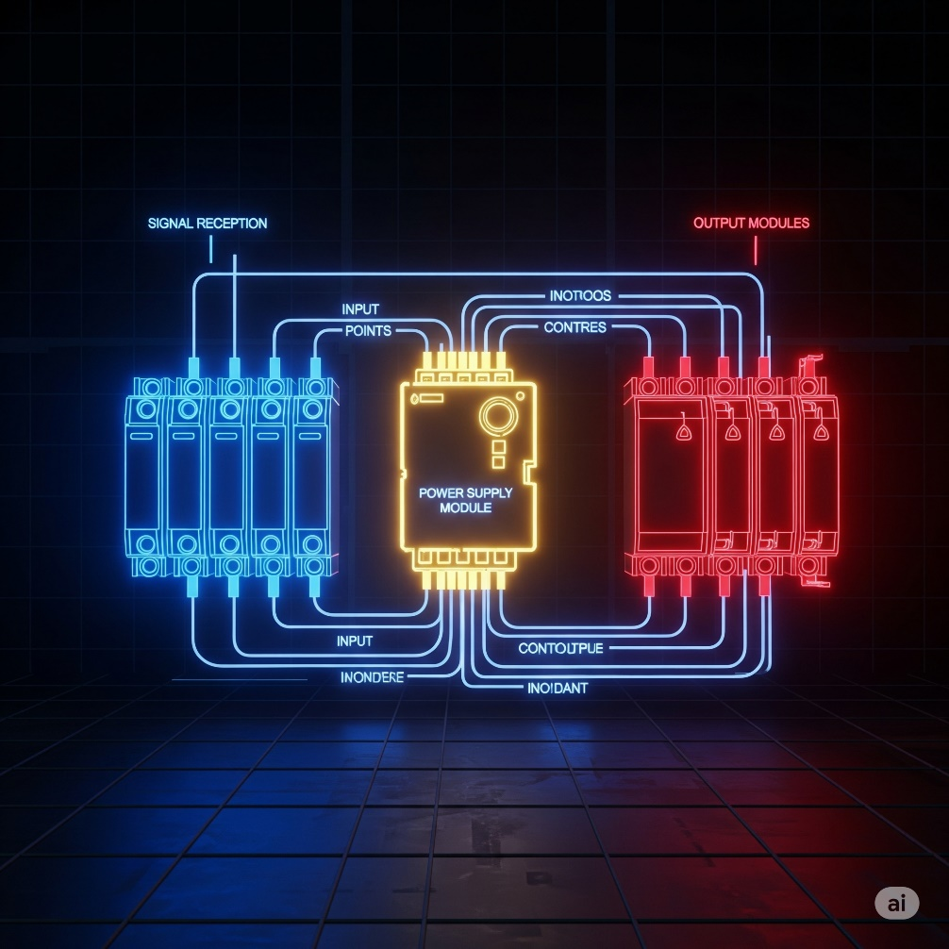

(b) Program (b) - Latching with Internal Relay and Dependent Outputs

This program demonstrates a common motor control type scenario where a main control (a latching circuit) enables or disables other outputs.

* **Rung 1: Start (NO) and Stop (NC) with IR (Latching) ➡ IR**
  + **Logic:** This is the standard latching (seal-in) circuit we discussed earlier.
  + The internal relay IR (Internal Relay) will be energized when the Start button is momentarily pressed, and it will stay energized even after Start is released, as long as Stop is not pressed.
  + IR essentially acts as a "System ON" or "Master Enable" flag.
* **Rung 2: IR ➡ Output 1**
  + **Logic:** Output 1 will be energized **IF** IR is ON. This means Output 1 will turn ON as soon as the main IR latching circuit is engaged, and it will stay ON as long as IR is ON.
* **Rung 3: IR AND Input ➡ Output 2**
  + **Logic:** Output 2 will be energized **IF** IR is ON **AND** Input is ON. This demonstrates that Output 2 can only be activated if the "System ON" (IR) is active AND a second condition (Input) is also met. If the IR is off, Output 2 can never turn on, regardless of Input.
* **Rung 4: IR AND Input ➡ Output 3**
  + **Logic:** Output 3 will be energized **IF** IR is ON **AND** Input is ON.
  + This is identical logic to Rung 3. It shows that multiple outputs can be controlled by the same combination of conditions. **END** does the obvious.

Purpose of IR and Dependent Outputs:

The IR internal relay provides a master control. If IR is not latched ON, none of Output 1, Output 2, or Output 3 can be turned on. This is extremely useful for:

* **Safety:** A single stop button can de-energize a critical master relay, shutting down an entire process or machine.
* **Sequencing:** It ensures that certain operations (like Output 2 or Output 3) only occur when the system is in its enabled state.
* **Modularity:** You can easily add more outputs or complex logic that depends on the IR being active without affecting the main start/stop control.

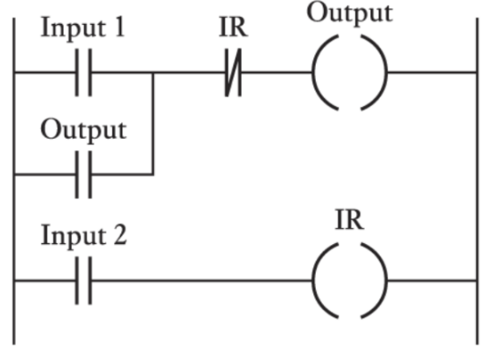This ladder logic diagram shows a **latching circuit** combined with an **internal relay (IR)** that acts as an override or condition for the main output. It’s a common control pattern, especially when you need a start/stop behavior with a “master stop” or enable function.

Rung 1: Latching Circuit with Input 1, Output, and IR

* **Input 1 (--| |--):** This is a Normally Open (NO) contact, likely representing a "Start" or "Enable" push-button.
* **Output (--| |-- in parallel with Input 1):** This is a Normally Open (NO) contact that is controlled by the Output coil itself. This forms the "seal-in" or "latching" part of the circuit.
* **IR (--|/|--):** This is a Normally Closed (NC) contact that is controlled by the IR coil in the second rung. This contact acts as a "stop" or "disable" for the first rung's logic.
* **Output (--( )--):** This is the output coil that this rung directly controls.

Logic of Rung 1:

The Output coil will be energized **IF** (Input 1 is pressed **OR** Output is already latched ON) **AND** IR is OFF.

* **How to start Output:** You press Input 1. If IR is currently OFF (its NC contact is closed), then current flows to the Output coil, energizing it.
* **How Output latches:** Once Output is energized, its parallel contact closes, creating a self-holding path. You can release Input 1, and Output will remain ON, provided IR stays OFF.
* **How to stop Output:** If IR turns ON (from Rung 2, as we'll see next), its normally closed contact in Rung 1 will open, breaking the circuit and de-energizing Output. This acts as a "master stop" controlled by Input 2.

Rung 2: Simple Control of IR

* **Input 2 (--| |--):** This is a Normally Open (NO) contact, likely a push-button or sensor.
* **IR (--( )--):** This is an **Internal Relay** (or memory bit) coil. It does not directly control a physical device but stores a logical state (ON or OFF) within the PLC's memory.

Logic of Rung 2:

The internal relay IR will be energized **IF** Input 2 is ON.

* When Input 2 is ON, IR turns ON.
* When Input 2 turns OFF, IR turns OFF.

How the Two Rungs Interact

The key here is how IR in Rung 2 influences Rung 1.

* **Input 2 as a "Master Stop" for Output:**
  + When Input 2 is activated, IR turns ON (Rung 2).
  + When IR turns ON, its Normally Closed contact (--|/|-- IR) in Rung 1 **opens**.
  + This opening breaks the power flow in Rung 1, forcing Output to turn OFF, regardless of Input 1 or Output's own latching contact.
  + So, pressing Input 2 effectively stops Output.

Overall Function

This program creates a **robust start/stop setup**:

1. **Start:** Press Input 1 to energize Output.
2. **Latch:** Output stays ON even after Input 1 is released.
3. **Stop:** Press Input 2. This energizes IR, which overrides and turns Output OFF.
4. **Reset:** Releasing Input 2 allows Output to be restarted with Input 1.

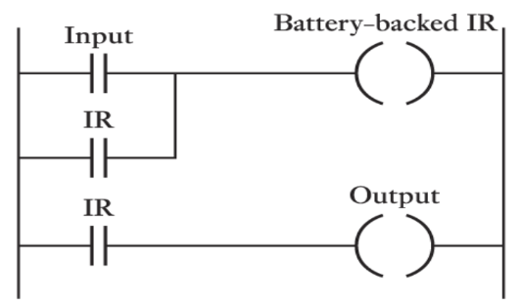This ladder logic diagram shows a specific type of internal relay: a **Battery-backed Internal Relay**. It also illustrates how such an internal relay can be used to control a physical output.

Rung 1: Latching Circuit for "Battery-backed IR"

* **Input (--| |--):** This is a Normally Open (NO) contact, acting as a "start" or "enable" trigger.
* **IR (--| |-- in parallel with Input):** This is a Normally Open (NO) contact controlled by the Battery-backed IR coil itself. This creates the self-latching (seal-in) mechanism.
* **Battery-backed IR (--( )--):** This is an internal relay coil, similar to the IR we discussed before. The crucial difference is the "Battery-backed" designation. This means that if the PLC loses power, the state (ON or OFF) of this specific internal relay is *retained by a small battery inside the PLC.* When power is restored, the Battery-backed IR will return to its state before the power loss. This is also called a "retentive" memory bit.

Logic of Rung 1:

The Battery-backed IR coil will be energized **IF** (Input is turned ON **OR** Battery-backed IR is already latched ON).

* **How to turn Battery-backed IR ON:** Press Input. The Battery-backed IR coil energizes.
* **How it latches:** Once energized, the Battery-backed IR's parallel contact closes, creating a holding path. You can release Input, and Battery-backed IR remains ON.
* **How to turn Battery-backed IR OFF:** There isn't an explicit "stop" button in this rung. To de-energize Battery-backed IR, you would typically need another rung with a normally closed stop contact in series, or a separate unlatch instruction for Battery-backed IR.

Rung 2: Controlling a Physical Output with "Battery-backed IR"

* **IR (--| |--):** This is a Normally Open (NO) contact controlled by the Battery-backed IR coil from Rung 1.
* **Output (--( )--):** This is a physical output coil, which would control an external device like a light, motor, or solenoid.

Logic of Rung 2:

The Output coil will be energized **IF** IR (the Battery-backed IR) is ON.

* This means the Output will simply follow the state of the Battery-backed IR. If Battery-backed IR is ON, Output is ON. If Battery-backed IR is OFF, Output is OFF.

Key Concept: Battery-backed / Retentive Memory

The standout feature of this diagram is the **Battery-backed Internal Relay (IR)**.

Non-Retentive (Volatile) Internal Relays

Most standard internal relays—like the ones we saw earlier—are **non-retentive**.

* If the PLC loses power, their state (ON/OFF) is **reset to OFF** when power comes back.
* This is fine for simple systems but not ideal for processes that need to “remember” their state.

Retentive (Battery-backed) Internal Relays

Battery-backed IRs are designed to **hold their state even through power cycles**.

* A small internal battery inside the PLC provides the backup power needed to maintain this memory.
* This is crucial for machines that need to **resume where they left off after a power outage**—for example, remembering that a sequence was halfway done or that a certain mode was active.

Overall Function of This Program

* Once the **Battery-backed IR** is latched ON (via an input signal), it **stays ON**, even if the PLC loses and regains power.
* The Output simply mirrors this persistent state—turning ON whenever the Battery-backed IR is ON.

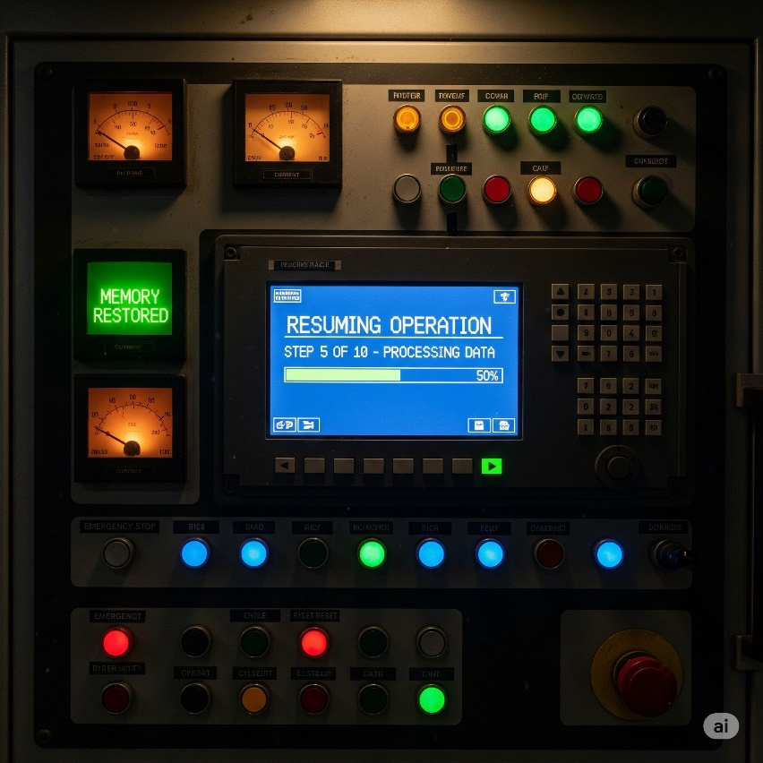

This makes retentive memory **invaluable for industrial processes** where a power cut shouldn’t mean starting over.



Key Concept: Data Handling and Comparison in Ladder Logic

This image introduces **special PLC instructions**—specifically, **MOV (Move)** and **Compare instructions**—which are essential for going beyond simple ON/OFF control. These tools let you handle numeric data, set thresholds, and build smarter logic based on real-world values (like temperature or pressure).

1. MOV (Move Instruction)

* **Ladder Symbol:** A box labeled MOV with S (Source address) and D (Destination address).
* **Purpose:** Copies data from one memory location to another.
* **How It Works:**  
  When the rung condition to the left of the MOV box is true, the PLC takes the current value at **S (Source)** and writes it into **D (Destination)**.
* **Example Use:** Move a setpoint value into a timer’s preset register or copy a counter’s current count into a display register.

2. > (Greater Than – Compare Instruction)

* **Ladder Symbol:** A box labeled > with S and D.
* **Purpose:** Checks if **S** is greater than **D**.
* **How It Works:**  
  If **S > D**, the instruction evaluates as true and allows the logic to flow to the right. Otherwise, it evaluates as false, and the rung stops there.
* **Example Use:** Compare a temperature reading (S) against a high-limit setpoint (D) to trigger an alarm.

3. Practical Application: ≥ and ≤ for High/Low Limits

**Top Rung: High-Limit Alarm**

* **Instruction:** ≥ K=80 S D
  + **K=80** is a constant value (80). The PLC checks if **S ≥ 80**.
  + **S** could be a process variable like a temperature input.
* **Logic:**  
  The Alarm coil turns ON if **(S ≥ 80) AND (IR is ON)**.
* **Purpose:**  
  This triggers an alarm when a high threshold is reached—e.g., if the temperature hits 80°C and the master alarm relay (IR) is active.

Bottom Rung: Low-Limit Control (IR Relay)

* **Instruction:** ≤ K=70 S D
  + Compares **S ≤ 70**.
  + **IR (--( )--)** is an internal relay coil that activates when this condition is true.
* **Purpose:**  
  This IR can represent a **low condition trigger**, such as signaling that the temperature has dropped to 70°C or lower. IR can then be used to control heating or enable alarms in the rung above.

Why This Matters

* **MOV and Compare instructions** give PLCs the ability to handle **numeric data** rather than just boolean states.
* They enable **threshold-based logic**, which is critical for analog sensors (temperature, level, flow, etc.).
* With these tools, you can implement smart control strategies, such as turning on a heater when the temperature is too low or sounding an alarm when it’s too high.



This image introduces another type of special instruction in PLC ladder logic: an **Arithmetic Instruction**, specifically the **ADD instruction**. These are used for performing mathematical operations on data within the PLC.

The ADD Instruction

* **Ladder Symbol:** A box labeled ADD with three fields below it: Au, Ag, and R.
* **Add instruction:** This indicates the type of mathematical operation to be performed. In this case, it's addition.
* **Au (Augend):** This is the memory address or value that represents the **first number** in the addition operation. Think of it as the "number to which something is added."
* **Ag (Addend):** This is the memory address or value that represents the **second number** in the addition operation. Think of it as the "number that is added."
* **R (Result):** This is the **destination memory address** where the sum of Au and Ag will be stored.

How it Works

* When the contact(s) to the left of the ADD instruction are true (i.e., the rung condition is met), the PLC will execute this instruction.
* It will retrieve the value from the memory address specified by Au.
* It will retrieve the value from the memory address specified by Ag.
* It will add these two values together (Au + Ag).
* The calculated sum will then be stored in the memory address specified by R.

Example Use Case

Imagine you have a process where you need to track a total count, or adjust a setpoint:

* **Counting:**
  + Au could be a register holding a current total (e.g., D100).
  + Ag could be a constant value 1 (if adding one each time) or another register (e.g., D101) that stores a batch quantity.
  + R would be the same register as Au (D100) if you want to update the running total in the same location, or a new register (D102) if you want the sum in a separate spot.
  + So, **ADD D100, 1, D100** would increment the value in D100 by 1 each time the rung is true.

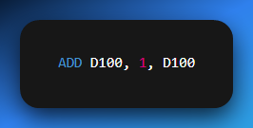

* **Adjusting a Setpoint:**
  + Au could be a base temperature setpoint (e.g., D200).
  + Ag could be an offset value (e.g., D201) that changes based on production mode.
  + R would be the actual operating setpoint that a temperature controller uses (e.g., D202).
  + So, **ADD D200, D201, D202** calculates the final setpoint.

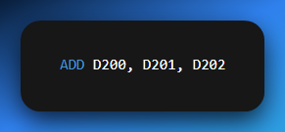

The ADD instruction—along with SUB (subtract), MUL (multiply), and DIV (divide)—is essential for handling numeric data from sensors and implementing calculations inside the PLC. These instructions are the backbone of more advanced control strategies.

**SUB, MUL, and DIV work the same way as ADD**—they just change the operation performed on the two values.

They all use:

* **Au (first value/memory)**
* **Ag (second value/memory)**
* **R (result destination)**

The only difference is:

* ADD → Adds **Au + Ag → R**
* SUB → Subtracts **Au – Ag → R**
* MUL → Multiplies **Au × Ag → R**
* DIV → Divides **Au ÷ Ag → R**

So yeah, we don’t need to write separate full notes for each.



Data Conversion Instruction: BIN

This image introduces another key PLC instruction—**BIN (Convert to Binary)**—which is used to **convert data from one numerical format (e.g., BCD) into pure binary** for internal processing.

BIN Instruction Breakdown

* **Ladder Symbol:** A box labeled BIN with two fields: **S** (Source) and **D** (Destination).
* **S (Source):** Memory address holding the original data (e.g., from an input module).
* **D (Destination):** Memory address where the converted binary value will be stored.

How It Works:

When the rung condition to the left is true, the PLC:

1. Reads the value from **S**.
2. Converts it into pure binary (if it’s in another format, such as BCD).
3. Stores the converted value into **D**.

Why Conversion Is Needed

* **BCD Inputs:** Devices like thumbwheel switches or certain displays often output **Binary Coded Decimal (BCD)**. In BCD, each decimal digit is stored as its 4-bit binary code (e.g., decimal 25 is 0010 0101 in BCD).
* **PLC Processing:** PLCs perform math and logic operations using **pure binary** (e.g., decimal 25 is 0001 1001 in binary).
* **Compatibility:** Data must be converted to binary before it can be used in instructions like ADD, SUB, or compare operations.

Example Use Case

Suppose a thumbwheel switch outputs a BCD value (e.g., 25) into register **I_Data_Register**

You want this number to be used as a **timer preset**. You’d use:

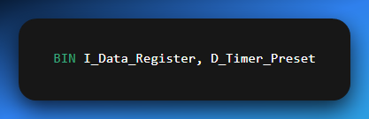

When the rung is true, the PLC converts 0010 0101 (BCD 25) into 0001 1001 (binary 25) and stores it in D_Timer_Preset.

Why It’s Important

The BIN instruction acts as a **bridge between external devices and internal PLC logic**, ensuring that data coming from different encoding schemes can be processed correctly.

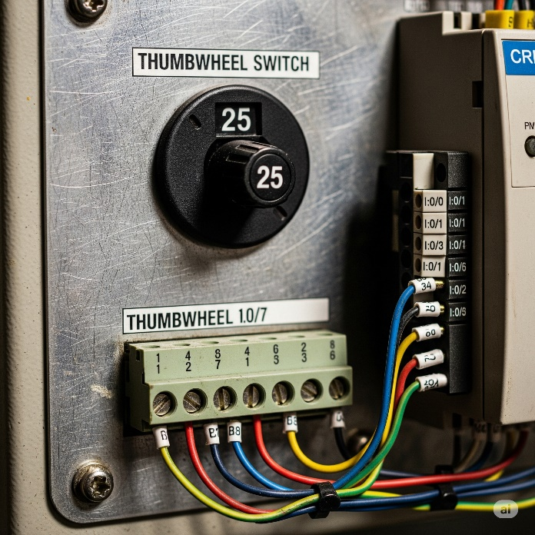

These were my personal notes, they mostly have no order of topics, I just threw in a bunch of pdfs together and made sense of them without caring about order, because I was just reading for basic understanding of PLCs and what they do. The next pdf is going to be hosting the ladder logic complex content, and then the questions on plcs will be in the final PDF.